

Mixed Migration, Forced Displacement

AND Job Outcomes in South Africa

**WORLD BANKGROUP**

|  |  |  |  |
| --- | --- | --- | --- |
|  |  | ra Imn| • H |  |
|  |  | ■ " { Wm **C——_** |  |
|  |  | **1 ■ .yvSBr W1** | ✓i |
|  | |  |  |

|  |  |  |  |
| --- | --- | --- | --- |
| it  ’V- | r | 7 | 'i-  < |
|  | -• | | **IT''** |
|  | **J** | F |  |
|  | /  **8~** | 1 | **\***  ■ t |
| *f* | | 1.^ |  |
| * . | |  | **- f** |

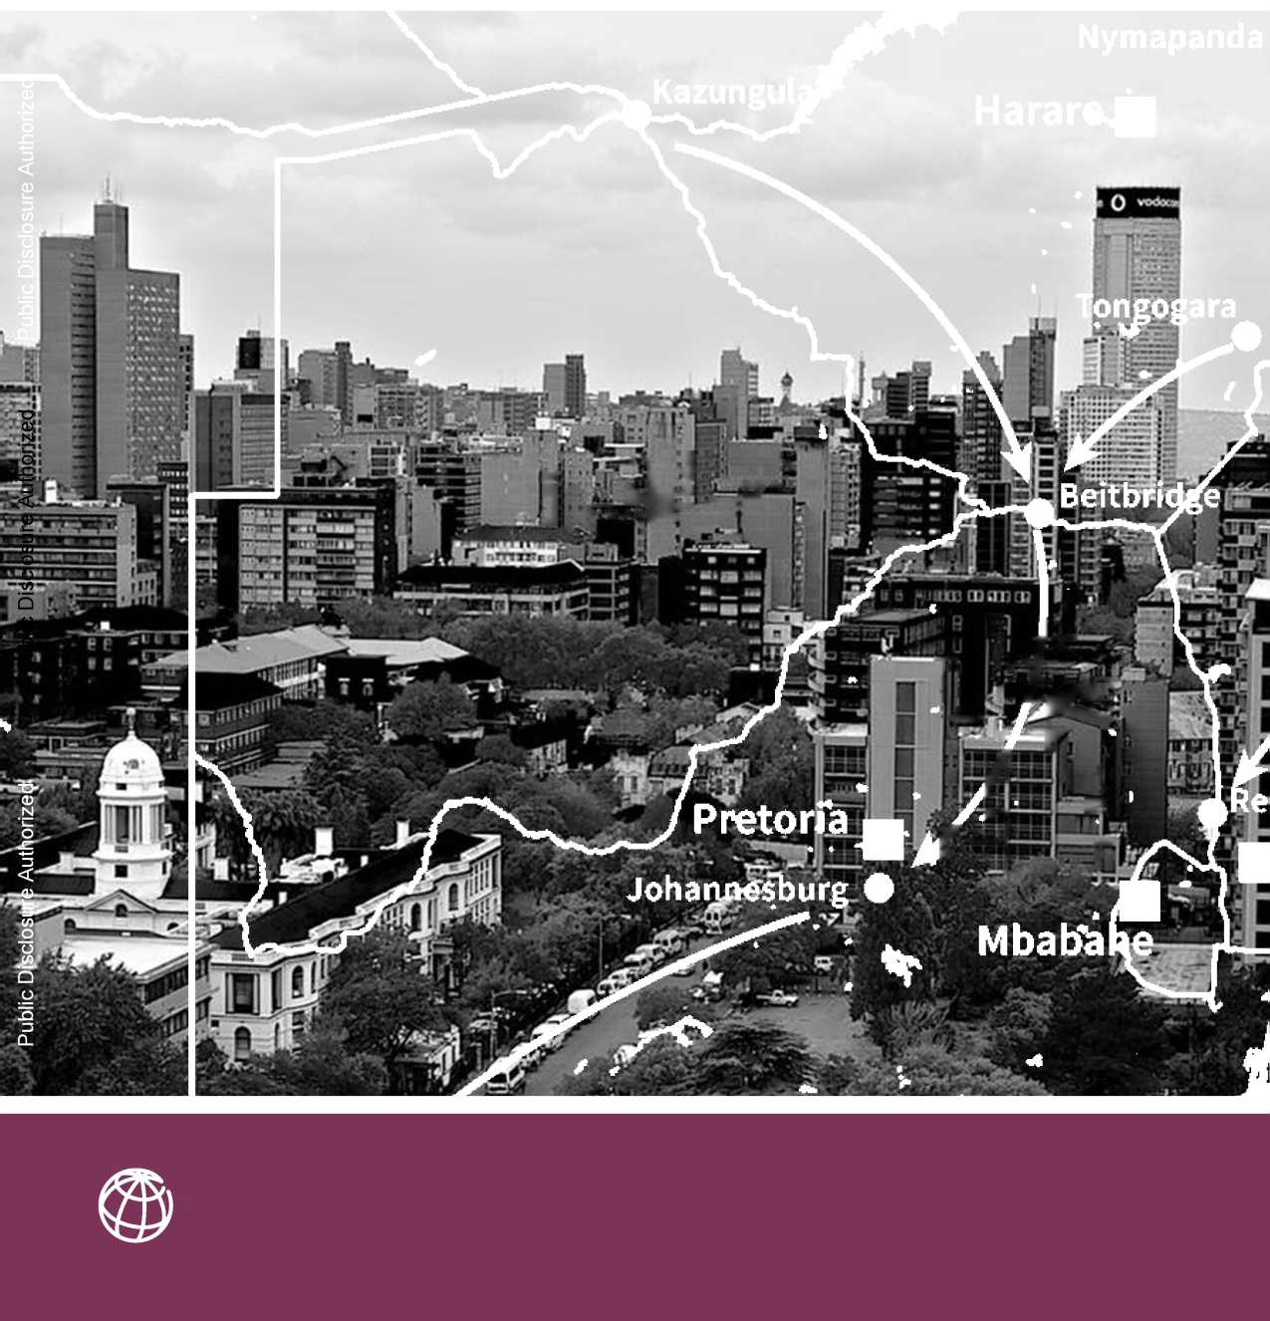

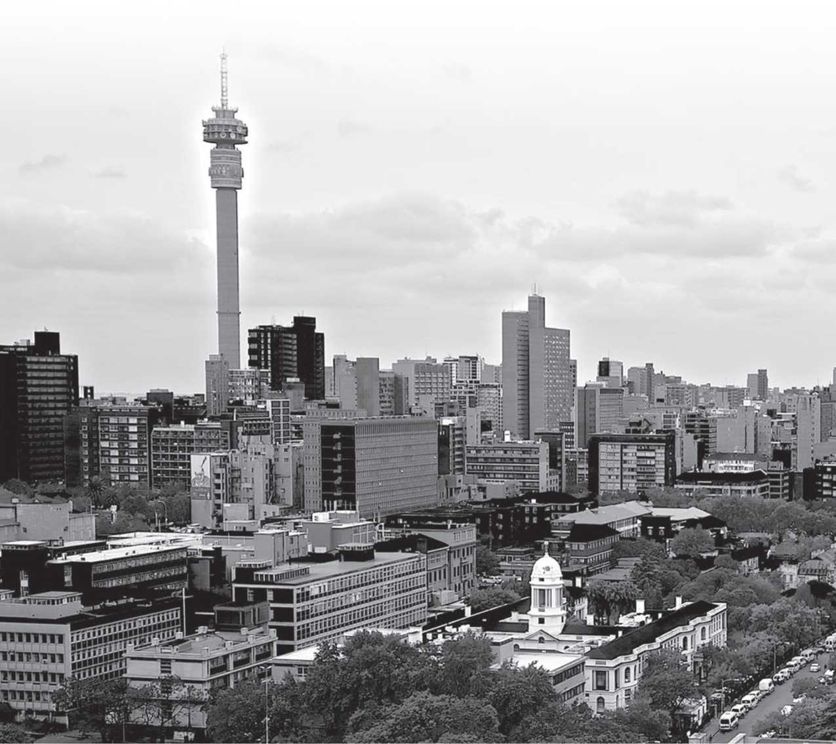



Cover image (and above): Johannesburg, South Africa

Photo credit: Bafedile Mafologele

Map credit: Eigo Tateishi / World Bank

Graphic design: Alston Taggart and Kevin Sample / Studio Red Design

**WORLD BANK GROUP**

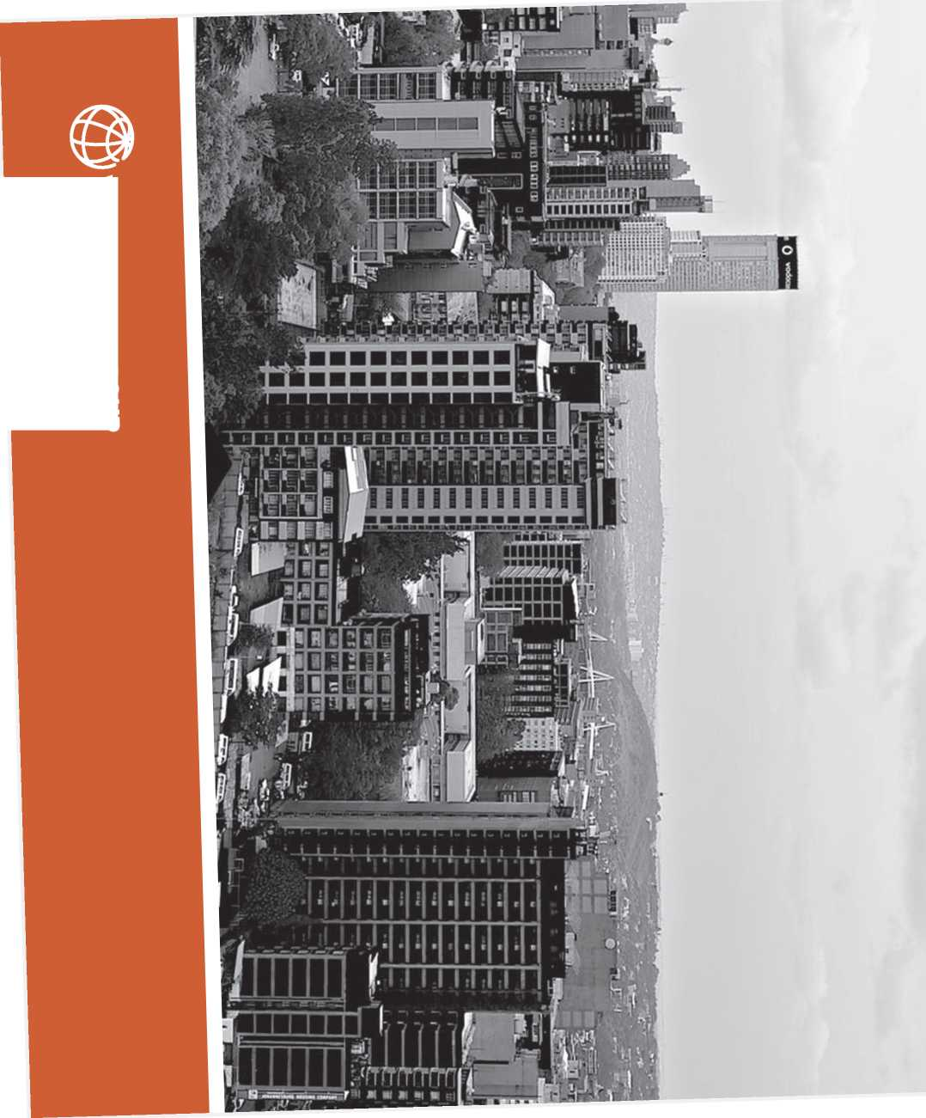

■

**X  
CD**

—«

**3 §**

**CD -**

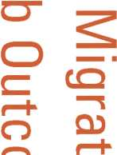

**Z2. CD o O Qj CD**

**2**

**CD**



© 2018 The World Bank Group 1818 H Street, NW Washington, DC 20433 Telephone: (202) 473-1000 Web site: [www.worldbank.org](http://www.worldbank.org)/ All rights reserved.

Disclaimer

This work is a product of the staff of The World Bank with external contributions. The findings, interpretations, and conclusions expressed in this work do not necessarily reflect the views of The World Bank, its Board of Executive Directors, or the governments they represent. The World Bank does not guarantee the accuracy of the data included in this work.

Rights and Permissions

The material in this publication is copyrighted. Copying and/ or transmitting portions or all of this work without permission may be a violation of applicable law. The World Bank Group encourages dissemination of its work and will normally grant permission to reproduce portions of the work promptly.

Table of Contents

EXECUTIVE SUMMARY

**7**

**7**

**8**

**9**

**10**

**10**

INTRODUCTION

Background, Objectives and Approach

Scope and Structure

Southern Africa: Why and Why Now?

The World Bank, Migration and Displacement

A Note on Terminology: Mixed Migration, Forced Displacement and Development

**1****3**

**1****4**

**15**

**18**

**19**

**21**

MIXED MIGRATION AND FORCED DISPLACEMENT INTO AND WITHIN SOUTHERN AFRICA

History of Labor Migration in Southern Africa

Trends of Migration and Displacement in Southern Africa

Displacement from the Great Lakes and the Horn of Africa

The Crisis in Zimbabwe

Migration in South Africa

**2****5**

**2****5**

**26**

**27**

**30**

LAWS AND POLICIES GOVERNING MIGRATION AND DISPLACEMENT IN SOUTHERN AFRICA

The International and Continental Governance of Migration and Displacement

The Regional Governance of Migration

Divergence between Laws, Policies and Practice on Migration and Displacement in South Africa

The Role of Local Authorities in the Governance of Migration

**33**

THE CASE FOR EMPIRICAL EVIDENCE: MIGRATION AND JOB OUTCOMES IN SOUTH AFRICA

**3****5**

**3****6**

**3****7**

**41**

**41**

MIXED MIGRATION, FORCED DISPLACEMENT AND JOBS IN SOUTH AFRICA

A Brief Look at Post-Apartheid Immigration History and Trends

Estimation Methodology

Results

Understanding the Results

**45**

CONCLUSION

**4****7**

**4****7**

**49**

**53**

**54**

ANNEXURES

Annex 1: A Note on Terminology: Mixed Migration and Forced Displacement

Annex 2: Methodology, Data and Limitations

Annex 3: List of Interviewees in South Africa

Annex 4: References

Acknowledgements

**T**

**HIS PUBLICATION WAS PREPARED BY A TEAM** of colleagues from across the World Bank Group. The team was led by Social Development Africa in close collaboration with the IFC, as well as the Poverty and Macro & Fiscal Global Practices.The team was led by Helidah Refiloe Ogude (Social Development Specialist, GSU20) with the core team including, Joanna P. de Berry (Senior Social Development Specialist, GTFDR), Shoghik Hovhannisyan (Research Officer, CSEIM), Aditya Sarkar (Consultant, GSU20), Christopher Baum (Senior Consultant, GSU07) and Hang Zhou (Consultant). Contributions were also made by the extended team, Marek Hanusch (Senior Economist, GMTA4), Victor Sulla (Senior Economist, GPV07), Robertus Swinkels (Senior Economist, GPV07) and Johannes Herderschee (Senior Economist, GMTA4).

Invaluable formal peer-review comments at different stages of its development were received from Manjula Luthria (GSP05), Sam Omollo (IOM, South Africa), Paolo Verme (GTFDR), VaralakshmiVerumu (GSU07), Loren Landau (Wits University) and Mauro Testaverde (GSP02).

The publication benefitted from discussions with representatives from multilateral organiza­tions including the ILO, IOM, UNHCR and UNFPA; academic institutions, University of the Witwatersrand, University of Johannesburg, University of Pretoria; South African national, pro­vincial and local government departments such as, the Department of Home Affairs, National Planning Commission, Department of Higher Education and Training, Department of Social Development, Statistics South Africa, City of Johannesburg and Gauteng Provincial govern­ment; NGOs and advocacy groups, Consortium for Refugees and Migrants in South Africa, Lawyers for Human Rights, Southern Africa Litigation Centre, Medicins Sans Frontieres, Church World Services and Jesuit Refugee Services. A full listing of persons consulted can be found in Annex 2.

The team thanks Xavier Devictor, Paul Nounba Um, Catherine Tovey, Senait Assefa, Robin Mearns, Sebastien Dessus, and Paolo Belli for their guidance at various stages of the preparation of the study.

Financial support was provided by the World Bank Forced Displacement Trust Fund, through the Fragility, Conflict and Violence Cross Cutting Solution Area (CCSA).

iv Acknowledgements

About the Authors

**Shoghik Hovhannisyan,** an Armenian national, joined the World Bank Group in 2010. She currently works for the Sector Economics and Development Impact Department at the IFC. Shoghik holds a Ph.D. degree in Economics from Boston College and a MA degree in International Development Policy from Duke University. She specializes in migration, growth, informal economy, and other areas of macroeconomics and labor economics.

**Christopher F. Baum** is Professor of Economics and Social Work at Boston College. His recent research has focused on Swedish immigrants' labor market outcomes and advances in computational econometric methods. He is a co-investigator on several research projects in social epidemiology, studying the impact of legislation on women's cancers, maternal mortality, and firearm suicides.

**Helidah Refiloe Ogude,** a South African-Kenyan national, is a Social Development Specialist at the World Bank. Her work focuses on the development dimensions of migration and forced displacement, social cohesion and violence prevention, and the political economy of reform. She holds a MSc in International Relations from New York University and is a Doctoral Candidate in Public and Urban Policy at The New School.

**Aditya Sarkar** is an independent researcher, and has worked as a consultant with the World Bank, the International Labour Organization, and Open Society Foundations. He is qualified as a lawyer in India and as a solicitor in England and Wales. He holds an MA degree from the Fletcher School of Law and Diplomacy, Tufts University and is a graduate of the National Law School of India University in Bangalore. His current research looks at political mobilization and rights-claiming among refugees and migrant workers in rights constrained systems.

Figures, Boxes and Tables

Figures

Figure 1: Total migrant stock (both sexes) including refugees and asylum seekers, in Southern Africa, mid-2017

Figure 2: Employment-Population Ratio

Figure 3: Share of Self-employed in Total Employment

Figure 4: Countries Covered by this Study

Figure 5: Total migrant stock (both sexes) including refugees and asylum seekers, in Southern Africa, mid-2017

Figure 6: Comparison of population age structures of migrants (including refugees and asylum seekers) in Southern Africa, 1990 and 2017

Figure 7: Refugees and asylum seekers in Southern Africa, mid-2017

Figure 8: External migrants in South Africa (as per the 2011 census data)

Figure 9: Immigrants' flows by country of origin in 1996, 2001, and 2011 (% in total)

Figure 10: Share of immigrants in total employment by industries and provinces in 1996, 2001, 2011.

Figure 11: Employment-Population Ratio

Figure 12: Share of Self-employed in Total Employment

Boxes

Box 1: Legal Changes in South Africa

Box 2: Basotho Female Migrants

Box 3: Informal Cross-border Trade: The case of South Africa and Zimbabwe

Box 4: Proposed Changes to South African Migration Policy

Box 5: ‘Time-theft' — Lived experiences of asylum-seekers in South Africa

Box 6: Johannesburg's Migrant Help Desk

Box 7: Zimbabwe and Mixed Migration in Southern Africa

Tables

Table 1: Estimated migrant population in Southern Africa, 1990-2015.

Table 2: Migrant, refugee and asylum-seeker statistics in South Africa (1990-2017)

Table 3: Major countries/territories of origin of asylum seekers and refugees in Southern Africa (end-2016)

Table 4: Industry of employment for migrants (QLFS 2014)

Table 5: Estimation Results

Table 6: Sources of UNDESA's migrant data in Southern Africa (UNDESA 2017)

vi | Figures, Boxes and Tables

Abbreviations and Acronyms

|  |  |
| --- | --- |
| ACMS | Africa Centre for Migration and Society |
| AU | African Union |
| DHA | Department of Home Affairs, Government of South Africa |
| GCRO | Gauteng City-Region Observatory |
| HoA | Horn of Africa |
| IDMC | Internal Displacement Monitoring Centre |
| ILO | International Labour Organization |
| IOM | International Organization for Migration |
| MSF | Medecins Sans Frontieres |
| OAU | Organization of African Unity |
| OHCHR | Office of the United Nations High Commissioner for Human Rights |
| UN-OCHA | United Nations Office for the Coordination of Humanitarian Affairs |
| SADC | Southern African Development Community |
| SAMP | Southern African Migration Project |
| StatsSA | Statistics South Africa |
| UNDESA | United Nations Department of Economic and Social Affairs |
| UNHCR | United Nations High Commissioner for Refugees |
| UNHCR ROSA | United Nations High Commissioner for Refugees Regional Office of Southern Africa |
| UNODC | United Nations Office on Drugs and Crime |

|  |  |  |  |  |  |  |  |  |  |
| --- | --- | --- | --- | --- | --- | --- | --- | --- | --- |
| **1** | \; | **H?** | | |  | -^1 IMS s ” J,-Vc ■ | | | |
|  |  |  |  | *\* -t -* | *—-T8* **ha^** | **- «■ >-*1 ■** | Ki - | **B** | i^ “!!" .k^ rs |
|  |  | pg § | **T F**  **tfjtf'** | **<> . ....** | **_ 1 M| i ’i il i 11‘**  **— , tf** | **\* -1 ■ i llh'li'lihii!**  **■»**  **^UiiVkKMBKMMs,** |  |  | ■££»;*; ,,/\ .S |

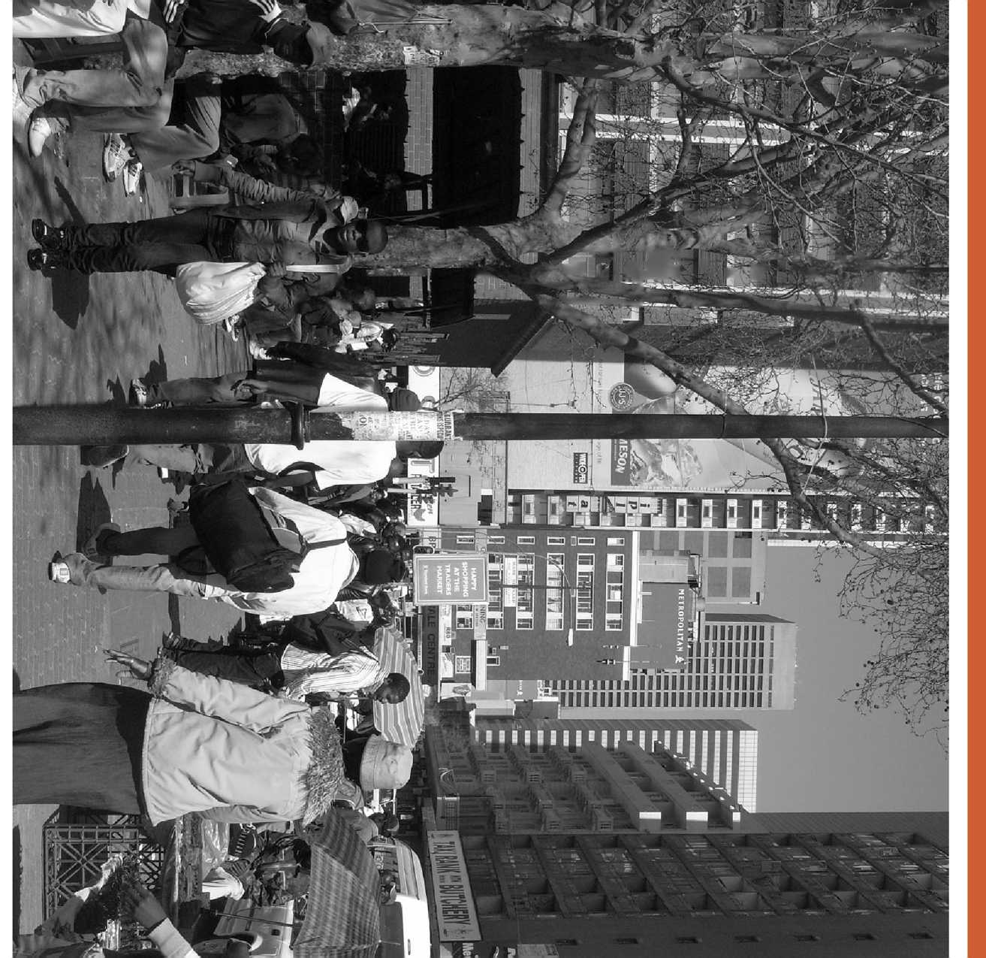

These complex patterns of migration and displacement, state responses to them, and the implications for labor market outcomes in South Africa, as the major destination country in the region, are the subject matter of this study.

Executive Summary

**S**

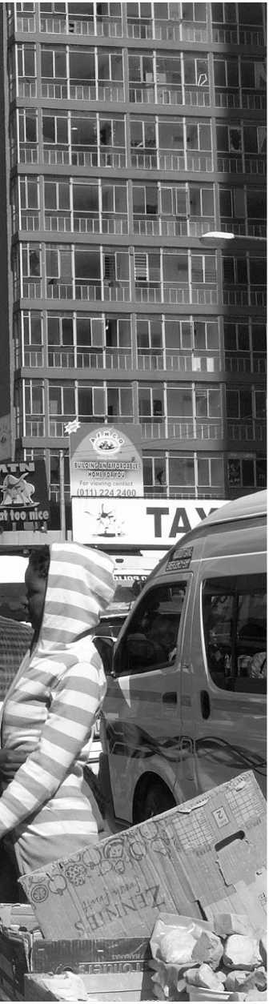**OUTHERN AFRICA HAS A LONG** history of human mobility centered around the migration of labor to farms and mines in the region. Patterns of migration and displacement were trans­formed by the end of Apartheid, changing economic systems, and conflict and political instability, both in the region and elsewhere. Today mobility in the region is (i) motivated by a combination of diverse social, political and economic rea­sons, (ii) shaped by long-standing historical movements and

reshaped by newer patterns of urbanization and displace­ment, (iii) organized through various legal and extra-legal means, and (iv) governed by fragmented and contradic­tory legal frameworks.

These complex patterns of migration and displacement, state responses to them, and the implications for labor market outcomes in South Africa, as the major destina­tion country in the region, are the subject matter of this study.

Scope

This study analyzes the characteristics, causes, and conse­quences of migration and forced displacement in Southern Africa. It includes a brief historical overview, as well as an analysis of current migration trends and their impacts. Further, a brief overview of the policy and legal framework governing migration and displacement across Southern Africa is provided

Given South Africa's position as the major destination for migrants and refugees in the region, the primary focus of this study is an analysis of the links between migration and labor market outcomes in South Africa, namely employment and wages between 1996 and 2011. The evidence provided can serve to inform policy in the region.

Angola

**638,499**

Zambia

\ Namibia

South Africa

Lesotho

**6,749 ,**

0 200 400 800 Km

<4,036,696

Base Map Source; Esri, USGS, NOAA

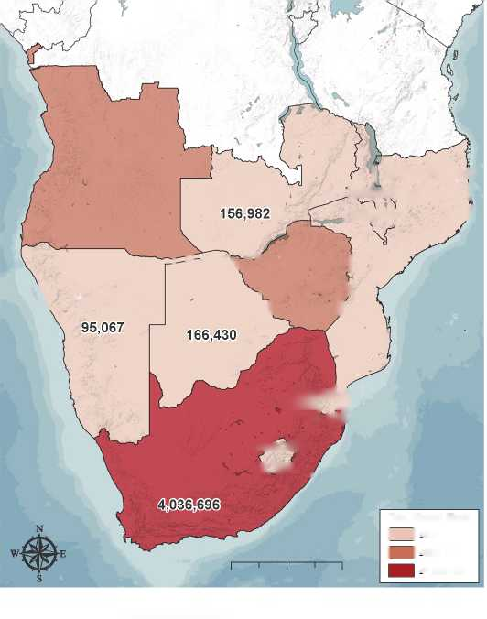Mixed Migration and Forced Displacement into and within Southern Africa

The discovery of diamonds in 1867 and gold in 1886 laid the foundations for South Africa's highly centralized mining indus­try, and led to the development of the region's migrant labor system. During this period, Southern African economies relied on a low-wage, low-skilled, highly-controlled, expendable work­force. Migrant workers, almost all men, were recruited from rural South Africa but also from Lesotho, Malawi, Mozambique, Zimbabwe, Zambia and Tanzania, and usually had to make long and hazardous journeys to their workplaces, where they lived and worked in dangerous, over-crowded conditions.

The racist regulatory measures which controlled mobility, and the extent to which they were enforced in different coun­tries, had a profound impact on the patterns and distribu­tion of poverty and inequality in Southern Africa. They also shaped the region's economies, urbanization, primary (and gendered) livelihood strategies as well as forms of political leadership, organization, and resistance. In South Africa, for instance, townships were designed to act as labor reservoirs for cities and industries centered around urban spaces. This has had direct implications for settlement patterns in South African townships, the provision of public services and for the availability and quality of housing in these townships.

Changes in Southern Africa's political economy led to a major re-structuring of the migrant labor system across the region. As economies shifted to more capital-intensive forms of growth, unskilled migrant labor became increasingly super­fluous to industry and the need for skilled and semi-skilled labor increased.

The profound economic and political upheaval surrounding the end of Apartheid in South Africa transformed migration and displacement across the region. Alongside the organized and controlled labor migration system, other forms of mobil­ity emerged and expanded: this included asylum-seekers flee­ing conflict and persecution, seasonal migrants and cross-border traders and smugglers. These changes took place within a broader socio-economic and legal context shaped by the rela­tionship between Southern Africa's system of mine-based capital accumulation and the migrant workforce on which it relied.

The content of laws governing migrants and refugees has changed in many cases since then, and often radically, but their implementation remains uneven. At the regional level, migra­tion continues to be governed by unenforceable conventions and a patchwork of bilateral agreements and treaties, while in many national contexts, bureaucratic and administrative practices of migration control persist. As a result, patterns of migration and displacement in the region are characterized by elements of both continuity and change.

TRENDS OF MIGRATION AND DISPLACEMENT

IN SOUTHERN AFRICA

The total migrant population in the Southern African countries covered in this study (see map below) has increased by about 68 per cent since 1990. This increase in mobility has not been uniform over time, nor across the region: the largest increases in migrant stock have occurred in South Africa, Botswana, Mozambique and Angola, whereas the number of migrants has decreased in the poorer economies of Malawi, Zambia, and Zimbabwe. South Africa is the single largest country of desti­nation. As of mid-2017, UNDESA estimated that it was host to about 67 per cent. of the regions total migrant population.

SOCIO-ECONOMIC CHARACTERISTICS

OF MIGRATION IN SOUTH AFRICA

The 2011 Census placed the number of international migrants in South Africa at 2,173,409, about 4.2 per cent.

**FIGURE 1:** Total migrant population (both sexes) including refugees and asylum seekers, in Southern Africa, mid-2017

^Mozambique Malawi **246,954 i ,237,104 /**

; ;;; v \ J Zimbabwe j

**, 403,866 )**

Botswana A ' I ■ I

Swaziland

**Mak, ij**

**33,263**

Total Migrant Stock | | <246,954

| | <638,499

World Bank Geospatial Operations Support Team: GOST (2018)

Data Source: United Nations, Department of Economic and Social Affairs. Population Division (2017). Trends in International Migrant Stock: The 2017 revision (United Nations database, POP/DB/MIG/Stock/Rev.2017).

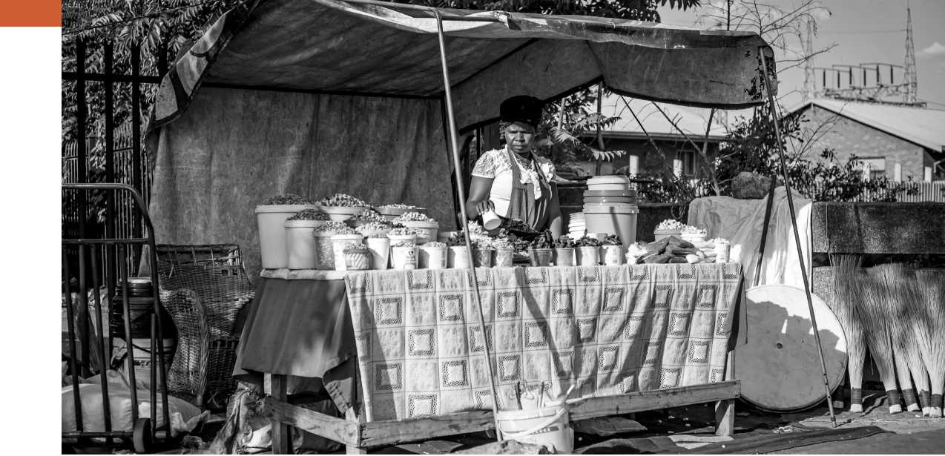of the country's total population at that time. The major­ity of migrants (around 75.3 per cent.) originated in other African countries, with significant populations from Europe (8.2 per cent.) and Asia (4.7 per cent.). The vast majority of all migrants in South Africa, 68 per cent., originated in other SADC Countries.

Not all provinces in South Africa attract migrants to the same extent. Gauteng, in particular, as the primary economic and financial hub in South Africa, hosted an overwhelming majority of international migrants with 52 per cent. of the total. South Africa is also among the more highly urbanized countries in Africa, and Gauteng is particularly highly urban­ized. As a result, migration and displacement in South Africa has important urban dimensions.

According to the same 2011 Census, 39.8 per cent., of inter­national migrants in South Africa were women. Interestingly, however, among migrants from SADC, more women than men aged 15-24 had migrated to South Africa (reversing his­torical trends). Around 23 per cent. of migrants fell below the national poverty income level, and in general, over half of all international migrants in 2011 were poor. Around 27 per cent. of all households were headed by women, but almost one- third of these female-headed households fell in the national poverty category. Around 63 per cent. (or three out of five) international migrants reported being employed. The major­ity were employed in the formal sector, while 17.2 per cent. reported earning their livelihood in the informal sector. 17 per cent. were employed in private households.

One immigrant worker generates approximately two jobs for locals.

Mixed Migration, Forced Displacement and Job Outcomes in South Africa

Migrants and refugees in South Africa are often entangled in political discourse that blames them for ‘stealing' local jobs. The implications of migration on local jobs, is therefore, highly contested. However, empirical evidence may provide the necessary information policy-makers require to develop policies and interventions that mitigate the costs that may be felt by locals, while enhancing the developmental opportuni­ties for migrants, refugees, locals and the wider economy.

It is within this context that this study estimates the impact of immigration on labor market outcomes such as employ­ment and wages in South Africa between 1996 and 2011, and posits several possible explanations for what might account for the results.

There are only a few papers that have studied the impact of immigration on labor market outcomes in South Africa. They have generally found no impact on total income but nega­tive effects on local employment. Compared to earlier papers, this analysis makes several contributions. First, the analysis uses industry-province level data, given significant variation in the utilization of immigrant labor across industries andprovinces. Applying data on a more aggregate level such as provinces instead of smaller geographical units such as districts reduces effects from potential outflows of locals in response to immigrants' inflows. Second, the analysis uses an *instru­mental variables (IV)* approach to address endogeneity issues. The instruments are constructed following the methodology proposed by Card (2001), who uses previous settlements of immigrants as an instrument in studying labor market effects of immigration across geographical regions. Third, the analy­sis includes all immigrants—not only males, as in some stud­ies—given a substantial share of female employment among immigrants. In 2011, females accounted for nearly 24 percent of total employment among immigrants. Next, the estimates focus on the relationship between locals and immigrants, and not on specific groups based on education and experience within each category. The latter captures only the partial own-skill effect and ignores cross-skill complementarities and externalities. Finally, the study uses wage data from the Post­Apartheid Labor Market Series (PALMS) harmonized survey, instead of relying on total income that includes both labor and non-labor earnings as in other studies. For details on the methodological approach, see chapter 4.

RESULTS

The estimation results indicate that immigration has a positive impact on local employment, labor earnings , and wages. The estimated effects of immigrant growth on local employment are positive and highly significant in all specifications and are similar in terms of magnitudes. They show that a one percent increase in the number of immigrants relative to the previous period raises local employment by 0.2 percent. In other words, one immigrant worker generates approximately two jobs for locals. The effects on labor earnings , wages, and self-employment earn­ings are insignificant in OLS estimations with an exception of wage earnings when only individual fixed effects are used. As the OLS results may be affected by simultaneity bias, the analysis has also produced IV estimates for Equations (1) and (2) (See chap­ter 5), using the instrument described and its square to permit overidentification of the equation. In both forms of the model, the immigrant growth rate for the industry, province and year has significant and positive effects on total earnings and wage earnings with values ranging from 0.3 to 1.4.

UNDERSTANDING THE RESULTS

This analysis suggests several explanations for the positive impact of immigrants on South Afri ca's labor market. First, given that immigrants and locals are not perfect substitutes, specialization in different tasks might lead to overall produc­tivity gains. Second, immigrants have nearly twice as high an employment-population ratio compared to locals, possibly reflecting the demand for the diverse set of skills they bring and this can result in large multiplier effects. Finally, immi­grants tend to be more risk-taking and entrepreneurial, which might generate positive externalities in the economy.

Foreign and local-born workers might specialize in perform­ing complementary tasks and, hence, the two groups might not compete for similar jobs. As a result, this complemen­tarity might increase the productivity of local workers and hence generate positive externalities for their employment and wages.

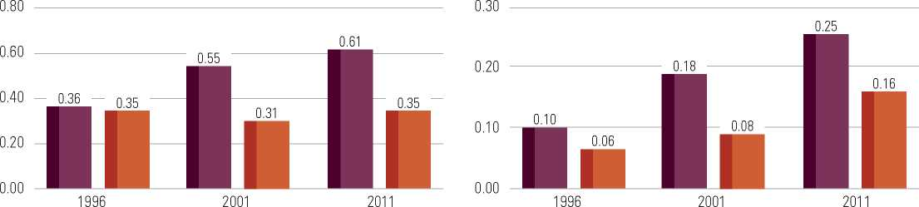To test this hypothesis the study compares occupations of immigrants and locals for tertiary and non-tertiary educated groups. It uses 2011 census data and constructs the Welch (1979) index to test whether immigrants and locals are per­fect substitutes. This index is similar to a correlation coeffi­cient, equaling one (1) when the two groups have identical occupational distributions and minus one (-1) when the two groups are clustered in completely different occupations. We obtain .35 for the non-tertiary educated group and .14 for the

**FIGURE 2:** Employment-Population Ratio

IMMIGRANTS

NATIVES

**FIGURE 3:** Share of Self-employed in Total Employment

IMMIGRANTS

NATIVES

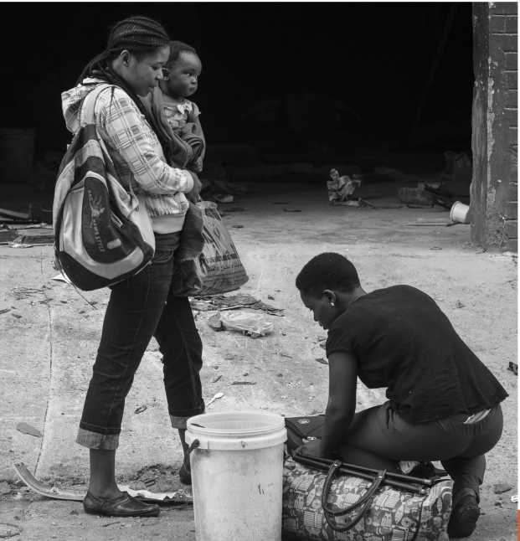

tertiary educated group. This shows that immigrants and locals are not perfect substitutes and the complementarity of tasks they perform might generate efficiency gains in the economy.

Finally, two stylized facts emerge from the comparison of the employment-population ratio and share of self-employed in total employment between locals and immigrants. First, although the employment-population ratios for locals and immigrants were similar in 1996, this drastically changed by 2011 (Figures 2 and 3). In particular, the share of employed immigrants in total increased from 36 to 61 per cent. com­pared to only 35 per cent. for locals.

This sharp increase in the employment-population ratio for immigrants was probably due to changes in immigration pol­icies post-Apartheid. Higher employment rates among immi­grants and hence higher labor earnings compared to locals might generate large multiplier effects in the economy.

Finally, we must also note the prevalence of self-employment among immigrants: self-employment accounted for 25 per­cent of total jobs for immigrants, compared to 16 percent for locals. Migrants are more likely to appear in entrepreneurial roles than locals, suggesting that their actions are likely to pro­mote economic growth by enhancing, for instance, the supply of small retail establishments. If those businesses are success­ful, they also will provide multiplier effects which may spread beyond the immediate family.

An important note of caution is that these results are retro­spective in nature given the data limitations mentioned, and therefore these results may differ in the current context. It is also well documented that even in the best circumstances, migration and displacement may have significant short-term costs for receiving communities.

Conclusion

**Labor Market Outcomes: An Opportunity for Policy Dialogue and Further Research**

The results and substantiations provided here, are significant for policy makers and development actors in South Africa and the wider region, and as such, their implications should be seriously considered. They provide a basis for substantive policy dialogue on how to enhance the development impacts of migration, especially for local job and wage outcomes and the South African economy. Critically, although such quanti­tative analysis is instructive, perceptions and subjective evalu­ations of well-being of both locals and migrants, matters. As such, any interventions in response to these results, should account for perceptions and lived experiences. Equally, the political will to advance policies based on empirical evidence, is a necessity for the achievement of any sustainable and posi­tive economic outcomes for locals and migrants, alike.

Crucially, these results also provide an important foundation upon which further large-scale research can be developed. Such research can potentially complicate and enable a richer understanding for how migrants, refugees and asylum-seekers engage with the South African economy and the economic relationships they share with locals. This research, may for instance, consider how circular migration, informality, undoc­umented movements and gendered dimensions have implica­tions for economic relationships.

The results and substantiations provided here are significant for policy makers and development actors in South Africa and the wider region, and as such, their implications should be seriously considered.

Mixed Migration, Forced Displacement and Job Outcomes in South Africa | 5





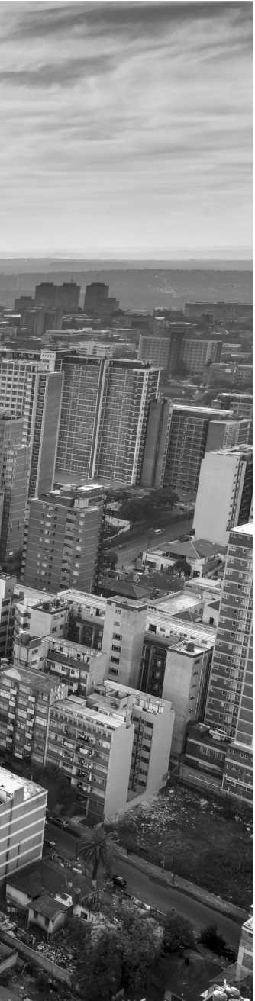

As people move for ever more diverse reasons, migration has become a central component of

livelihood and protection strategies for many. Governments, however, have struggled to respond to the governance challenges presented by

these complex movements.

Introduction

1

Background, Objectives and Approach

**S**

**OUTHERN AFRICA HAS A LONG** history of human mobility. The movement of people, and efforts to control mobility, have substantially shaped the region's societies and economies. Contemporary migration patterns in Southern Africa are complex, and are motivated by a combination of diverse social, political and eco­nomic reasons. They have been shaped by long-standing histor­ical movements and reshaped by newer patterns of urbanization

and displacement. Today, cross-border movements take place through various legal and extra-legal means and are governed by fragmented and contradictory legal frameworks.

In recent years, a com­bination of poverty and inequality (and in the case of Zimbabwe, political instabil­ity and attendant economic turmoil), has driven migra­tion and displacement to wealthier countries within

Southern Africa. Migration from other parts of Africa

has consisted largely of people fleeing protracted con­flict, repression, and economic insecurity in the Great Lakes Region and in the Horn of Africa (HoA). Southern Africa also hosts migrants and refugees from West Africa and as far afield as South and East Asia (see Crush *et al*, 2017). As people move for ever more diverse reasons, migration has become a central component of livelihood and protection strategies for many. Governments, however, have struggled to respond to the gov­ernance challenges presented by these complex movements. Some have strengthened borders and tightened legal regimes, or are in the process of doing so.

The broader question addressed by this study is not unique to Southern Africa, and in this sense, this study is relevant

Mixed Migration, Forced Displacement and Job Outcomes in South Africa 7

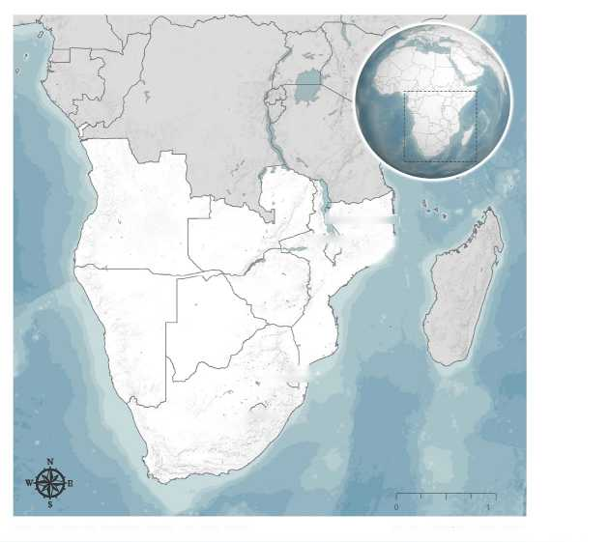

**FIGURE 4:** Countries Covered by this Study

Angola

Zambia

Zimbabwe

Namibia

Botswana

,000 Km

World Bank Geospatial Operations Support Team: GOST (2018)

Base Map Source; Esri, USGS, NOAA

250 500

Mozambique

Malawi

■ *J*

Lesotho

South Africa-/Ar"

**• />' -6**

Swaziland

for many other contexts. Refugees, asylum-seekers and other migrants are major subjects of political debate in many coun­tries. The implications of migration and forced displacement for local jobs is widely contested. Concurrently, nation-states, regional actors and others have increasingly begun to rec­ognize the inevitability and potential benefits of migration (Castles, de Haas and Miller 2013, p.1). This duality points to the fact that migration and displacement are connected to broader, deeply political questions of social transformation, global inequality and societal development (Castles 2003, p.22; Bakewell 2008a; Van Hear 2011, p.4).

Therefore, fully grasping the governance of mobility and its effects on, for instance, host country labor market outcomes, requires inquiry beyond the legal regulation of mobility. That is, it requires an understanding of how mobility is governed *in practice*. For example, actual practices of bureaucratic detention, deportation and asylum adjudication must be analyzed in addi­tion to the existing asylum policy regime. Further, the often informal, opaque, and complex local power structures which regulate access to services for migrants and refugees must be accounted for, notwithstanding the laws and policies on these topics. Critically, it also involves an examination of how migra- tion/displacement intersects with several other policy sectors, which may not, on surface, appear to be directly related to mobility, but nevertheless affect how both migrants and hosts engage with the economy and society. This includes access to labor markets, education, housing and health services, etc.

The remainder of this introductory section outlines the scope and structure of this study, sets out the World Bank's role and interest in understanding migration and displacement in Southern Africa and briefly explains the meaning of some terminology used throughout the study.

Scope and Structure

SCOPE

Geographically, this study primarily covers South Africa. However, within the chapters that provide context on the causes, extent and characteristics of movements into and within Southern Africa, Lesotho, Swaziland, Namibia, Botswana, Zimbabwe, Mozambique, Malawi, Angola and Zambia, which are all members of the Southern African Development Community (SADC), are discussed to a limited extent. Of the other member states of SADC, the World Bank usually considers Tanzania as falling within East Africa and the Democratic Republic of the Congo (DRC) as part of Central Africa, which will be the case in this study too. Mauritius, Madagascar and Seychelles are not covered in this study.

South Africa is the largest economy in Southern Africa, and the only middle-income country in sub-Saharan Africa with an economy based on industry, services and manual work. As a result, it remains an extremely important destination for migrants from all over Africa, and increasingly, it appears, from parts of Asia. At the same time, it has a history of xenopho­bic attacks against ‘foreign nationals' and other locally defined ‘outsiders' based on the unsubstantiated notion that migrants and refugees are major sources of criminality, disease and are the cause of local unemployment (Kihato forthcoming).

This study has a particular focus on the impact of international migration on jobs in South Africa. The availability of labor related micro-data in South Africa, allows for nuanced empirical exam­ination of the links between migration and domestic labor market outcomes, such as jobs and wages. This empirical work can serve to inform evidence-based policymaking across the region.

STRUCTURE

1. This paper is divided into 3 substantive sections. The first section analyzes the characteristics, causes, and conse­quences of migration and forced displacement in Southern Africa. It includes a brief historical overview, as well as an analysis of current migration trends and their impacts.
2. The second section provides a brief overview of the policy and legal framework governing migration and dis­placement across Southern Africa.
3. Given South Africa's position as the largest destination for migrants and refugees in the region, the third section and primary focus of this study, seeks to foreground evi­dence-based analysis that can provide policy guidance for governments in the region, as well as work to dispel myths that may otherwise be used to mobilize ill-formed prac­tices and policies. As such, through quantitative analysis, Chapter 4 estimates the impact of immigration on South African labor market outcomes, such as employment and wages, between 1996 and 2011.

The methodology for the study, [including additional details of the methodology used to assess the impact of international migration on jobs in South Africa] and the list of interviewees met in South Africa, are included as Annexures].

Southern Africa: Why and Why Now?

There have been major changes in the patterns of displacement and migration in Southern Africa since the 1990's. Some of these were addressed in a World Bank 2011 Study, even though it had a different thematic and geographic focus. Nevertheless, there remains urgent need for a comprehensive updated anal­ysis of mixed migration and forced displacement trends in the region, most notably because of recent transformations in the Changes made to South African refugee laws, which include new restrictions on asylum-seekers, are likely to have significant impacts on mobility in the region

region's political economy, major political changes and policy amendments, which have all had important implications for regional mobility.

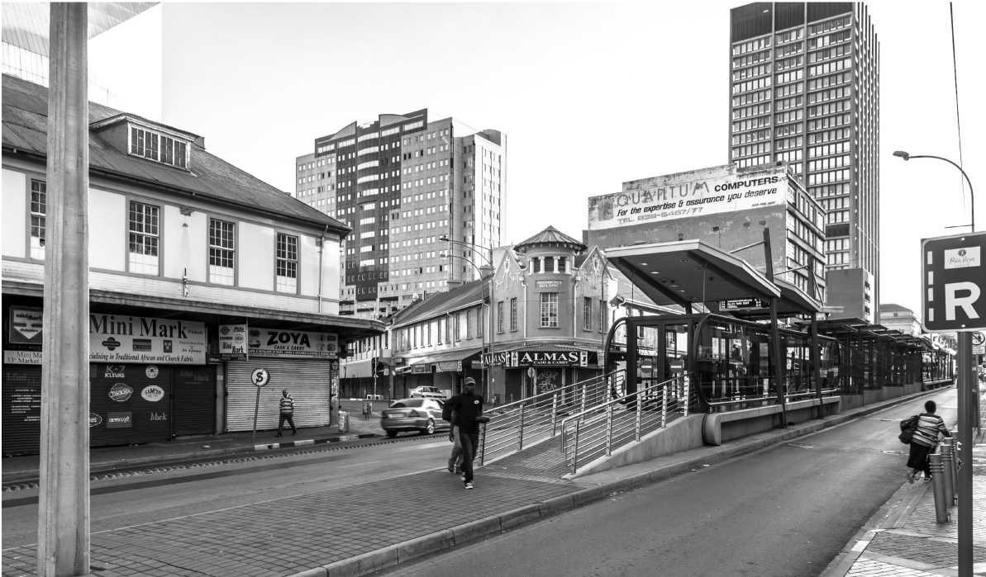Since 1990, the overall estimated number of migrants in Southern Africa — that is, the number of foreign people in the study countries — has increased by about 68 per cent.[1] This increase in mobility has not been uniform across the region: the largest increases in the numbers of migrants and refugees have been in South Africa, Botswana and Angola, whereas they have decreased in the poorer economies of Malawi, Zambia, and Zimbabwe. In fact, South Africa has become the single most important migration destination in the region, hosting 67 per cent. of all migrants in the region in 2017. In mid-2017,

it also hosted 215,860 asylum-seekers, and 92,296 refugees or persons in refugee-like situations (UNHCR, 2018).[2] All of this has taken place against the backdrop of increased pan-African mobility. Across Africa, the migrant stock increased by an esti­mated 57 per cent. between 1990 and mid-2017 (UNDESA, 2017). As evidenced by these numbers, migration has become a central component of people's livelihoods and protection strategies, both in the region, and across the continent.

Southern Africa has a history of highly organized and insti­tutionalized labor migration. This system was developed to supply the labor needs of the large commercial farms and mines of the region (Segatti 2016). With the end of the twen­tieth century, and with the decline of mining and manufac­turing in the region, this system collapsed. Today's migration patterns are individualized, ad hoc and often irregular (Kihato forthcoming, p.6). In addition to international (cross-border) migration and displacement, there is substantial rural-to-urban migration within countries. Further, in an already highly-ur­banized region, these population movements have had espe­cially significant impacts on towns and cities, and have added to existing pressures on urban housing, health and education.

Recently, there have also been important policy and political shifts in the region. Several countries in the region (including South Africa) have made changes to existing laws, or have announced that they are in the process of formulating new migration policies. Changes made to South African refugee laws, in particular, which include new restrictions on asy­lum-seekers, are likely to have significant impacts on mobil­ity in the region. South Africa also continues to experience sustained ‘xenophobic' violence - as recently as April 2018[3], in fact. At times, this violence is widespread and significant. Further compounding issues, South Africa struggles with high levels of unemployment, inequality, and poverty, which influ­ences debates on migration and social cohesion more broadly.

In Zimbabwe, long the country of origin of numerous asy­lum-seekers in neighboring countries, Robert Mugabe was succeeded in late 2017 after 37 years in power by President Emmerson Mnangagwa (International Crisis Group 2017a). The implications of this change for regional mobility and dis­placement are yet to be fully understood.

Finally, this study comes at a time when global migration policy is changing rapidly — with both Europe and North America advancing more restrictive postures. The European Union (EU), in particular, is playing an increasingly active role in the governance of African migration, through ‘regional consultative processes' such as the Rabat and Khartoum Processes (Frouws 2015, p.31-32).

The World Bank,

Migration and Displacement

The World Bank is a relatively recent entrant to the group of multilateral organizations which work on forced displace­ment, although it has long been active in working on issues of labor migration and employment.[4] Its work in mixed migra­tion and forced displacement has been driven by a demand from client countries for financing support, policy advice and research. Consequently, it has an interest in developing strong, empirically grounded analytical research, which can form the basis for evidence-based policy recommendations, focused on developmental impacts and poverty reduction.

A Note on Terminology: Mixed Migration, Forced Displacement and Development

How we understand migration and displacement is a func­tion of the categories that we use to study and analyze these phenomena. In this section, therefore, we briefly explain some of the terms used throughout this study (further detail on terminology can be found in Annex 1). The use and scope of these terms have been the subject of extensive debates in academic and policy literature; our intention in this study is not to engage these broader debates. However, we think it critical to point out how these terms (and the phenomena they describe) have practical implications in the context of Southern African migration.

At its broadest, ‘migration' can be understood as: ‘The movement of a person or a group of persons, either across an international border, or within a State. It is a population movement, encom­passing any kind of movement of people, whatever its length, composition and causes; it includes migration of refugees, dis­placed persons, economic migrants, and persons moving for other purposes, including family reunification.” (IOM 2011, p. 62). It includes both voluntary migration and forced displacement.

‘Forced displacement' or ‘forced migration', on the other hand, can be understood as the ‘involuntary movement, individually or collectively, of persons from their country or community, notably for reasons of armed conflict, civil unrest, or natural or man-made catastrophes' (IOM 2011, p. 39). This term includes ‘refugees', those who are displaced by large devel­opment projects (for instance, dams), environmental catastro­phes (such as floods) or man-made calamities such as famine (United Nations and World Bank 2018). It also includes inter­nally-displaced persons, who are forced to move within their own countries and do not cross international borders. Jeff Crisp, (then the head of UNHCR's Policy Development and Evaluation Service) noted in 2008 - not only does migra­tion often have ‘mixed' motivations, ‘[r]efugees and migrants increasingly move alongside each other, often in an irregular manner, making use of the same routes and means of trans­port and engaging the services of the same human smugglers' making them harder to distinguish from each other (Crisp 2008, p. 4-5).[5] The expression ‘mixed migration' emerged in this context, to recognize the complexity of motivations and movements of contemporary migration and displacement. Mixed migratory flows are used to describe the intermingled movement of refugees and asylum-seekers, as well as those who fall outside established protection categories but who may be in need of interventions, such as vulnerable migrants, and economic migrants (World Bank 2016, p.4).

The reality of mixed migratory flows has had significant prac­tical implications in Southern Africa and particularly in South Africa. Countries in the region, which have generally restric­tive immigration regimes,[6] have tightened asylum procedures and developed restrictive migration policies, arguing that economic and voluntary migrants are “abusing” their asylum systems (Long and Crisp 2011; Betts 2013). In South Africa, which has had one of the most liberal asylum regimes in the African continent (at least on paper), researchers have sug­gested that increases in mixed migration have been accompa­nied by stronger immigration enforcement, restrictive asylum determination practices and allegations of procedural irreg­ularities in detention and deportation of migrants (Fassin, Wilhelm-Solomon, and Segatti 2017; Amit 2012; Amit 2015; Vigneswaran 2011). Significantly, the use of the term ‘mixed migration' is pervasive in South Africa. It is used by govern­mental departments, opposition political parties, civil society actors, and humanitarian organizations, usually referencing its allegedly negative impacts. Mixed flows have therefore become mired in several other policy discussions, most notably, around irregular movements, border controls, applications for refugee Mixed migratory flows are used to describe the intermingled movement of refugees and asylum-seekers, as well as those who fall outside established protection categories but who may be in need of interventions, such as vulnerable migrants, and economic migrants

status, as well as the return and readmission of asylum-seekers whose claims to refugee status were initially rejected.

In countries marked by widespread inequality and poverty, where nationals and migrants and refugees compete for ‘scarce resources, services and opportunities', the role of migration in hindering or advancing national development agendas also remains a major point of debate.[7] The relationship between migration, displacement and development is, of course, a com­plex one, and remains understudied, especially in the context of movement between developing countries. Migration can have economic benefits for countries of origin (sending communi­ties) and destination (hosts), as well as migrants themselves (see World Bank 2016; World Bank 2017b, p.57-73). The extent and nature of these benefits, however, are highly dependent on con- text.[8] Even in the best circumstances, migration and displacement may have significant short-term costs for host communities. These costs may be economic, social and institutional, and often manifest themselves in strains on local service delivery (World Bank 2017b, p. 69). Further, it is usually the poorest in those communities who bear these costs, even when there are aggre­gate benefits at the national level in the medium or long-term (Landau 2017). Where these costs are not addressed, and even if they are only perceived, migrants and refugees can become the fulcrum of political contestation, as is the case in Southern Africa (Misago 2012). This study considers and remains sensitive to these economic and political costs and incentives.

The following section analyses contemporary trends in migra­tion and forced displacement into and within Southern Africa framed within their historical context.



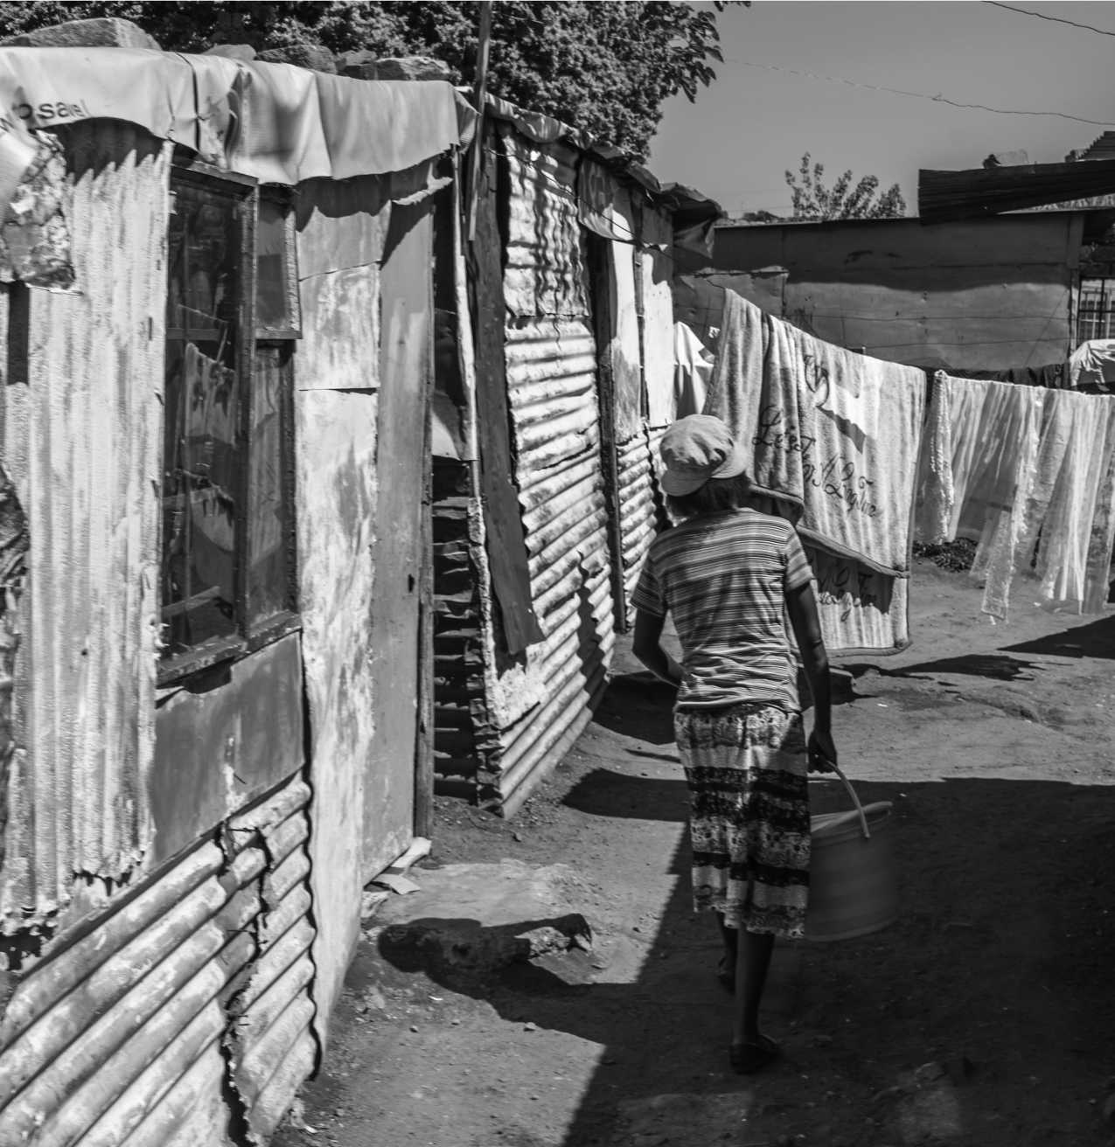

At the regional level, migration continues to be governed by unenforceable conventions and a patchwork of bilateral agreements

and treaties, while in many national contexts, bureaucratic and administrative practices of migration control persist.

Mixed Migration and Forced Displacement into and within Southern Africa

**O**

**FFICIAL NEGOTIATIONS TO** end Apartheid in South Africa began in 1990, and white minority rule formally ended in 1994. The profound economic and political upheaval of this period transformed migration and displace­ment across the region. Alongside the organized and controlled labor migration system, other forms of mobility emerged and expanded: this included asylum-seekers fleeing conflict and persecution, seasonal migrants and cross-border traders and smugglers. Existing patterns of regional mobility were over­laid with new forms of movement as people moved for more

diverse reasons. These changes took place within a broader socio-economic and legal context shaped by the rela­tionship between Southern Africa's system of mine-based capital accumulation, and the migrant workforce on which it relied. The content of laws governing migrants and ref­ugees has changed in many cases since then, and often radically, but their implemen­tation remains uneven. At the regional level, migration continues to be governed by unenforceable conventions

and a patchwork of bilateral agreements and treaties, while in many national contexts, bureaucratic and administrative practices of migration control persist. As a result, the story of migration and displacement in the region today has elements of both continuity and change.

This section analyses contemporary trends in migration and forced displacement in Southern Africa and does so by placing them within their historical context. It has three objectives - to describe the history of migration and displacement into and within Southern Africa, the changes that have taken place in regional mobility and displacement patterns, and finally, the characteristics of contemporary migration and displacement in the sub-continent with a special focus on South Africa.

History of Labor Migration in Southern Africa

The discovery of diamonds in 1867 and gold in 1886 laid the foundations for South Africa's highly centralized mining industry. Over the next century, extractive industries were to become the core of the South African economy (Fine and Rustomjee 1996, p.71).[9] Their growth, combined with the expansion of commercial agriculture, directly led to the development of Southern Africa's highly controlled labor migration system, which remained in place until the 1990's (Marais 2011, p.8-10; Jeeves and Crush 1997).

In its early years, the growth of the mining industry was accompanied by the inflow of foreign, mainly British cap­ital to the sector and by the migration of European skilled and semi-skilled workers to South Africa. However, both the mining sector and commercial agriculture required a steady supply of cheap and unskilled labor to ensure profitability and growth; a purely ‘voluntary' workforce proved insufficient for the needs of these industries (Comaroff and Comaroff 1987, p. 196). Various coercive legal and political measures were there­fore taken to force black South Africans into the labor ‘market'.

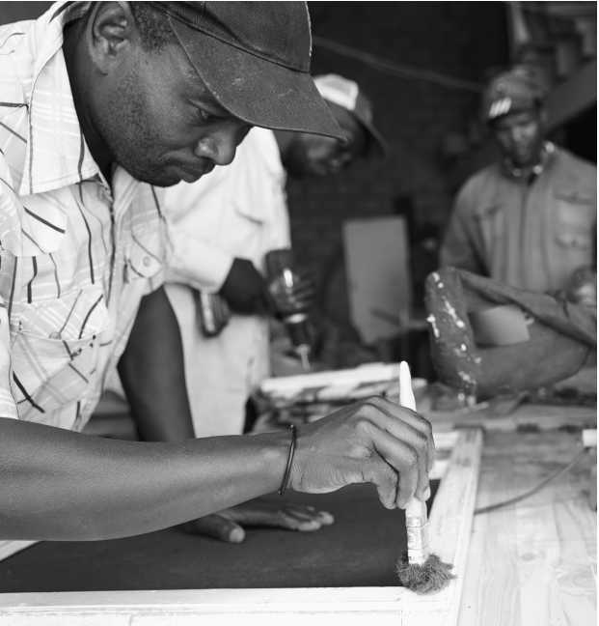Initially, workers from rural Southern Africa were forced into low-wage jobs in the mines and farms to settle hut and poll tax liabilities. Rural agricultural production was also undermined by forcible land grabs, and by the enactment of a series of highly restrictive laws which progressively deprived African peasantry of land and restricted their ability to earn a live­lihood from farming (Ferguson 1994, p.177; Wolpe 1972).[10] [11] A system of pass laws imposed controls on their ability to migrate to the newly urbanizing spaces (such as Johannesburg) to seek employment. Together, these measures left black South Africans little choice but to enter the migrant labor system which served the mines and commercial farms. Conflict between the mines and farms over access to cheap labor were frequent, and played out in competition between recruiters and recruitment agencies, as well as different factions of state bureaucracy (Crush 1993).

In short, the economy of South Africa during this period was based on the exploitation of a low-wage, low-skilled, highly-controlled, expendable work-force. Migrant workers, almost all men, were recruited from rural South Africa but also from Lesotho, Malawi, Mozambique, Zimbabwe, Zambia and Tanzania, and usually had to make long and hazardous journeys to their workplaces, where they lived and worked in dangerous, over-crowded conditions (Jeeves and Crush 1995). They were also expected to supplement their wages from labor by subsistence agriculture, either in the ‘native reserves' or ‘Bantustans' or the foreign countries where they were required to maintain their permanent residences (Wolpe 1972, p.427; Moodie and Ndatshe 1994, p.18).11 The costs of family maintenance, retirement, education, other social ser­vices were not accounted for in the wages paid to these work­ers, which allowed for wages to be maintained at artificially low levels (Arrigi, Aschoff and Scully 2010, p. 412). Similar systems were implemented, albeit with important differences, to serve the coal mines of Southern Rhodesia (Zimbabwe) and the copper mines of Northern Rhodesia (Zambia) as well as agriculture in these areas (Burawoy 1976, p.1079). South Africa's institutionalized labor migration regime dwarfed all other cross border movements in the region, however, and effectively turned parts of Southern Africa into labor reserves for the South African economy.

Changes in South Africa's political economy led to a major re-structuring of the migrant labor system. Concerted anti-Apartheid resistance grew, and was accompanied by increasing unemployment, as the economy shifted to more

capital-intensive forms of growth. Unskilled migrant labor became increasingly superfluous to industry and the need for skilled and semi-skilled labor increased. Further, increasing mechanization of agriculture on commercial farms and eco­logical degradation in the homelands led to growing migration to cities, despite the Apartheid state's efforts at influx control (Marais 2011, p.32). In these cities, work remained scarce, wages were low, and the state continually harassed residents.

Widespread and well organized anti-Apartheid movements, global and domestic financial crises (exacerbated by South Africa's involvement in regional conflicts in Namibia and Angola), and international sanctions finally led to talks which dismantled the apartheid regime. Elections took place in 1994, and South Africa's new constitution was adopted in 1996.

Trends of Migration and Displacement in Southern Africa

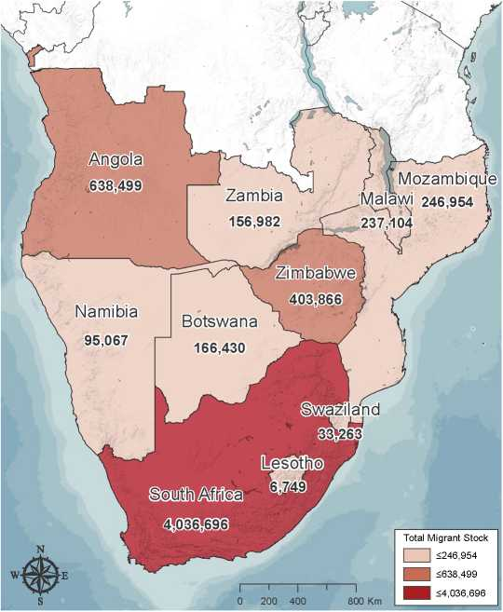Table 1 plots changes in the estimated migrant and refugee numbers in the study countries between 1990 — 2017, using data from UNDESA.[12] Annexure 3 replicates this chart for each of the study countries.

| **CATEGORY** | **1990** | **1995** | **2000** | **2005** | **2010** | **2015** | **2017** |
| --- | --- | --- | --- | --- | --- | --- | --- |
| Total estimated migrant stock (including refugees and asylum seekers)**a** | 3,581,782 | 2,316,839 | 2,427,952 | 2,572,688 | 3,413,504 | 5,775,998 | 6,021,610 |
| Total estimated male migrant stock | 1,966,456 | 1,313,698 | 1,357,349 | 1,428,265 | 1,905,600 | 3,120,649 | 3,258,213 |
| Total estimated female migrant stock | 1,615,326 | 1,003,141 | 1,070,603 | 1,144,423 | 1,507,904 | 2,655,349 | 2,763,397 |
| Refugees and asylum seekers (both sexes)**b** | 1,343,324 | 248,213 | 296,044 | 219,105 | 146,162 | 1,377,937 | 454,646 |
| Total population (in thousands)**c** | 95,886 | 108,429 | 120,924 | 134,272 | 149,710 | 168,741 | 176,842 |
| International migrants as a proportion of total population (in per cent.) | 3.74 | 2.14 | 2.01 | 1.92 | 2.28 | 3.42 | 3.41 |
| Refugees and asylum seekers as a proportion of International migrants (in per cent.) | 37.50 | 10.71 | 12.19 | 8.52 | 4.28 | 23.86 | 7.55 |
| Refugees and asylum seekers as a proportion | 1.40 | 0.23 | 0.24 | 0.16 | 0.10 | 0.82 | 0.26 |

**TABLE 1:** Estimated migrant population in Southern Africa, 1990-2015

**FIGURE 5:** Total migrant stock (both sexes) including refugees and asylum seekers, in Southern Africa, mid-2017

World Bank Geospatial Operations Support Team: GOST (2018) Base Map Source; Esri, USGS, NOAA

Data Source: United Nations, Department of Economic and Social Affairs. Population Division (2017). Trends in International Migrant Stock: The 2017 revision (United Nations database, POP/DB/MIG/Stock/Rev.2017).

of total population (in per cent.)

Source: UNDESA 2017

a UNDESA calculates the migrant stock by extrapolating from national census data up to mid-2017. The data on the number of refugees and asylum seekers is drawn from end-2016 figures as reported by UNHCR. See UNDESA 2017.

b The major spike (and subsequent decline) between 2010-2017 is largely attributable to a huge number of asylum applications made in South Africa. UNHCR explains the changes in estimated numbers of refugees and asylum seekers in South Africa between 2015 and 2016 as follows: “An adjustment to 2015 and 2016 end of year figures, in particular for the number of asylum applications pending on appeal and review, has resulted in a substantially lower figure for numbers of asylum seekers reported in South Africa.” (UNHCR Popstats). In mid-2017, UNHCR reported that the total number of refugees and asylum seekers in the region was 489,266.

c This has been rounded up or down to the nearest thousand.

**TABLE 2:** Migrant, refugee and asylum-seeker statistics in South Africa (1990-2017)

|  |  |  |  |  |  |  |  |
| --- | --- | --- | --- | --- | --- | --- | --- |
| **CATEGORY** | **1990** | **1995** | **2000** | **2005** | **2010** | **2015** | **2017** |
| Total estimated migrant stock (including refugees and asylum seekers)**d** | 1,163,883 | 1,003,807 | 1,001,825 | 1,210,936 | 2,096,886 | 3,816,696 | 4,036,696 |
| Total estimated male migrant stock | 717,227 | 611,083 | 600,032 | 712,219 | 1,216,129 | 2,122,100 | 2,244,421 |
| Total estimated female migrant stock | 446,656 | 392,724 | 401,793 | 498,717 | 880,757 | 1,694,596 | 1,792,275 |
| Refugees and asylum seekers (both sexes)**e** | 90,000 | 101,408 | 15,063 | 29,714 | 57,899 | 1,217,709 | 309,342 |
| Total population (in thousands)**f** | 37,561 | 42,088 | 45,728 | 48,821 | 51,585 | 55,291 | 56,717 |
| International migrants as a proportion of total population (in per cent.) | 3.10 | 2.39 | 2.19 | 2.48 | 4.06 | 6.90 | 7.12 |
| Refugees and asylum seekers as a proportion of International migrants (in per cent.) | 7.73 | 10.10 | 1.50 | 2.45 | 2.76 | 31.90 | 7.66 |
| Refugees and asylum seekers as a proportion | 0.24 | 0.24 | 0.03 | 0.06 | 0.11 | 2.20 | 0.55 |

of total population (in per cent.)

Source: UNDESA 2017

d UNDESA calculates the migrant population by extrapolating from national census data up to mid-2017. The data on the number of refugees and asylum seekers is drawn from end-2016 figures as reported by UNHCR. See UNDESA 2017.

e In mid-2017, UNHCR reported that the total number of refugees and asylum seekers in South Africa was 308,156 (see “Mid-Year Trends 2017”, UNHCR Popstats). UNHCR explains the changes in estimated numbers of refugees and asylum seekers in South Africa between 2015 and 2017 as follows: “An adjustment to 2015 and 2016 end of year figures, in particular for the number of asylum applications pending on appeal and review, has resulted in a substantially lower figure for numbers of asylum seekers reported in South Africa.”

f This has been rounded up or down to the nearest thousand.

The total numbers of migrants and refugees (including asylum seekers) in Southern Africa has increased by about 68 per cent since 1990. This increase in mobility has not been uni­form over time, nor across the region: the largest increases have occurred in South Africa, Botswana, Mozambique and Angola, whereas the numbers have decreased in the poorer economies of Malawi, Zambia, and Zimbabwe. South Africa is the single largest country of destination. As of mid-2017, UNDESA estimated that it was host to about 67 per cent. of the migrants and refugees in the region. Table 2 plots the number of refugees and asylum seekers in Southern Africa over time, as well as the total number of migrants, including refugees and asylum seekers (disaggregated by gender). It also plots the numbers of migrants and refugees in South Africa to show how, in recent years, migration and displacement num­bers in the region have overwhelmingly been driven by move­ment to South Africa. To a smaller extent, the more recent increases are also a result of Angola's 2014 General Population and Housing Census, which was its first for 40 years (UNFPA 2016) and which reported far higher numbers of international migrants than had been expected.

DECLINE OF MINE-BASED MIGRATION

It is worth noting that contract migration to the mines of Southern Africa has decreased sharply in recent years. The Employment Bureau of Africa (TEBA), which has histori­cally been the labor recruitment agency for the mining sector, reported that the number of mineworkers fell from 477,000 to 215,000 between 1980-2010, and the proportion of for­eign mineworkers fell from about 60 per cent. in 2003 to 23 per cent. in 2013. This has affected the flow of remittances to the historic areas of origin for mineworkers and also resulted in the participation of former mineworkers in dangerous but lucrative illicit mining in abandoned mines (see Crush, Dodson, Williams, and Tevera 2017, p. 10).

DEMOGRAPHIC PROFILE OF MIGRANTS

IN SOUTHERN AFRICA

Since 1990, the proportion of migrants[13] aged 15-49 in Southern Africa has increased sharply (see Figure 6). Across the region, UNDESA data also suggests that the gendered make-up of migrants has remained relatively constant,although some scholars have argued that there has been a change in the types of migration, that is, independent women's migration has increased (Crush, Dodson, Williams and Tevera 2017).[14] In 1990, around 45% of the total migrant population is estimated to have been made up of female migrants. This increased mar­ginally, to 45.89 per cent., in 2017.

**BOX 1:** Legal Changes in South Africa

The increase in migrants and refugees moving to South Africa was influenced to a significant extent by legal and policy changes enacted after the end of Apartheid. Existing, and highly restrictive immigra­tion policies, including the evocatively named 1991 Aliens Control Act, continued to act as the cornerstone of South African immigra­tion policy through the 1990's. These were ultimately replaced by the Immigration Act of 2002, which was adopted in 2004 after a great deal of internal debate.

Segatti (2011) suggests that the process of legal reform was fraught with political contestation. On one hand, activist networks argued for more open and liberal immigration regimes, pointing to ‘a moral debt owed by South Africa to the rest of the continent'. The immi­gration regime that finally emerged, she notes, ensured minimal conformity with the rights guaranteed in the constitution of 1996, pursued a dual system of limited permanent high-skilled migration alongside temporary lower-skilled migration (with limited avenues for legal migration) and retained power within central government, and concentrated it within the Department of Home Affairs, reiter­ating ‘control and sovereignty as core values guiding immigration policy in South Africa' (p.45).

Immediate progress was made, however, in reforming, or more accurately, formulating refugee legislation. South Africa published a Green Paper on International Migration in 1997, and the extremely progressive Refugee Act was adopted in 1998 (however it came into force in 2000). This allowed asylum-seekers to work and study while their applications were pending. In recent years, however, this legislation has been amended to become more restrictive. Further, as is discussed later in this study, lack of bureaucratic capacity has meant that many of the rights nominally guaranteed by the legisla­tion remain unavailable to asylum-seekers and refugees in practice (Segatti 2011a; Kihato (forthcoming); Crush, Dodson, Williams and Tevera 2017).

The experience of migration is, of course, highly gendered. This manifests itself not only in terms of the vulnerabilities experienced by those who migrate, but also their reasons for moving, the different infrastructure that male and female migrants and refugees draw upon while moving (for instance, how they access money to pay for travel), the remittances they send, and their experience of being migrants, refugees or asy­lum-seekers in foreign countries. While a few studies have spe­cifically focused on the experience of women in South Africa, this remains a major research gap in the region more generally.

**REFUGEES AND ASYLUM-SEEKERS**

IN SOUTHERN AFRICA

In mid-2017, UNHCR estimated the total number of refu­gees and asylum-seekers in the region at 489,266. The major countries of origin for refugees and asylum-seekers in the region are listed below. In addition to the major movements from the HoA, the Great Lakes Region and Zimbabwe, asy­lum-seekers also originate in Western Africa, and the sub-conti­nent also hosts a small but significant number of asylum-seekers from South Asian countries. Needless to say, these numbers are only part of the story. They do not include a large number of asylum-seekers who may have abandoned their applications, nor do they account for circular migrants, or those who choose to stay undocumented, either because they wish to remain invisible to the authorities, or due to fear of xenophobic violence, etc.

In the region, South Africa is the single most important coun­try of destination for asylum-seekers and refugees, followed by Angola, Zambia and Malawi.

The sub-sections which follow outline trends in displacement from the major regions of origin - the Great Lakes and the Horn of Africa, and then go on to discuss the crisis in Zimbabwe.

**FIGURE 6:** Comparison of population age structures of migrants (including refugees and asylum seekers) in Southern Africa, 1990 and 2017

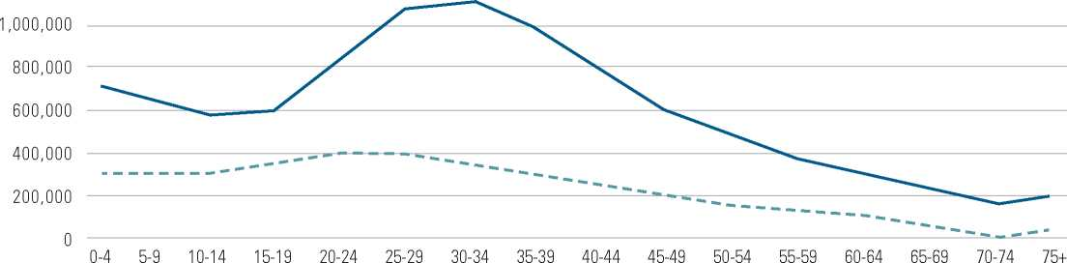

1990 2017

1,200,000

Age

Source: UNDESA 2017

**TABLE 3:** Major countries/territories of origin of asylum seekers and refugees in Southern Africa (end-2016)

|  |  |  |  |
| --- | --- | --- | --- |
| **MAJOR COUNTRIES OF**  **ORIGIN OF ASYLUM SEEKERS** | **NUMBER IN END-2016** | **MAJOR COUNTRIES OF ORIGIN OF REFUGEES** | **NUMBER IN END-2016** |
| Various/Unknown | 142,380 | DRC | 76,273 |
| Zimbabwe | 41,357 | Somalia | 32,163 |
| DRC | 25,029 | Ethiopia | 17,919 |
| Burundi | 10,829 | Burundi | 10,313 |
| Guinea | 9,150 | Rwanda | 7,180 |
| Somalia | 6,851 | Congo | 5,420 |
| Cote d'Ivoire | 5,975 | Zimbabwe | 5,351 |
| Mozambique | 5,608 | Eritrea | 2,063 |
| Mauritania | 5,403 | Namibia | 924 |
| Rwanda | 4,736 | Uganda | 703 |

Source: UNHCR Popstats

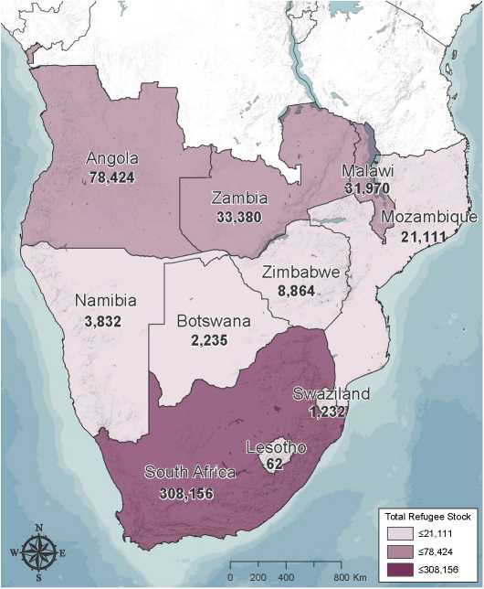

**FIGURE 7:** Refugees and asylum seekers in Southern Africa, mid-2017

World Bank Geospatial Operations Support Team: GOST (2018) Base Map Source; Esri, USGS, NOAA

Data Source: UNHCR Population Statistics Database - "Mid-Year Trends *2017'*

Displacement from the Great Lakes

and the Horn of Africa

Between the 1960's and the 1990's, a series ofanti-colonial inde­pendence wars and struggles against white-minority regimes took place in the region. These led to waves of forced displace­ment, most notably from Angola, Mozambique, and Zimbabwe. In recent years, however, trends in mobility have changed, and have come to be dominated by migration and displacement from the Great Lakes regions, the HoA and Zimbabwe.

MIGRATION AND DISPLACEMENT

FROM THE GREAT LAKES

The countries of the Great Lakes region include Burundi, Rwanda, the DRC, Tanzania, Uganda and Zambia. Among these, conflict in Burundi, DRC, and to a lesser extent, Rwanda, have led to large numbers of people fleeing across international borders for protection (World Bank and UNHCR 2015a). In 2013, in fact, 98 per cent. of all regis­tered refugees in the region came from those three countries (p.19). Waves of displacement began as early as the 1950’s, and continue till the present day.

Protracted crisis in the DRC began as early as 1992, and cyclical patterns of violence have continued since, involving neighbouring countries in several instances. Persistent insecu­rity, economic deprivation and to some extent even famine15 have meant that DRC now hosts one of the largest IDP populations in the world, while large numbers of Congolese

refugees and asylum-seekers have sought protection in neigh­bouring countries. Among the countries in Southern Africa, Angola and Zambia, and of course, South Africa are primary countries of destination. Researchers have alleged that states in the region have sometimes engaged in *ad-hoc* deportations of migrants, refugees and asylum seekers from their territo­ries: between 2003-2009, for instance Angola is said to have deported between 300,000 - 400,000 Congolese from its Lunda Norte region (Betts 2013, p. 90).

Elections have been postponed in the DRC since the end of 2016, and may finally be held in December 2018, with major changes in electoral laws and voting technology (International Crisis Group 2018). If political contestation around the elec­tions turns violent, this may have implications for displace­ment within and from the country.

Burundi too, has been both a country of origin and refuge. In the 1970's civil war broke out (along ethnic lines), and resulted in the mass displacement of Burundians to Tanzania (Malkki 1995b). Periodic conflict, since then, has meant that neighb ouring countries host large numbers of Burundian refugees and asylum seekers (World Bank and UNHCR 2015a). In 2015, President Nkurunziza's decision to run for a third term and subsequent re-election transformed existing unrest into a low-intensity conflict. The economy and public finances deteriorated, as did the everyday living conditions for Burundians. Over 400,000 Burundians have since fled the country (International Crisis Group 2017b).[15]

While the largest movement of Rwandans took place during the genocide in 1994, and many have since returned to Rwanda from neighboring countries (and indeed, elsewhere), some Rwandan asylum-seekers and refugees remain in the camps and towns of Southern Africa.

**THE ‘SOUTHERN ROUTE' FROM THE HORN OF AFRICA** Protracted political instability and persistent conflict has led to large volumes of displacement within and from the Horn of Africa. Much of the displacement is confined to neighbour­ing countries, but some mixed migration continues to take place along the ‘southern route' to South Africa (Frouws and Horwood 2017).

The Regional Mixed Migration Secretariat (RMMS) for the HoA notes that the vast majority of those moving along this route are Ethiopians and Somalis. In 2009, an IOM report estimated that between 17,000-20,000 ‘mixed' migrants from these countries were traveling along the Great Lakes and through the Southern African countries to get to South Africa each year (Horwood 2009). A 2017 study by RMMS (Frouws and Horwood 2017) updated this estimate to suggest that no more than 13,000-14,050 are doing so now, although higher numbers may be leaving the Horn using the southern route. RMMS attributes the fall in numbers to the attractiveness of other destinations (such as Europe), low rates of recognition of asylum applications in South Africa, and finally, intolerance towards foreigners and xenophobic violence in South Africa. Most of those moving along the southern route intend for South Africa to be their final destination, even though some may travel onwards to Europe, North America or Australia. Continued political instability and droughts in Somalia, famine and conflict in South Sudan, and political reform in Ethiopia, combined with a lack of economic opportunities may con­tinue to drive mixed migratory flows along the Southern Route, though the impact of South Africa's restrictive new legislation on such movement remains to be seen. Between June-December 2017, for instance, IOM interviewed 174,654 migrants leaving the Horn of Africa. Of those, only .004% (or 7 people) reported South Africa as their intended destina­tion (IOM 2018). This may have been a result of where these migrants were interviewed (Yemen, Somalia and Djibouti, none of which are on the Southern route) or a reflection of lower interest in moving to South Africa.

The Crisis in Zimbabwe

Zimbabwe's liberation war ended in 1980, and resulted in mass emigration of white Zimbabweans to South Africa and elsewhere. A large number of Zimbabweans also fled to South Africa and Botswana as the new government sought to con­solidate its power in Matebeleland through force (Mlambo 2010). In the late 1990's a series of policy decisions taken by then President Mugabe, including the payment of pensions to 50,000 war veterans, confiscation of 15,000 white-owned farms with limited compensation (termed as ‘fast-track land reform'), and involvement in conflict in the DRC resulted in economic collapse and massive outward migration (Fassin, Wilhelm-Solomon, and Segatti 2017, p.162).[16]

‘Fast-track' land reform caused a few thousand white owners and their families to move off the farms but more signifi­cantly, also led to a much larger movement of agricultural workers whose livelihoods were disrupted or destroyed (Potts 2010, p. 80). In 2005, the government embarked on a massive campaign against informal housing and employment in the towns, calling it Operation Murambatsvina (Restore Order/ Clear Out the Trash). By some estimates between 650,000­700,000 people lost their livelihoods, or homes, or both (Potts 2010, p.100). This led to massive internal movement within the cities themselves, as dislocated people sought replace­ment accommodation, and produced significant short-term out-migration from the towns by people who could find no other urban livelihood or accommodation.

After the contested elections of 2005, and 2008, violence broke out between supporters of Zimbabwe African National Union Patriotic Front (ZANU-PF, the governing party) and the primary opposition party, the late Morgan Tsvangirai's Movement for Democratic Change.[17] This took place against the backdrop of wide-spread economic deprivation. Between 1998 and 2004, the economy lost 400,000 jobs and agricul­tural production declined sharply. Food insecurity, political violence and persecution of the opposition were exacerbated by hyperinflation, an international sanctions regime, and a cholera outbreak. In this context, perhaps up to one quarter of the population left the country, with most moving to the neighboring countries of South Africa and Botswana (Betts 2013, p. 54). While no accurate statistics are available, Betts (2013), has suggested that between 1-1.5 million Zimbabwean migrants crossed into South Africa between 2000-2012 (see also Crisp and Kiragu 2010; Polzer 2008). The particular cir­cumstances of their migration/displacement mean that they fall into a ‘protection gap' — for the most part, not accorded formal refugee status or the attendant rights which accom­pany formal legal status, despite fleeing a humanitarian crisis, and subject to police action, detention and deportation. Polzer (2008) and Betts and Kaytaz (2009), have argued that the South African government's *ad hoc* response to complex, mixed flows of Zimbabweans to South Africa were ineffective both in protecting South African national interests, as well as for meeting the needs of some extremely vulnerable migrants.

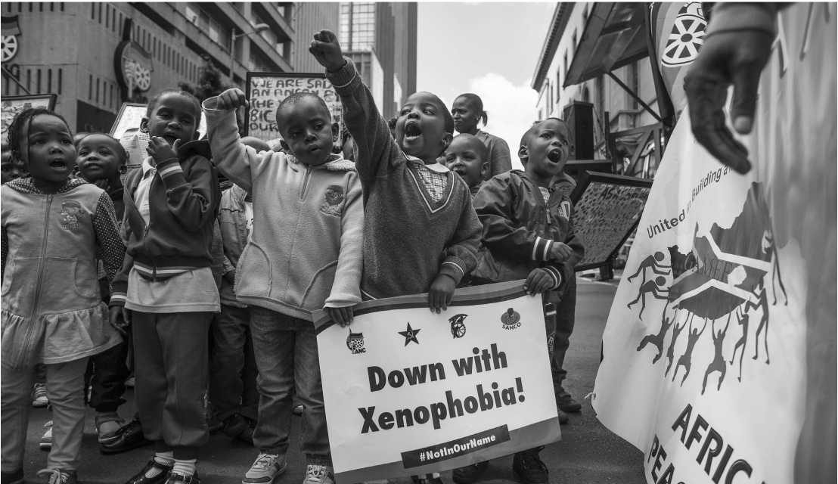In late-2017, former president Robert Mugabe was succeeded by President Emmerson Mnangagwa after 37 years in power (International Crisis Group 2017a). While this may have impli­cations for mobility in the region (with some pointing to the possibility of return of Zimbabwean diaspora), most subject matter experts interviewed for the study believed that the fun­damental drivers of Zimbabwean outward migration have not changed, and that practically, little has likely changed for the average Zimbabwean migrant. Further, they substantiated this by noting the prevalence of trans-local livelihood strategies in the region, which change very slowly. From a South African policy perspective, it may result in the termination of tem­porary policy dispensations which have allowed a segment of Zimbabweans to live and work in South Africa legally. In prac­tice, it may result in even higher rejection rates of Zimbabweanasylum requests. But ultimately, the recent political changes may not affect mobility patterns in any significant way.

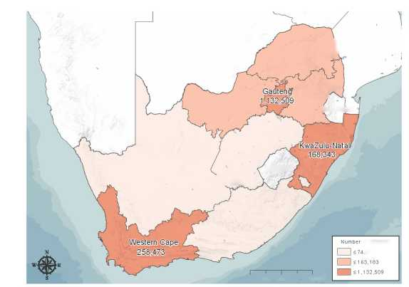The next sub-section analyzes contemporary characteristics of migration and displacement in South Africa.

Migration in South Africa

Capturing data on international migration is extremely diffi­cult, especially for developing countries (and arguably also for developed ones). Despite StatsSA's sophistication, it continues to grapple with some of these challenges. South Africa con­ducted censuses in 1996, 2001, and 2011, and these remain the most comprehensive source of data on international migra­tion in South Africa. StatsSA also conducts a number of other surveys such as the Community Survey (last conducted in 2007 and 2016). These do not, unfortunately provide suffi­cient basis for measuring and analyzing migration because of much smaller sample sizes, and sample design issues. Neither the surveys conducted by StatsSA, nor the Census actually asks respondents about their legal status. As a result, the infor­mation is not disaggregated by respondents' status as migrant, refugee or asylum-seeker. In addition, administrative data is collected by the DHA on both the volume and characteris­tics of documented migrants and asylum-seekers. This section draws on a combination of these data, but relies primarily on data from the 2011 census (See StatsSA 2015).[18] Figure 8 plots the distribution of external migrants in South Africa.

1. Unless acknowledged otherwise, data in this section is extracted from the 2011 Census.

**FIGURE 8:** External migrants in South Africa (as per the 2011 census data)

Botswana

North West

151,816

Lesotho

SOCIO-ECONOMIC PROFILE OF MIGRANTS

The 2011 Census placed the number of international migrants in South Africa at 2,173,409, or about 4.2 per cent, of the country's total population at that time.[19] The major­ity of migrants (around 75.3 per cent.) originated in other African countries, with significant populations from Europe (8.2 per cent.) and Asia (4.7 per cent.). The vast majority of all migrants in South Africa, 68 per cent., originated in other SADC Countries, and a large proportion of all migrants (11 per cent.) chose not to disclose their country of origin. In 2011, 672,308 migrants were from Zimbabwe, and accounted for 30.9 per cent. of the total migrant population, and 45.5 per cent. of all migrants from SADC. 393,231 migrants reported being from Mozambique, and accounted for18.09 per cent. of the total migrant population, and comprised 26.6 per cent. of migrants from SADC countries. A breakdown of international migrants by origin, as reported in the 1996, 2001, and 2011 Censuses is provided in Chapter 4.

Unsurprisingly, not all provinces in South Africa attract migrants to the same extent. At the time of the 2011 Census, Gauteng and the Western Cape had the greatest proportion of their populations born outside the province. Gauteng, in par­ticular, as the primary economic and financial hub in South Africa, hosted an overwhelming majority of international migrants with 52 per cent. of the total, followed by Western Cape with 12 per cent. and KwaZulu Natal (8 per cent.). Free State, Eastern Cape and the primarily Afrikaans speaking Northern Cape had the lowest percentages of international migrants. It is worth noting that migration and displacement in South Africa has important urban dimensions, since South Africa is among the more highly urbanized countries in Africa, and within it migrants and refugees overwhelmingly move to the urban and per-urban spaces in Gauteng, because of its economic dynamism (UNDESA 2015).

According to the same 2011 Census, 39.8 per cent., of inter­national migrants in South Africa were women. Interestingly, however, among migrants from SADC, more women than men aged 15-24 had migrated to South Africa (reversing his­torical trends). Around 23 per cent. of migrants fell below the national poverty income level, and in general, over half of all international migrants in 2011 were poor. Around 27 per cent. of all households were headed by women, but almost one- third of these female-headed households fell in the national

World Bank Geospatial Operations Support Team: GOST (2018)

Eastern Cape

74,888

0 100 200

400 Km

:f Migrants

Data Source: Community Survey 2016, Statistical release P0301 / Statistics South Africa. Base Map Source: Esri, USGS, NOAA

20 The 2016 Community Survey found, surprisingly, that the number of migrants in South Africa appeared to have decreased to 1.6 million. Given methodological concerns, StatsSA believe this significantly underreports the number of migrants in South Africa, and should not be relied upon in the absence of additional material (StatsSA 2016).

poverty category. Around 63 per cent. (or three out of five) international migrants reported being employed. The major­ity were employed in the formal sector, while 17.2 per cent. reported earning their livelihood in the informal sector. 17 per cent. were employed in private households.

These statistics were buttressed by data collected from a migration module included as part of the Quarterly Labour Force Survey (QLFS) in the third quarter of 2012. The results from the QLFS pointed to several important trends.21 First, that people born out­side the country were more likely than locally-born workers to be employed in construction and trade, and also more likely to be working in agriculture or private households (where they would be working as domestic workers, gardeners and child-care workers (Budlender 2014, p.27). While trade is the most common occu­pation for those who are self-employed, agriculture and domestic work are known to be generally low-paying occupations, with poor working conditions (Kiwanuka, Jinnah and Hartman- Pickerill 2014). Second, and affirming the findings from the 2011 Census, foreign born workers were also much more likely than South Africans to be working in the informal sector. As a con­sequence, they have poor access to social protection mechanisms such as pension or retirement funds, medical insurance or coverage and paid annual leave. It is also worth noting that the QLFS found that the unemployment rates of migrants were lower than the rate for South African workers, although the difference between migrant and South African women was marginal. Table 8 provides a detailed breakdown of industry by proportion of migrants (and refugees/asylum seekers) employed.

1. Results drawn from the QLFS Migration Module draw heavily on Budlender's (2014) analysis.

**TABLE 4:** Industry of employment for migrants (QLFS 2014)

|  |  |
| --- | --- |
|  | |
| **INDUSTRY** | **NUMBER OF MIGRANTS EMPLOYED (AS PER CENT.)** |
| Agriculture | 6 |
| Mining | 3 |
| Manufacture | 10 |
| Utilities | 0 |
| Construction | 12 |
| Trade | 30 |
| Transport | 4 |
| Financial | 10 |
| Services | 12 |
| Private Households | 11 |
| Other | 0 |

GENDER AND MIGRATION

A note on gender and migration in South Africa is appropri­ate here. Historically, female migration in Southern Africa (and South Africa) was driven by the opportunities for informal sector trading and by the need to procure goods and services (Dodson 1998). Migration policies too, were largely focused on male migration — and as a result, did not adequately address the changing gender trends in migration (Dodson 2001). As Kihato has argued (2007, p. 100), female migrants move to, and stay in South Africa (and in particular, Johannesburg) after having faced significant legal and material obstacles. Many struggle to earn a decent wage. As a result, explanations for female migration need

**BOX 2:** Basotho Female Migrants

For most of the 20th Century, single and young Basotho men went to work in the gold mines of South Africa and were instrumental in providing household income to those who remained in Lesotho. However, since the 1990s - following the collapse of Apartheid and the concomitant decline in opportunities for male migrants in South African mines - patterns and demographics of migration changed; including increased female migration to South Africa and growing internal female migration within Lesotho.

Today, Basotho women migrate to South Africa for several reasons including - poverty and unemployment, marital status, support for their children's education and support for HIV/AIDS-related orphans. The changing nature of patriarchy in the country and its effects on marital status is also key to female migrations trends. Crush et al. (2010) note that female migration and female household headship are closely linked. In a survey they conducted, they found that the absence of a male household head, either due to separation, divorce or widowhood, appears to compel some female out-migration and within Lesotho. The vast majority of Basotho female migrants in South Africa are employed as domestic workers, while others are involved in the informal sector, the commercial farm industry, self-employment, professional and skilled work.

Lesotho has the highest ratio of migrants living in South Africa compared to the rest of the world, and among SADC countries, Lesotho has the highest dependence on remittances. In 2015, remit­tance inflows made up 16.05 percent of GDP and nearly 97 percent of remittance inflows to Lesotho originated in South Africa. Basotho female migrants are instrumental in remitting funds to Lesotho. However, because a significant number of the migrants are seasonal and working under precarious conditions for low wages, they often don't have access to banking services and mostly rely on informal channels for remitting income and goods to Lesotho.

(Crush et al., 2010; World Bank 2017a; Nalane et al., 2012; Botea et al., 2018)

to go beyond purely economic rationales - though those are important — and also take into account the changing structures of patriarchy in the region, as well as the struggles of women to assert their own agency within these broader structures. Through their mobility, Kihato argues, ‘women are reposition­ing themselves, both in the family and in their communities, in ways that challenge traditional notions of their subordinate socio-economic status' (Kihato 2007, p. 100). It is also worth noting that the relationship between gender and migration in Southern Africa remains a major research gap (although there are exceptions).[20] In recent years, research on gender in migra­tion has disproportionately focused on women's vulnerability to trafficking, or their exposure to gender-based violence (and to a small extent remittances). More can and needs to be done on this, especially focusing on the way migrant women in Southern Africa access services, and the livelihood choices that they make.

REFUGEES AND ASYLUM-SEEKERS IN SOUTH AFRICA

It is difficult to compare the socio-economic conditions of migrants and refugees in South Africa. This is because census data does not distinguish between people born outside South Africa based on their migration status. However, the UNHCR recently conducted a livelihoods survey among 1,000 refugee and asylum-seeker households. Among those surveyed, 53 per cent. were asylum-seekers, whereas 43 per cent. had received refugee status. The majority of those surveyed were from the DRC, Burundi and Somalia, and the largest number had only completed secondary schooling.

When asked what would be of most help to them, in order to become self-reliant, a large number of respondents mentioned access to capital to be able to start businesses, assistance with rent-payment, and school fees. Significant numbers also pointed to the difficulties that they faced in integrating into South African society, as well as obstacles in obtaining relevant documentation.

A separate survey covering migrants and hosts in Johannesburg and Maputo (among others), found that legal status as a refu­gee or asylum seeker was not a key determinant of protection outcomes. In the case of police harassment, informal employ­ment and violence, foreigners were more vulnerable, irrespec­tive of their immigration status. The survey also found little empirical difference in the socio-economic circumstances of those who had been displaced by violence, compared to those who reported having left their country of origin for economic reasons.

Interestingly, the findings suggested that those migrating to cities from urban spaces from rural areas were among the most vulnerable, regardless of whether they had crossed an interna­tional border. Social networks were the most significant factor in explaining the ‘success' of some migrants and refugees in accessing food, shelter, and jobs. Needless to say, these out­comes were also highly gendered: men were more likely to face physical attack, robbery and arrest, whereas women faced greater challenges in accessing work, housing or other services.

As most migrants and refugees in South Africa choose to reside in urban areas, the hardships they face alongside local residents include high rates of unemployment, poor service delivery, poverty, overcrowding, high crime rates, and drug and alcohol abuse.

One of the most important challenges for migrants, refugees, and asylum-seekers relates to documentation, as illustrated in the UNHCR data. Even when refugees and asylum-seekers do possess the requisite permits and documents, few service providers accept these as valid forms of identity. This point was reiterated in almost all interviews that we conducted in South Africa. As a result, asylum-seekers are unable to open bank accounts, go to state hospitals, rent housing and have limited access to education too. In many instances, and as per­haps demonstrated by the abandonment of 92 per cent. of all asylum applications, many have become ‘irregular' after several years in South Africa.

South Africa's strong national legal framework for protection of asylum seekers has been unevenly implemented. In real­ity, migration is governed through a combination of law and informal political structures.

The survey also found little empirical difference in the socio-economic circumstances of those who had been displaced by violence, compared to those who reported having left their country of origin for economic reasons.

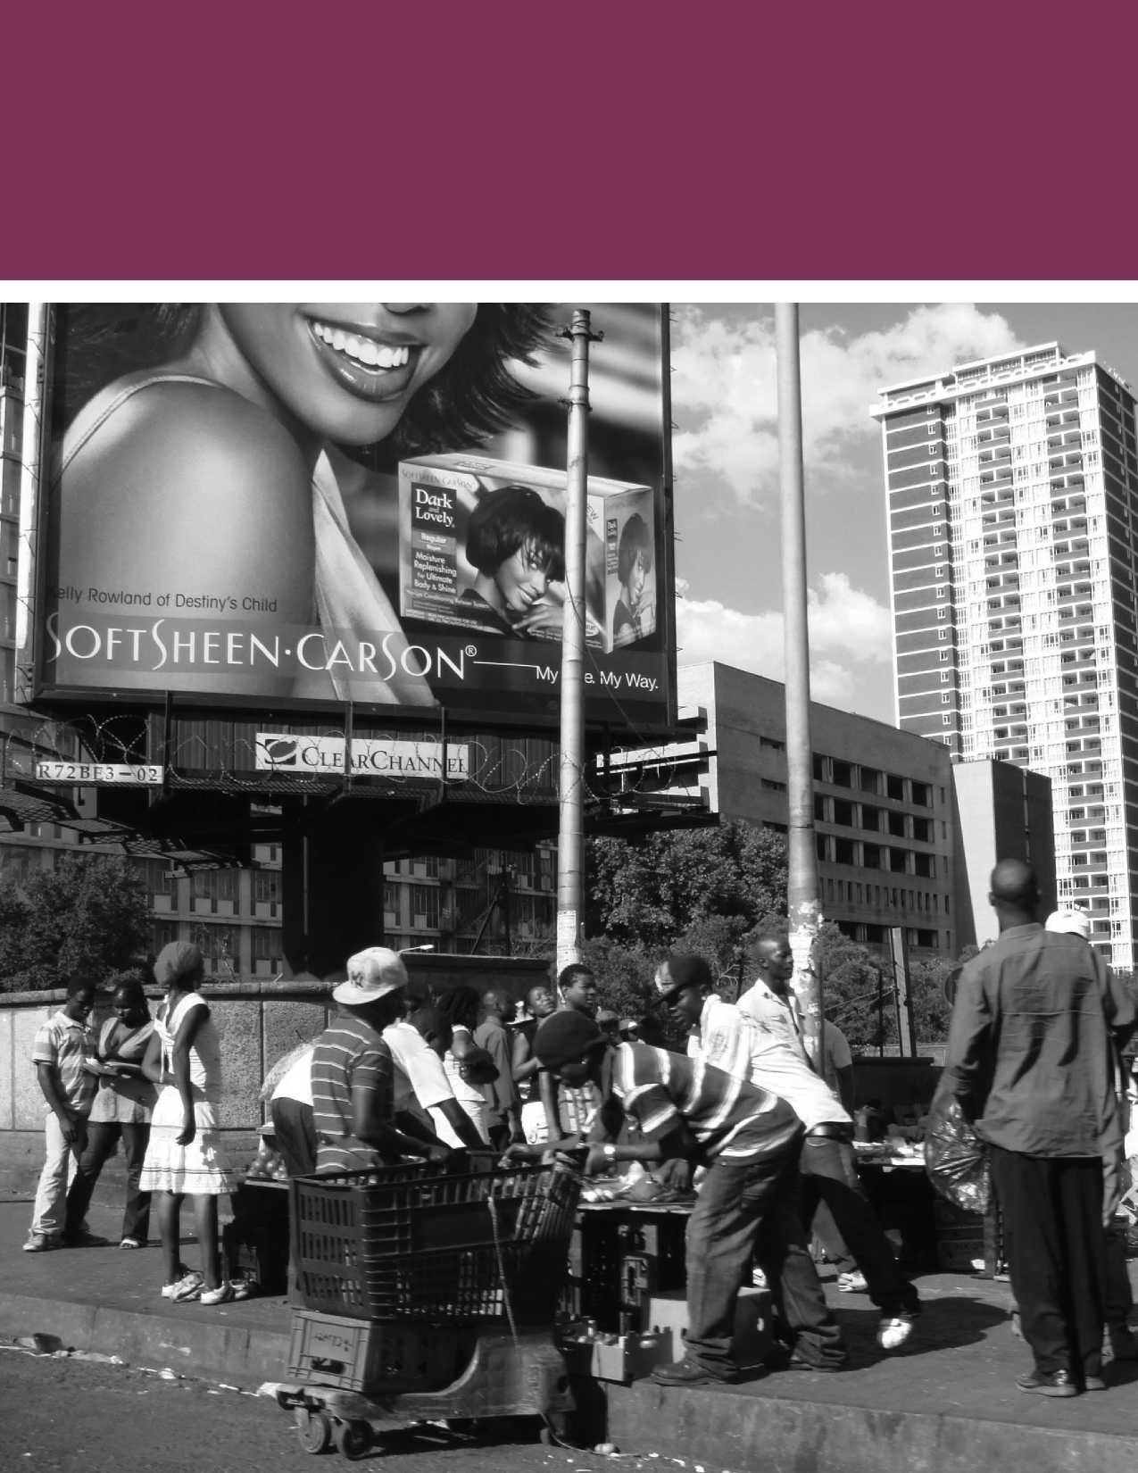

Many of the regional economic communities (REC's) in Africa have taken important steps towards facilitating greater labor mobility within their territories. SADC, unfortunately, lags behind both Economic Community of West African States (ECOWAS) and the East African Community(EAC) in this regard.

Laws and Policies Governing Migration and Displacement in Southern Africa

**I**

**N SOUTHERN AFRICA, LEGAL CHANGES** have influenced, and in turn, been motivated by pat­terns of migration and displacement. As a result, the relationship between law and mobility is a complex one. Historically, and as discussed above, laws were used to restrict and control migration. Legal changes which accompa-

nied the end of Apartheid reconfigured these controls, and transformed patterns of movement. Today, laws and policies are being formu­lated and amended across the region in response to the perceived socio-eco­nomic and security chal­lenges posed by migration and displacement.

The legal regime in the region is deeply fragmented, with co-existing, and some­times contradictory instru­ments governing the same phenomena. National laws are usually restrictive, com­pared to aspirational and

liberal regimes on labor mobility contained in international,

continental, and regional legal instruments.

**The International and Continental Governance of Migration and Displacement** The primary international legal instrument on forced dis­placement is the Refugee Convention, as amended by the 1967 Protocol Relating to the Status of Refugees. Both have been signed and ratified by all the countries in Southern Africa, although most have also made reservations to the text of the treaty. Most states in the region maintain an encamp­ment policy and restrict the freedom of movement of refu­gees and asylum-seekers. South Africa is a notable exception, and does not maintain an encampment policy, though it has

amended its refugee legislation recently, which will make it more difficult for asylum-seekers to work and study.[21] All the study countries, barring Namibia, have also signed and ratified the OAU Convention Governing Specific Aspects of Refugee Problems in Africa, 1969 (hereafter the OAU Refugee Convention).[22]

In contrast to the international instruments related to refu­gees, Southern African countries have a poor record of signing and ratifying international conventions related to the rights of migrant workers. The most important of these are the International Convention on the Protection of Rights of All Migrant Workers and Members of their Families (ICPRMW) 1990 (A/RES/45/158), ILO Convention (C097) concern­ing Migration for Employment (Revised 1949), and finally, the ILO's Migrant Workers (Supplementary Provisions) Convention No. 143 of 1975. These conventions suffer from extremely low rates of ratification, generally. Scholars argue that this is largely due to states' antipathy towards binding international legal instruments in the field of migration gov­ernance (Pecoud 2009; Kalm 2010). For instance, among the study countries, only Lesotho and Mozambique have signed and ratified the ICPRMW, and only Malawi has signed and ratified ILO Convention C097.

A number of legal instruments at the level of the African Union also exhort states to take steps to adopt employment policies which will promote free movement of workers. Prominent among these are the Treaty establishing the African Economic Community 1991 (also referred to, as the Abuja Treaty)[23], as well as the Migration Policy Framework for Africa, and the African Common Position on Migration and Development. These, and the other AU declarations and policy instruments which affect migration, are not binding on states. They merely provide guidelines for how states could use migration for national and regional development (Fioramonti and Nshimbi 2016, p.15). These policy instruments have been supple­mented by initiatives such as the ‘Joint Labour Migration

Programme' (JLMP) which aims to strengthen ‘the effective governance of labour migration' and promote ‘decent work' against the background of ‘regional integration and inclusive development in Africa' (Fioramonti and Nshimbi 2016, p.14­16; ILO 2015).

The Regional Governance of Migration

Many of the regional economic communities (REC's) in Africa have taken important steps towards facilitating greater labor mobility within their territories. SADC, unfortunately, lags behind both Economic Community of West African States (ECOWAS) and the East African Community(EAC) in this regard. Regional efforts to forge a common approach towards migration have resulted in several non-binding legal and policy instruments, and states have been unwilling to ratify and implement anything that might impinge on their sover­eignty in any way (Crush, Dodson, Williams and Tevera 2017, p. 25). SADC member states prefer to deal with each other through a series of bilateral treaties and memoranda of under­standing. In effect, this creates a system of overlapping agree­ments with South Africa in the center, rather than a coherent regional system of migration governance (Fioramonti and Nshimbi 2016, p.29; Nshimbi and Fioramonti 2014).

Article 5(2) of the SADC Treaty states that members of SADC should aim to develop policies which progressively eliminate

**BOX 3:** Informal Cross-border Trade:

The case of South Africa and Zimbabwe

Informal cross-border trade has long been a feature of mobility in Southern Africa. It has especially been used by border communities to secure food and job security. Today, it accounts for 30-40% of intraregional trade. Notably, trade at the Zimbabwe-South Africa border is significant, with woman dominating trade activities - up to 68% - by some accounts.

The lives of informal trades are highly mobile and circular. Some research found that Zimbabwean traders travel relatively frequently to South Africa, with 67% making at least one trip a month and 82% travelling more than four times a year. Despite research showing that informal cross-border traders make significant contributions to country economies, government policy in the region towards informal traders has been largely invisible. Efforts by the Zimba­bwean and South African government are however underway to create a one-stop Beitbridge border post - the busiest border-post on the continent; this may ease movements and economic activities for informal traders.

(Peberdy et al, 2015, Chikanda and Tawodzera, 2017) obstacles to the free movement of labor, and people (more generally).[24] This was sought to be given effect by two major protocols: the 1995 Draft Protocol on the Free Movement of Persons[25], and then, the 2005 Draft Protocol on the Facilitation of Movement of Persons.[26] Neither of these had, at the time of writing, come into effect, for lack of ratification. Various other SADC instruments also contain non-binding provisions affecting migration, including, the SADC Protocol on Employment and Labour,[27] the 2008 SADC Code on Social Security,[28] and the SADC Regional Labour Migration Policy Framework.[29] These are supplemented by the forum on Migration Dialogue in Southern Africa (MIDSA), which is an informal, non-binding, inter-state forum for dialogue on migration (Crush, Dodson, Williams and Tevera 2017, p. 32).

The use of bilateral instruments began in the 1960's and the 1970's as South Africa began to conclude treaties with its neigh­bors (and sources of migrant labor) to regulate and control the supply of migrant mineworkers to the South African mines. For instance, the 1973 Agreement between South Africa and Lesotho[30] was initially used by the The Employment Bureau of Africa (TEBA) and various smaller companies recruiting exclu­sively for the gold and coal mines. In the mid 2000's it began to be used by farmers to recruit labour legally from Lesotho, through the use of agents (Bamu 2014, p.16; Ulicki and Crush 2007). Many of these agreements are now defunct, but have never been formally repealed (Crush, Dodson, Williams and Tevera 2017, p.28). After the end of Apartheid, Memoranda of Understanding and Joint Permanent Commissions have prolif­erated alongside formal agreements.[31]

...The existence of laws has not always guaranteed protection for vulnerable migrants in practice.

This is not to suggest, of course, that SADC is not active as a forum in formulating migration policies. New initiatives by the IOM, ILO, UNODC and UNHCR, at the level of SADC, are seeking to improve the policy environment for labor migration across the sub-region, while improving informed decision-making around and responses to mixed migration flows, and protecting vulnerable migrants**.** These initiatives envisage creation of a regional ‘labor migration observatory', facilitation of labor migration by standardizing the way countries evaluate workers' qualifications, increase in the portability of social protections such as pensions across regional borders, and development of a comprehensive policy framework on mixed migration in the region.

This focus on establishing and improving migration policy confronts several major challenges. The first is that the exis­tence of laws has not always guaranteed protection for vulner­able migrants in practice. Second, the ability and willingness of states to enforce policies remains uneven. Finally, many of the recent policy changes in the region have actually been aimed at tightening laws governing migration and displace­ment and imposing stricter border controls. While the exact impact of these changes remains unclear, it is possible that these laws will only succeed in driving cross-border move­ment underground, rather than stopping irregular movement across borders (Kihato forthcoming).

Divergence between Laws,

Policies and Practice on Migration and Displacement in South Africa

As with the actual trends of migration and displacement, there are elements of continuity and change tying together policies governing migration in South Africa. Between 1910­1991, the governance of migration in South Africa took place through what was known as the ‘two-gate' policy (Segatti 2011b). This privileged the entry of people correspond­ing to the minority government's notions of ‘attractiveness' which were predicated on social, racial and religious preju­dices, whereas the back gate kept out (or tried to keep out) unwanted migrants, while allowing in carefully controlled numbers of labour migrants. These policies were closely con­nected to the Apartheid system, and its homelands policy, and were maintained through an elaborate system of laws, policies and opaque administrative practices.

The 1991 Aliens Control Act, one of the last legislations passed by the Apartheid regime, formed the basis of South Africa's immigration policy through the 1990's and was only replaced by the current Immigration Act in 2002. Refugee movements in the region, primarily from Angola, Mozambique and from the Great Lakes regions were dealt with in an ad hoc way, through the signing of specific agreements between the Apartheid gov­ernment and UNHCR, since no formal asylum-system existed before the passing of the Refugee Act in 1998. As a result, debates around migration in post-Apartheid South Africa had a highly coercive legal instrument focused on migration control, and policing as their point of departure (Segatti 2011b, p.39). Further, the reform of immigration policy sought to accommo­date a diverse group of interests. These can be broadly divided into the following overlapping strands: first, a withdrawal of the state from migration matters, and subcontracting of the admin­istrative process of control to employers, with a particular focus on providing incentives for highly skilled migrants; a second approach which favoured balanced migration control, taking into account democratic commitments and state capacity, and finally, a security and sovereignty centred agenda. The regime which emerged finally, embodied elements of each of these three approaches (ibid, p.46).

These legislative changes took place after the establishment of the new South African constitution in 1996, an extremely progressive document. It guarantees to all persons the right to life, and the right to live with dignity, protection of the due process of the law as well as the right to have access to healthcare services, sufficient food and water, and social secu­rity as well as social assistance (though distinctions are drawn between asylum-seekers and refugees as to the enjoyment of these rights). The Refugee Act of 1998 also created one of the most progressive asylum regimes in Africa, if not the world. Further, other departments amended their legislations to bring those into conformity with constitutional protections: for instance, the Department of Social Development amended the Social Development Act in 2008, thus providing refugees, but not asylum seekers, access to social grants on an equal basis with citizens.

The final immigration system that emerged was a liberal one insofar as higher skilled migrants, refugees and asylum-seekers were concerned, but a restrictive one when it came to low- skilled migration. Conflict between the three sets of interests

**BOX 4:** Proposed changes to South African Migration Policy

In March 2017, the Department of Home Affairs published a ‘White Paper on International Migration in South Africa', which was intended to provide a ‘comprehensive review of the policy frame­work [on migration and displacement] which can inform systematic review of the legislation' to overcome issues of ‘irregular migra­tion... unacceptable levels of corruption, human rights abuse and national security risks'.

Broadly, it recommends the following: (a) strengthening border management techniques (by collecting data more stringently), (b) establishing a border management authority**a**, (c) restricting the conditions in which citizenship can be obtained by a migrant or refugee (by delinking residency and citizenship, removing the category of permanent resident and replacing it with a ‘long-term residency' and finally only allowing refugees to apply for long term residence after 10 years of continuous residence in South Africa), and (d) moving to a points-based system of migration to privilege higher skilled migrants. Among the measures it proposes is a special permitting regime for international students studying in specific ‘critical' fields to apply for permanent residency.

In general, the approach to international migration articulated in the White Paper is predicated on the assumption that there are a large number of irregular migrants from Zimbabwe and Lesotho staying in South Africa, and that there is a need to prioritise the needs of poor South Africans whose lives are being negatively (allegedly) affected by these migrants (p.64).

The White paper proposes to change the asylum process by (a) estab­lishing ‘Asylum Seeker Processing Centres' (p.70), (b) removing the automatic right to work and study for asylum seekers, (c) exploring options for resettlement of refugees to other countries, and (d) crim­inalising the non-compliance with deportation orders.

(Department of Home Affairs, Republic of South Africa 2017)

a The proposed Border Management Authority Bill was passed by the South African Parliament in June 2017, and at the time of writing, was under consideration by the National Council of Provinces. A full text of the Bill is available at <https://www.parliament.gov.za/storage/app/media/Docs/> bill/615716_1.pdf. Accessed 18 April 2017.

identified above have played out in amendments to immigra­tion legislation, the initiation of, and opposition to, restrictive policing of migration, and finally in uneven implementation of the asylum system.

Much of this conflict has played out in successive waves of litigation in South Africa's court systems, and civil society organizations in South Africa (such as Lawyers for Human Rights (LHR), Southern African Litigation Centre (SALC) and Consortium for Refugees and Migrants in South Africa (CORMSA), among others) continue to play a major role in publicly scrutinising migration policy. [32] Researchers argue, however, that notwithstanding the changes in laws, polic­ing and administrative practices aimed at coercive migra­tion control persist, and can be observed most easily in the administration of asylum, as well as the detention and depor­tation of undocumented migrants (Segatti 2011b; Sutton and Vigneswaran 2011; Hoag 2014; Vigneswaran, Araia, Hoag and Tshabalala 2010).

ASYLUM IN SOUTH AFRICA

The difficulties faced by asylum-seekers in navigating the asylum system has long been documented by scholars work­ing on South Africa. This point was reiterated by almost all respondents during our field trip to South Africa. In fact, the asylum system displays a series of highly contradictory impulses. It acknowledges the right to protection, but asy­lum-seekers remain vulnerable to coercive policing tech­niques. Asylum-seekers and refugees find it difficult to access the socio-economic rights and services guaranteed to them by the constitution and law. Finally, the DHA remains signifi­cantly understaffed and under-resourced, especially in relation to the magnitude of its tasks (Fassin, Wilhelm-Solomon, and Segatti 2017, p. 163).

Three sets of bureaucracies are involved in the asylum process. First, at the ports of entry, border officers issue a ‘Section 23 permit' with a validity of 5 days, allowing for the submission of their claim to a Refugee Reception Office. [33] Researchers note that border officials may choose not to issue these Section 23 permits on the grounds that the person claiming asylum may have travelled through safe third countries before arriving at the South African border, or because they assess claims to be unfounded (as appears to have become systematic practice in case of Zimbabweans after 2011). Those who are rejected may be summarily deported (Amit 2012; 2015).

Asylum-seekers encounter a second level of bureaucracy at the refugee reception offices (RRO's), where claimants exchange the ‘Section 23 permit' for a ‘Section 22 permit' with a valid­ity of 6 months, which then have to be renewed. Researchers have alleged that this stage of the application process is both burdensome, deeply complicated, and marked by pervasive corruption (see Amit 2015). Many asylum-seekers abandon Researchers argue, however, that notwithstanding the changes in laws, policing and administrative practices aimed at coercive migration control persist, and can be observed most easily in the administration of asylum, as well as the detention and deportation of undocumented migrants.

their applications, facing the prospect of traveling long dis­tances at great cost and queuing for long periods. One survey found that around 23 per cent. of all applicants had to visit a RRO 6 times before being allowed inside (Vigneswaran, Araia, Hoag and Tshabalala 2010, p. 474). In these over­whelmed offices, an alternate economy of bribes has devel­oped, which can allow for the circumventing of lines, and facilitation of steps such as photocopying, taking of pictures, etc (Fassin, Wilhelm-Solomon, and Segatti 2017, p. 169). We understand that, in response, the DHA has taken some steps to re-organize the RRO's.

Some of the respondents we interviewed during our research visit to South Africa pointed out that in practice, most refugee reception offices no longer accept new asylum-seekers, and instead simply renew existing asylum documents. Further, they and civil society representatives, suggested that some RRO's now have rejection rates approaching 100 per cent. Further, several of the existing RRO's have been closed, nota­bly the one in Cape Town, and remain closed although courts have ordered them re-opened. The DHA, for its part, notes that there is no direct migration to Cape Town, and while the existing residents will be dealt with where they are, it is not likely to that newcomers will be received in Cape Town.

The final level of bureaucracy is encountered by rejected asylum-seekers, who choose to maintain an appeal. The appeals process is notoriously slow, in large part because of the workload and backlog of the adjudicators. Recent legislative changes by the DHA have been intended to bolster investigation of departmental corruption, and streamline the asylum appeals process, though the effects of these changes are still not known. It is also worth noting that there have been multiple ad hoc measures to relieve the stress on the asylum system — for instance, in 2010, South Africa approved a legalization amnesty for Zimbabwean migrants already in the country. They could apply for rights of domicile, study, work and entrepreneurship on 4-year permits under the Zimbabwe Documentation Project (DZP). 242,731 DZP permits were issued and expired in 2014, to be replaced by the Zimbabwe Special Dispensation Permit, which was in turn, replaced by the Zimbabwean Special Exemption Permit (Thebe 2017). Similar measures were put in place for the Basotho between 2016 and 2017.

While South Africa has deported significant numbers in past years, according to DHA's administrative records, these num­bers have declined significantly — from 103,529 in 2012 to 23,454 in 2016. Since 2013, the top three nationalities of those deported are Mozambique, Zimbabwe and Lesotho (in that order). Many of those deported may have been deported multiple times in a single year (Department of Home Affairs, Republic of South Africa 2017).

Documentation is not a guarantor of protection outcomes in South Africa, nor do they accurately predict the likelihood of asylum-seekers or refugees being able to access services, education and jobs. A combination of technical reasons (dif­ferences in the format of national and asylum-seeker identity documents, no standardized methods for evaluation of quali­fications) and exclusionary attitudes result in the exclusion of migrants and refugees.

Some have argued that effectively assisting migrants and refugees in diverse environments requires an examination of the role that local authorities could play in the governance of migration

**box 5:** 'Time-theft' -

Lived experiences of asylum-seekers in South Africa

Asylum-seekers evocatively argued that the broader system governing migrants and refugees in South Africa was ‘stealing their time'. Many asylum-seekers, they argued, have been waiting for as long as ten years for the determination of their claims. In the meantime, they have been unable to access education, or when they have been able to do so, have found it difficult to obtain opportuni­ties in the South African labor market. Many end-up working as car washers, security personnel at various establishments, and in some cases, they are reduced to begging.

Informal migrants who do not go through the asylum pro­cess remain subject to frequent and very coercive practices of policing (Sutton and Vigneswaran 2011; Landau et al forth­coming). A large number of migrants cross the border illegally despite the possibility of legal crossing, and these policing practices impose major limitations on their mobility.

In circumstances where laws are weakly enforced, and charac­terised by pervasive anti-migrant and anti-refugee sentiment, what are the possibilities of alternate forms of governance? Some have argued that effectively assisting migrants and ref­ugees in diverse environments requires an examination of the role that local authorities could play in the governance of migration (Landau, Kihato, Sarkar and Sanyal 2017a). This is particularly true, they argue, in urban spaces.

The Role of Local Authorities in the Governance of Migration

Across the world, and in Southern Africa, migration and dis­placement is an increasingly urban phenomenon (World Bank 2017a). While the majority of analyses focus on national and regional impacts of migration, the consequences of migra­tion are often felt most acutely at the municipal or provin­cial level (Landau, Segatti and Misago 2011). It is also these local authorities which are at the forefront of delivering ser­vices to migrants and refugees. This is not to suggest that local authorities are automatically predisposed towards protecting migrants and refugees; they may in fact be extremely hos­tile to outsiders. A recent study in Ekurhuleni (South Africa) found that local residents and officials blamed migrants for most of the problems faced by the community, including ‘undermining the local labor market by providing cheap com­petition, providing ‘illegitimate' competition by invading and closing local business spaces or undermining existing local businesses, overburdening public resources through resources

**BOX 6:** Johannesburg's Migrant Help Desk

Some laudable steps have been taken to support migrants at a local level - notable among this is the creation of a Migration Help Desk in the City of Johannesburg in 2007, primarily established to counter xenophobia and to help integrate cross-border migrants. The Help Desk aims to provide services such as counselling, information, economic opportunities, and legal advice to internal, cross-border migrants and refugees. Importantly, the Help Desk provids informa­tion to all migrants, legal or illegal and seeks information about their immigration status (Kihato forthcoming).

The City of Johannesburg continues to run awareness campaigns on xenophobia, and to conduct dialogues with both migrants and locals, though they have faced significant challenges in ensuring constructive dialogue between these two groups. In their work, they collaborate closely with civil society actors, as well as government departments including the Department of Labour, Department of Home Affairs, Department of Justice, among others.

Over time, it appears that fewer migrants are seeking help from the Migrant Help Desk, primarily fearing arrest and deportation. Equally, the operation of various programs at the city, provincial and national level are not always well coordinated.

outflow and less investment in local economic development, and being responsible for a broad range of social maladies including crime, conflict, violence, fraud and corruption, drug and substance abuse, disease, moral degeneration and lack of social cohesion' (Misago 2016, p. 15).

Changing these narratives requires a deep contextual analysis of the role of local government. In South Africa, for instance, although the Constitution includes provisions allowing municipalities to govern the local government affairs of its own community, subject to national and provincial legislation, most municipalities believed migration to be a subject to be regulated at the national level (Landau, Segatti and Misago 2013). Similarly, the particular bureaucratic incentives which motivate local authorities need to be accounted for. For instance, the role played by the National Treasury in South Africa in promoting of local revenue raising, was found to have influenced planning by municipal authorities, including for mobility (ibid, p.119). Improving protection outcomes will therefore require engagement of local authorities in multiple policy fields, and creation of pragmatic incentives for them to work with migrants and refugees (Kihato and Landau 2017).

StatsSA and the Department of

Social Development have created an ‘Urbanization and Migration Forum' which will, among other things, aim to improve data collection and data use in migration in South Africa

Close attention must also be paid to the collection and use of data. Policy-makers may not have the capacity (or incentives) to use available data effectively (Landau and Duponchel 2011). As the research team inferred from its meetings in South Africa, different levels of government, and different departments and ministries have diverse motivations for wanting better data on migration. These range from service delivery (such as access to education), assessing the protection needs of unaccompanied minors, to eviction from occupied buildings, and deportation (Fassin, Wilhelm-Solomon, and Segatti 2017). Some depart­ments (especially at the municipal level) noted that they do not have the capacity to use the data for policy-making, nor sufficient access to the policy-making process itself.

Laudably, StatsSA and the Department of Social Development have created an ‘Urbanization and Migration Forum' which will, among other things, aim to improve data collection and data use in migration in South Africa and has already engaged the City of Johannesburg and the Gauteng Provincial Government in its meetings.

-

|  |  |  |  |
| --- | --- | --- | --- |
| <• | |  |  |
|  | ■ zz |  | **rwf- Y/ ... tj**  ■ Jh^^L **3'**  **|||L. ^HR ’■B^^n —T'-^'** |

|  |  |  |  |
| --- | --- | --- | --- |
| **fl** |  | | |
| 1 V | | □ | *ll*  1 |
|  | |  | |

|  |  |
| --- | --- |
| J | m  g |
|  | Mr |
| **L (., ’• .. ...... Z !'■** | |
| **r »** | |

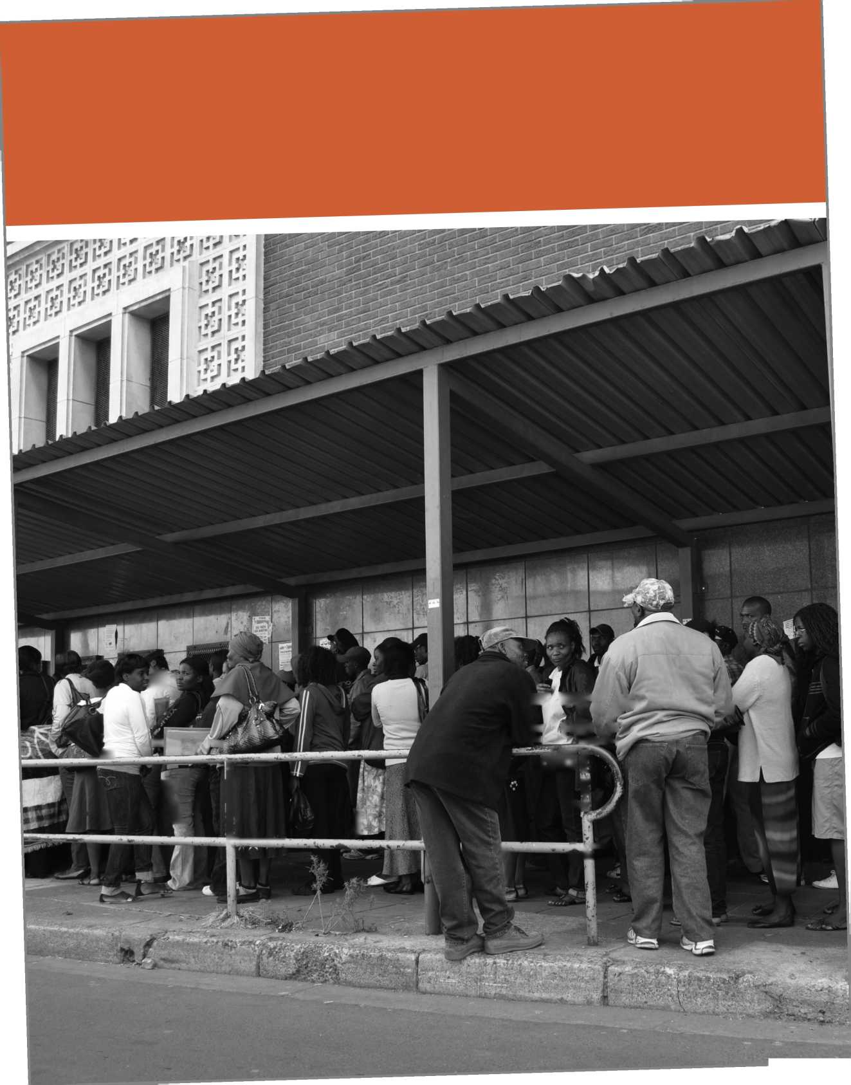

The Case for Empirical Evidence: Migration and Job Outcomes in South Africa

**AS NOTED IN THE INTRODUCTION,** this study recognizes that migration and dis­placement are connected to broader, deeply political questions of social transformation and economic inequity. As such, analysis on a topic as politi­cally contentious as migration and displacement can at times become embroiled in public perceptions and unsubstantiated political assertions, which can serve to override empirically based information. For this reason, it is ever more important to foreground evidence-based analysis that can provide policy guidance.

The analysis provided in the following section has been con­ducted in this vein. It provides an empirical analysis on a con­tested and significant issue in South Africa, the relationship between migration, displacement and local South African jobs.

Although critical analysis on its own cannot lead to sound and well-evidence policies, which also rely on political will and

available resources, it can however work to dispel myths that

Although critical analysis on its own cannot lead to sound and well­evidence policies, which also rely on political will and available resources, it can however work to dispel myths

that may otherwise be used to mobilize

ill-formed practices and policies.

may otherwise be used to mobilize ill-formed prac­tices and policies. Instead, this kind of analysis can redirect attention towards people, places and processes that warrant attention and that may otherwise be mis­understood or neglected (Landau & Achiume, 2017).



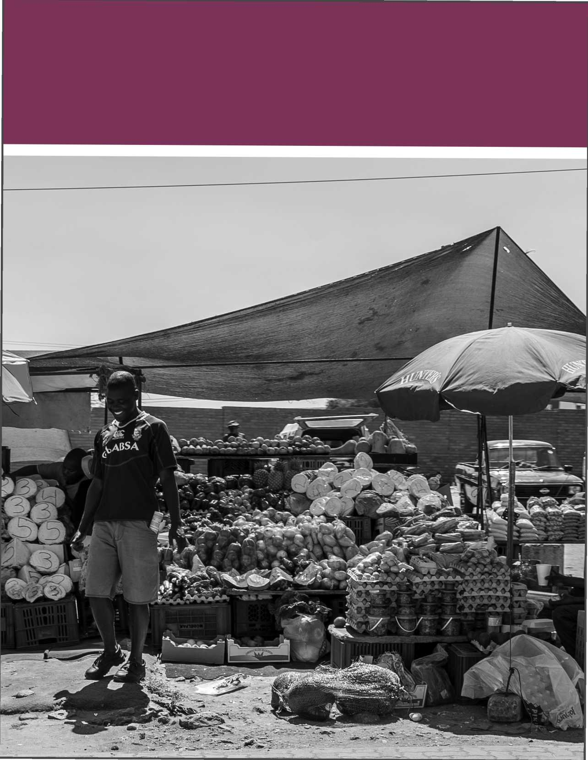

Mixed Migration, Forced

Displacement and Jobs in South Africa

**THE TRIPLE THREAT, AS IT IS** referred to in South African policy circles, remains a key policy priority for the govern­ment; namely, inequality, poverty and joblessness.

The latter — unemployment — was 26.7% in the fourth quarter of 2017 (QLFS, 2017) and at such high rates, the issue is a crit­ical development issue in contemporary South Africa.

Social cohesion in South Africa,

and as is the case in other parts

of the world, is often entangled

in political discourse that blames

migrants and refugees for ‘stealing'

Significantly, within the context of high levels of internal migra­tion, where local migrants are themselves in search of better livelihoods in urban contexts, access international migrants, asy­lum-seekers and refugees have to the South African labor market is a contentious issue (Fauvelle- Aymar, 2014). Notably, social cohesion in South Africa, and as is the case in other parts of the world, is often entangled in political discourse that blames migrants and refugees for ‘stealing' local jobs in a context where resources are already limited (Afrobarometer, 2017).

local jobs in a context where

resources are

already limited.

The implications of migration on local jobs, is therefore, highly contested. However, empirical evidence may provide the nec­essary information policy-mak­

ers require to develop policies and interventions that mitigate the costs that may be felt my locals, while enhancing the develop­mental opportunities for migrants, refugees, locals and the wider economy. It is within this context that the following chapter 1) estimates the impact of immigration on the labor market out­comes such as employment and wages in South Africa between 1996 and 2011, 2) provides an overview of the results and 3) posits several possible explanations for what might account for the results. The chapter also includes a) an overview of the estimation methodology and justification for its use, b) an overview of the results of previous studies focused on the impact of immigration on labor market outcomes in South Africa, and c) contributions the analysis makes to existing literature. Further details on data description and methodology, are provided in Annexures.

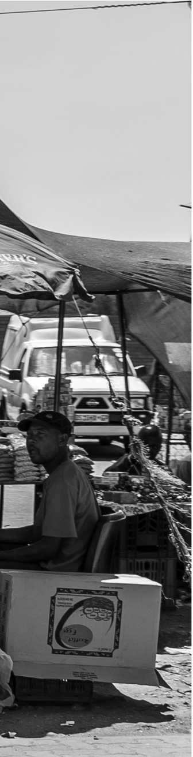

A Brief Look at Post-Apartheid Immigration History and Trends

South Africa's long history of migration and the contempo­rary regional and South African immigration regime are well documented in previous chapters. It is however worth provid­ing a cursory overview of several Apartheid and post-Apart­heid historical migratory and policy trends that are especially relevant for the period this analysis covers (1996-2011).

South Africa has long been a major immigration hub in the region hosting migrants, refugees and asylum-seekers from vari­ous African countries as well as people from outside of the con­tinent (See Figure 1 for migrant by country of origin in 1996, 2001 and 2011). After 1990, international immigration in South Africa increased rapidly and underwent a major transforma­tion, shifting from collective mining labor agreements to largely informal and individual immigration (World Bank, 2011). In the 1990s, South Africa hosted refugees, although fewer than many other African countries system. There were two major inflows of immigrants to South Africa: the Mozambican refugees from 1984 and Zimbabweans in 2000s. Mozambican refugees were officially granted that status after an agreement between the UNHCR and the South African government from 1993. Despite this protection, many Mozambicans were deported from the country as ‘illegal immigrants' and only a few were able to stay and legalize their status. Despite the emergence of South Africa as a major immigration hub, immigrants' share in the population has not significantly increased over 1996-2011, rising from 3.3% to nearly 4.0% percent over the period.

Policies instituted during this period affected immigration to the country. Near the end of the apartheid regime, the de Klerk administration adopted the 1991 Aliens Control Act to manage international migration, which lasted until 2002 with a few modifications. After a 10-year consultative process, the government of South Africa passed a new Immigration Act in 2002 followed by the Amendment Act of 2005. This leg­islation had elements of continuity with the previous immi­gration regime, but two major changes were introduced: it ensured minimum constitutional conformity of immigra­tion legislation with South Africa's progressive Constitution of 1996, while retaining a dual system of limited permanent high-skilled immigration and temporary lower-skilled migra­tion implemented through corporate permits (Segatti 2011b, p. 34-35). A new and extremely progressive refugee legislation was enacted in 1998: this allowed asylum seekers the right to work and study while their applications were being adjudi­cated, and granted refugees and asylum seekers freedom of movement (unlike most other countries in Southern Africa).

The following section describes the estimation methodology that will be used within the context of established method­ologies. It also provides an overview of the results of previous studies focused on the impact of immigration on labor market outcomes in South Africa and the contributions this analysis makes to existing literature.

36 Mixed Migration, Forced Displacement an

Jobs Jn South Africa

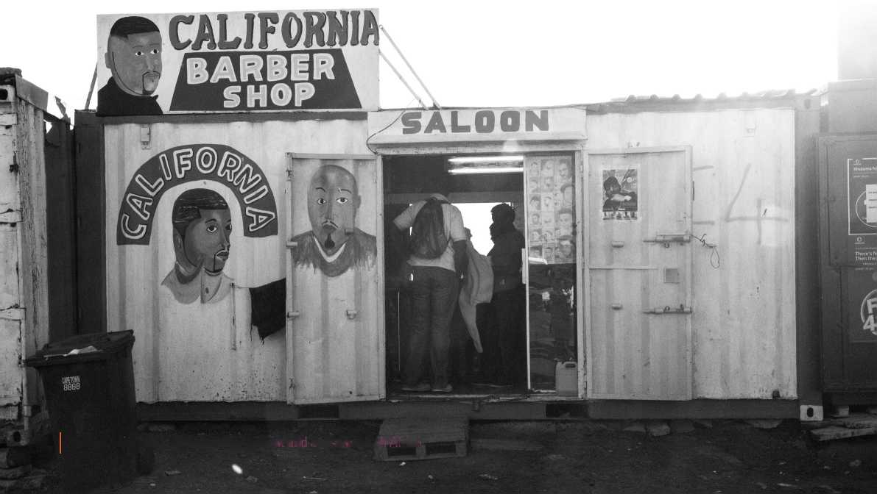

**FIGURE 9:** Immigrants' flows by country of origin in 1996, 2001, and 2011 (% in total)

1996

2001

2011

Estimation Methodology

Zimbabwe

Mozambique

Lesotho

Malawi

UK

Namibia

Swaziland

India

Zambia

Ethiopia

Nigeria

Congo

Somalia

DRC

Germany

Bangladesh

Pakistan

Portugal

China

Botswana

" 4.0

™3.8

| 1.9

**'1-7**

**'1-5**

| 1.4

| 1.3

| 1.3

| 1.2

11.1

11.1

11.0

10.9

10.8

10.8

'0-7

10.6

0.00 20.00 40.00

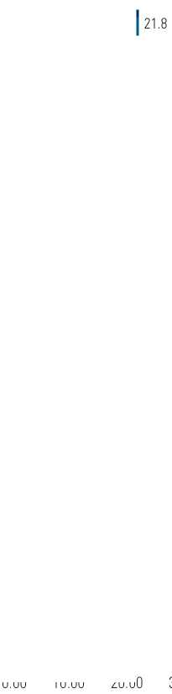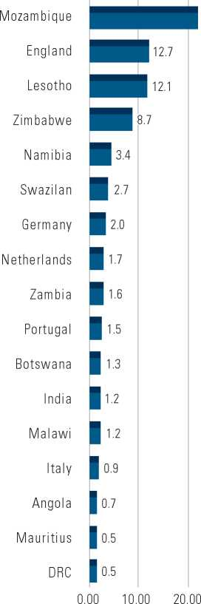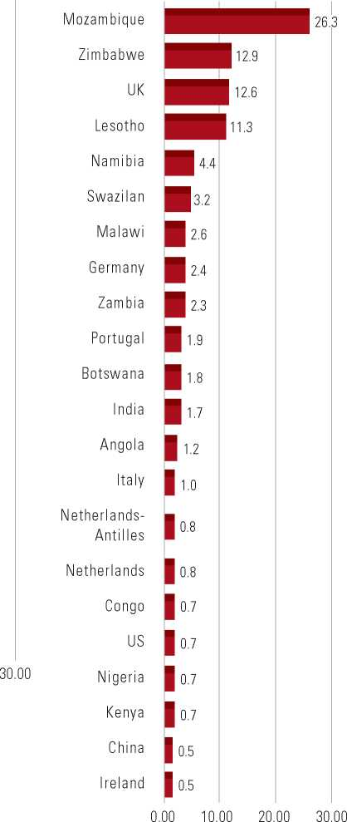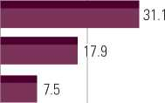

The empirical literature on immigration has generally focused on its impact on the labor market outcomes of the local pop­ulation. A vast variety of empirical papers can be divided into two main streams: those employing the spatial correla­tion approach and those using national-level data categorized by education and experience. The first group of papers uses geographical areas to study effects of immigration at a sub­national level by using data on the geographic distribution of immigrants. LaLonde and Topel (1991), Altonji and Card (1991), Borjas, Freeman, and Katz (1997), and others find only a modest impact of immigration on the variables of interest. More recent papers in that stream including Basso and Peri (2015) generally find a positive impact of immigration on labor market outcomes of locals.

In the second stream of research, the skill-cell method stud­ies the immigration impact on labor market outcomes using national level data, thus avoiding the bias in estimates caused by local labor market adjustments likely to appear in thespatial correlation approach. If there is a significant inflow of immigrants to one region, locals will respond by moving to other regions, thus diffusing the impact of immigration beyond the local labor markets. These methods generally group labor inputs into skill-cells based on education and experience, assuming there is no mobility across these groups. Borjas' (2003) seminal paper utilized national level data, dis­aggregated into skill-cells by education and experience, and found a significant negative effect of immigration on locals' wages and employment. In his approach, using national level data helps overcome endogeneity issues, as there will be no outflow of locals in response to immigration inflows in the skill-cell. Workers' education and experience levels can be considered as predetermined characteristics for both locals and immigrants, unaffected by current labor demand.

There are only a few papers that have studied the impact of immigration on labor market outcomes in South Africa. They have generally found no impact on total income but nega­tive effects on native employment. Among them Faccini et

**FIGURE 10:** Share of immigrants in total employment by industries and provinces in 1996, 2001, 2011.

BY INDUSTRIES

BY PROVINCES

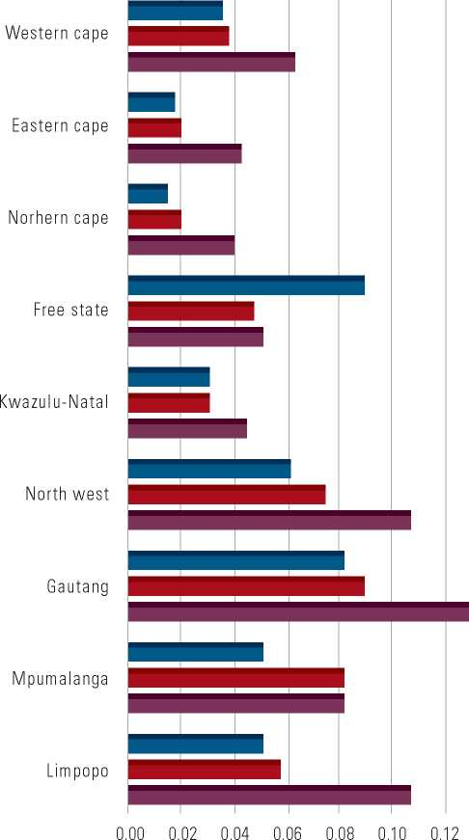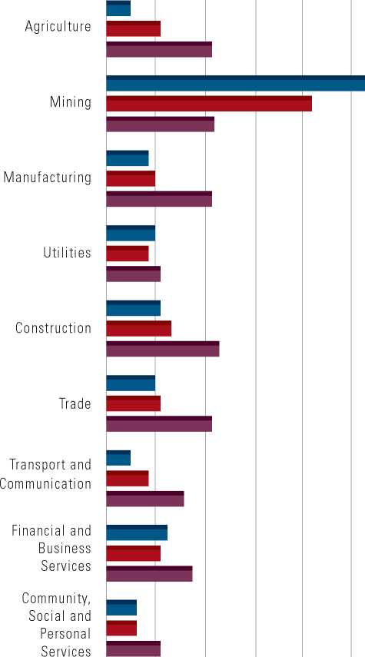

1996

2001

2011

1996

2001

2011

0.00 0.05 0.10 0.15 0.20 0.25 0.30

+ *Ci* + *Zj* + *eijt* (1)

+ *Ci* + *Zj* + *mt,j* + *eijt* (2)

al. (2011) analyze the relationship between migrants' share in total employment and locals' employment, using district and skill-level data based on education and experience. Broussard (2017) finds a negative impact of immigration on black locals' employment-population ratio and income in South Africa using data disaggregated by district councils and metropolitan areas and two types of skills: secondary or higher education and less than secondary education. Finally, Fauvelle-Aymar (2015) uses skill-level data based on education and experience and finds that an increase in immigrants' share of the labor force reduces the employment-population ratio, while there is no impact on the employment rate.

This chapter estimates the impact of immigration on labor market outcomes such as employment and wages in South Africa. Compared to earlier papers, it makes several contribu­tions. First, the analysis uses industry-province level data, given significant variation in the utilization of immigrant labor across industries and provinces (Figure 2). Applying data on a more aggregate level such as provinces instead of smaller geo­graphical units such as districts reduces effects from potential outflows of locals in response to immigrants' inflows. Second, the anlysis uses an *instrumental variables (IV)* approach to address endogeneity issues. The instruments are constructed following the methodology proposed by Card (2001), who uses pre­vious settlements of immigrants as an instrument in study­ing labor market effects of immigration across geographical regions. Third, the analysis includes all immigrants—not only males, as in some studies—given a substantial share of female employment among immigrants. In 2011, females accounted for nearly 24 percent of total employment among immigrants. Next, our estimates focus on the relationship between locals and immigrants, and not on specific groups based on educa­tion and experience within each category. The latter captures only the partial own-skill effect and ignores cross-skill com­plementarities and externalities. Finally, the study uses wage data from the Post-Apartheid Labor Market Series (PALMS) harmonized survey, instead of relying on total income that includes both labor and non-labor earnings as in other studies.

The main empirical strategy is to estimate the immigration impact on the labor market outcomes such as local employ­ment and wages in South Africa using reduced-form equations:

*Tbljt TNjt*

*bijt-i* h*h NFt-i*

*T* b*ijt T NiFjt*

= h*fc F bijt-1 Nijt-1*The dependent variable is constructed from , the level of local employment, labor income, wage earnings or non-wage labor earnings in industry , province , and year . The key indepen­dent variable is the growth rate of immigrants in industry , province , and year , where is the number of immigrants. and are respectively industry and province fixed effects while is a zero-mean random shock. In the second equation, indus­try-province fixed effects are also included.

Estimation of this reduced-form structure with *ordinary least squares (OLS)* is prone to simultaneity and omitted variable bias that might generate biased estimates of the impact of immigrants on the variables of interest. To solve for these problems, the analysis follows the methodology adopted by Card (2001) which uses previous settlements of immigrants as an instrument in studying labor market effects of immigra­tion across geographical regions. Immigrants' networks play a key role in their location and industry choices, as information acquisition from individuals from the same countries of origin substantially reduces migration costs and drives migrants to the places and industries with higher concentrations of immi­grants. This network-driven immigration is exogenous to local labor market developments and can be used as an instru­ment to study the labor market effects of immigration.

To construct the instrument, this approach classifies immi­grants in South Africa into five groups according to their birthplace, or nationalities of origin based on Census data: (1) Lesotho, (2) Malawi, (3) Mozambique, (4) Zimbabwe, and (5) rest of the world. For each nationality of origin the total number of immigrants in each industry and province in 1996, , is constructed. Then, the national growth rates for each nationality of origin in South Africa are computed for the following census years 2001 and 2011 relative to 1996:

*Popn,t — Popn,1996*

*Gn,t-1996* = *pOP*

*Popn,1996*

Next, these growth rates are applied to the number of immi­grants from each nationality of origin in each industry and province in 1996 in order to impute the number of immi­grants by the nationalities of origin in the subsequent years across industries and provinces. Therefore, the imputed number of immigrants from the nationality of origin n, for time t, industry i and province j would be:

*Popn,i,j,t Popn,i,j,1996 x* [ 1 + *Gn,t-1996* ]

They show that a one percent increase in the number of immigrants relative to the previous period raises local employment by 0.2 percent. In other words, one immigrant worker generates approximately two jobs for locals.

The imputed total number of immigrants in each industry and province is obtained by summing over the nationalities of origin:

*Pop*}*F,i,j,t* = R *Pop*}*n,i,j,t*

*n*

Finally, the instrument for the growth rate of immigrants for each industry and province is constructed:

*T} = TPo}*

*TN}1 TPop}j,t-i*

This instrument imputes network-driven immigration that should be exogenous to industry and location-specific devel­opments. The literature generally applies longer lags when evaluating immigrants' prior settlement patterns. However, in the case of South Africa, the paper uses 1996 data to construct

**TABLE 5:** Estimation Results

|  |  |  |  |  |
| --- | --- | --- | --- | --- |
| **REGRESSIONS/**  **DEPENDENT**  **VARIABLES** | **LOCAL EMPLOYMENT** | **EARNINGS** | **WAGE EARNINGS** | **SELF-EMPLOYMENT**  **EARNINGS** |
| **OLS with individual** | **0.219\*\*\*** | **0.138** | **0.096\*\*** | **-1.291** |
| **fixed effects** | **(0.036)** | **(0.102)** | **(0.039)** | **(1.515)** |
| RMS Error | 0.170 | 1.404 | 0.243 | 33.26 |
| Observations | 162 | 162 | 162 | 128 |
| **OLS with all** | **0.218\*\*\*** | **0.05** | **0.083** | **1.741** |
| **fixed effects** | **(0.051)** | **(0.154)** | **(0.056)** | **(3.344)** |
| RMS Error | 0.197 | 1.508 | 0.299 | 31.10 |
| Observations | 162 | 162 | 162 | 128 |
| **IV with individual** | **0.281\*\*\*** | **1.149\*** | **0.386\*\*** | **1.452** |
| **fixed effects** | **(0.096)** | **(0.672)** | **(0.169)** | **(7.041)** |
| RMS Error | 0.163 | 1.423 | 0.274 | 30.86 |
| J p-value | 0.369 | 0.305 | 0.176 | 0.242 |
| C p-value | 0.447 | 0.049 | 0.027 | 0.592 |
| Observations | 162 | 162 | 162 | 128 |
| **IV with all fixed effects** | **0.225\*\*\*** | **1.371\*\*\*** | **0.341\*\*** | **2.132** |
|  | **(0.09)** | **(0.518)** | **(0.142)** | **(1.656)** |
| RMS Error | 0.139 | 1.226 | 0.242 | 21.47 |
| J p-value | 0.295 | 0.145 | 0.206 | 0.540 |
| C p-value | 0.880 | 0.041 | 0.014 | 0.594 |
| Observations | 162 | 162 | 162 | 128 |

Note: Each cell shows the coefficient on the variable “immigration growth” from a different regression. The units of observations are province-industry level data. All variables are converted into five-year changes to equalize the time intervals between various census years. Regressions are weighted by the total number of employment in the previous period. Standard errors are presented in parentheses and are clustered by industry and province. (*, **,***) indicate respectively significance at 10%, 5% and 1% confidence levels.

the instrument, as previous Census data are not representative of the country and exclude certain regions and population segments. While this instrument is widely used in the liter­ature, its limitations are also acknowledged. The validity of this instrument depends on the assumptions that immigrants did not initially settle in the region and find employment in industries that would have the highest growth potential in later years.

The following section provides an overview of the results.

Results

The estimation results indicate that immigration has a positive impact on native employment, labor earnings, and wages**.** Results from Equations (1) and (2) using OLS and IV approaches are pre­sented in Table 1. The estimated effects of immigrant growth on native employment are positive and highly significant in all speci­fications and are similar in terms of magnitudes. They show that a one percent increase in the number of immigrants relative to the previous period raises local employment by 0.2 percent. In other words, one immigrant worker generates approximately two jobs for locals. The effects on labor earnings, wages, and self-employment earnings are insignificant in OLS estimations with an exception of wage earnings when only individual fixed effects are used.

As the OLS results may be affected by simultaneity bias, we also produced IV estimates for Equations (1) and (2), using the instrument described above and its square to permit overiden­tification of the equation. The J p-value refers to the Hansen J test of overidentifying restrictions, which is generally sat­isfactory. The C p-value reports the Hayashi (2000) GMM distance test for endogeneity, which is asymptotically equiv­alent to the Durbin-Wu-Hausman test comparing OLS and IV methods. For both earnings and wage earnings, the C test rejects its null hypothesis that OLS yields consistent estimates, suggesting that IV methods are required to produce consistent estimates. In both forms of the model, the immigrant growth rate for the industry, province and year has significant and pos­itive effects on total earnings and wage earnings with values ranging from 0.3 to 1.4. The coefficient on local employment in Table 5 is very similar in magnitude to that of Table 2, as the C test for that model does not reject the OLS estimates. The immigration impact on self-employment remains insig­nificant but becomes positive in all IV estimates.

Understanding the Results

This study suggests several explanations for the positive impact of immigrants on South Africa's labor market. First, given that immigrants and locals are not perfect substitutes,

We obtain .35 for the non-tertiary educated group and .14 for the tertiary educated group. This shows that immigrants and locals are not perfect substitutes and the complementarity of tasks they perform might generate efficiency gains in the economy.

**FIGURE 11:** Employment-Population Ratio

IMMIGRANTS

NATIVES

**FIGURE 12:** Share of Self-employed in Total Employment

IMMIGRANTS

NATIVES



*Gin* =

specialization in different tasks might lead to overall produc­tivity gains. Second, immigrants have nearly twice as high an employment-population ratio compared to locals, possibly reflecting the demand for the diverse set of skills they bring and this can result in large multiplier effects. Finally, immi­grants tend to be more risk-loving and entrepreneurial, which might generate positive externalities in the economy.

The positive effects of immigrants on locals' labor market out­comes might be explained by various task specialization between immigrants and locals. Foreign and local-born workers might specialize in performing complementary tasks and, hence, two groups might not compete for similar jobs. As a result, this com­plementarity might increase the productivity of native workers and hence generate positive externalities for their employment and wages. To test this hypothesis the study compares occu­pations of immigrants and locals for tertiary and non-tertiary educated groups. It uses 2011 census data and constructs the Welch (1979) index to test whether immigrants and locals are perfect substitutes, where and give the fraction of immigrants (i) or locals (n) employed in occupation c, and gives the fraction of the entire workforce employed in that occupation.

*Rc(Qic- QMc- QC)/Qc  
Rc[(Qic - QrWQK - Qy/Qcl*

This index is similar to a correlation coefficient, equaling one (1) when the two groups have identical occupational distribu­tions and minus one (-1) when the two groups are clustered in completely different occupations. We obtain .35 for the non-tertiary educated group and .14 for the tertiary educated group. This shows that immigrants and locals are not perfect substitutes and the complementarity of tasks they perform might generate efficiency gains in the economy.

Finally, two stylized facts emerge from the comparison of the employment-population ratio and share of self-employed in total employment between locals and immigrants. First, although the employment-population ratios for locals and immigrants were similar in 1996, this drastically changed by 2011 (Figures 11 and 12). In particular, the share of employed immigrants in total increased from 36 to 61 percent com­pared to only 35 percent for locals. This sharp increase in the employment-population ratio for immigrants was probably due to changes in immigration policies discussed above and in chapter 3. Higher employment rates among immigrants and hence higher labor earnings compared to locals might gen­erate large multiplier effects in the economy. Finally, we must

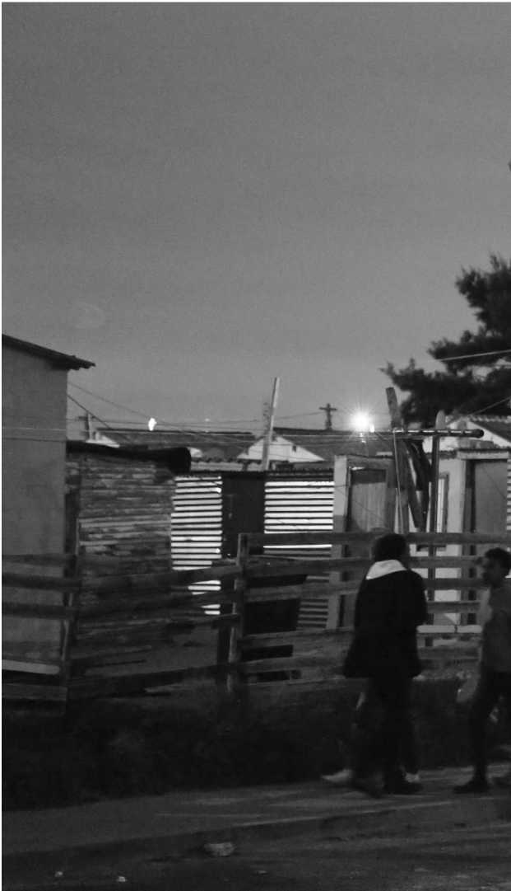Short-term costs can however be mitigated and addressed, while long-term benefits maximized through preemptive and sustained interventions that are based on empirical evidence.

also note the prevalence of self-employment among immi­grants: self-employment accounted for 25 percent of total jobs for immigrants, compared to 16 percent for locals. Migrants are more likely to appear in entrepreneurial roles than locals, suggesting that their actions are likely to promote economic growth by enhancing, for instance, the supply of small retail establishments. If those businesses are successful, they also will provide multiplier effects which may spread beyond the imme­diate family.

An important note of caution is that these results are retrospec­tive in nature given the data limitations mentioned, and there­fore these results may differ in the current context. Notably too, the South African economy has witnessed economic decline in the years following the period covered in this analy­sis, that may have affected the impact of immigration on labor market outcomes today. It is also well documented that even in the best circumstances, migration and displacement may have significant short-term costs for receiving communities. These costs may not necessarily manifest economically, but in social and institutional ways. Short-term costs can however be mitigated and addressed, while long-term benefits maximized through preemptive and sustained interventions that are based on empirical evidence (World Bank 2017b).

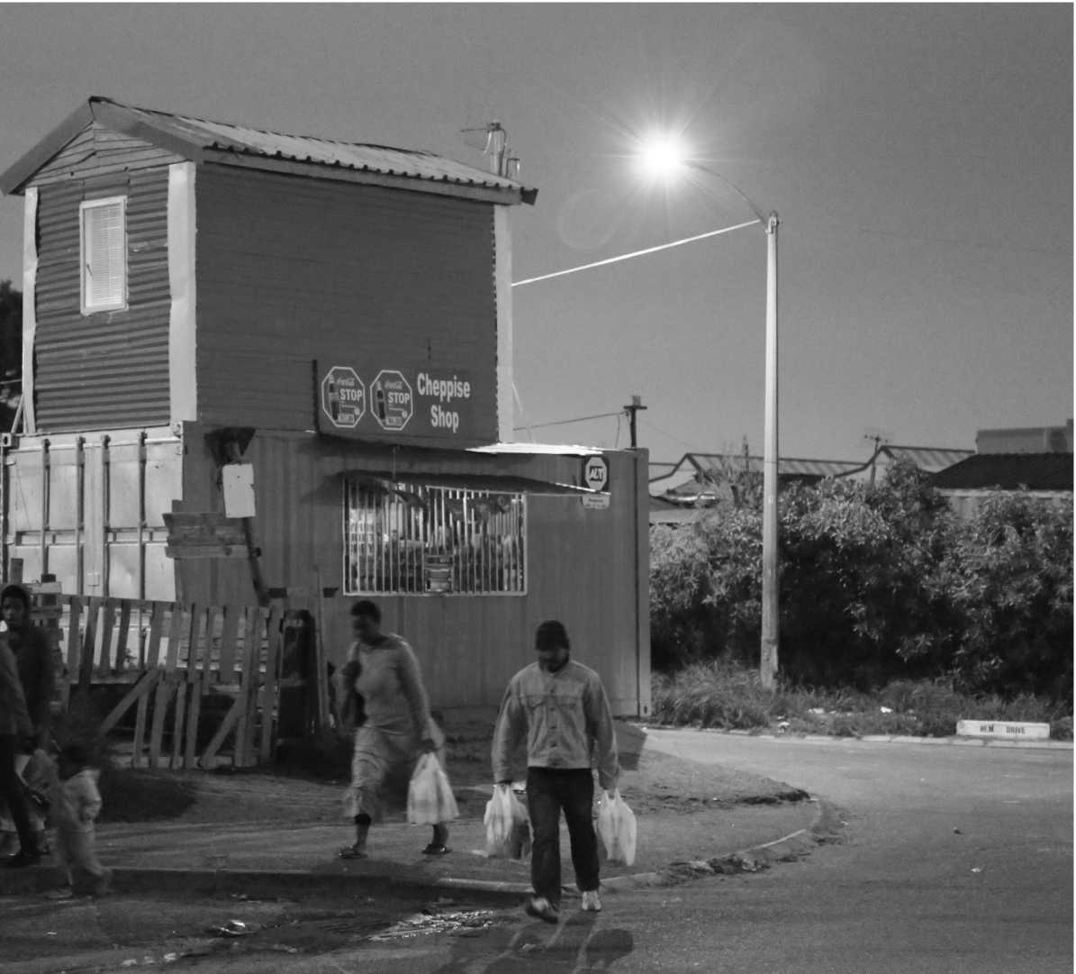

***METROBUS***

*JOHANNESBURG*

*It all comes together with a Castle*

**Traffic *Square£ TW^C SQUAREGj Milk Bar***

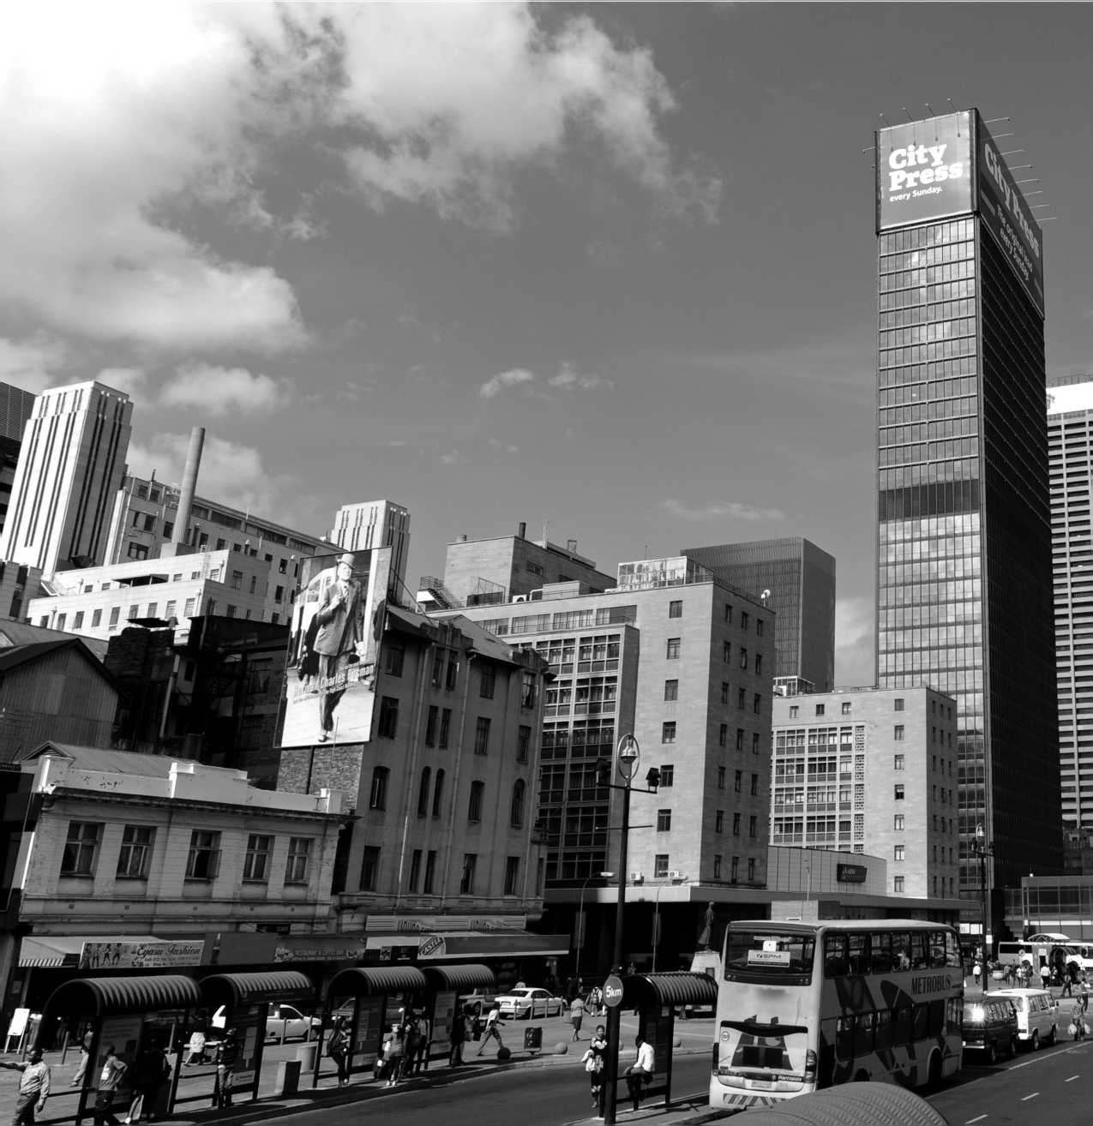

heavily urbanized sub-re­gion in Africa. These popu­lation movements have had especially significant impacts

— both in positive social, cul-

and lived experiences.

Conclusion

5

**T**

**HE RELATIONSHIP BETWEEN** migration, displacement and development is, of course, a complex one, and remains under­studied, especially in the context of movement between developing countries. Our emphasis in this study has been on the relationships between displacement/migration, poverty, and livelihoods, as well as the implications mobility has for labor market outcomes in the major destination coun­try of the region, South Africa.

As evidenced by the statistics and analysis, migration is a cen­tral component of people's livelihoods and protection strate­gies, both in the region, and Any interventions in response to these across the continent. Further,

Southern Africa is the most

results should account for perceptions

on the regions towns and cities

tural and economic ways, but they have also added to existing pressures on urban housing, health and education.

Significantly, our analysis finds that a one percent increase in the number of immigrants relative to the previous period raises local employment by 0.2 percent or that one immi­grant worker generates approximately two jobs for locals. The results and substantiations provided here, are significant for policy makers and development actors in South Africa and the wider region, and as such should be seriously considered. They provide a basis for substantive policy dialogue on how to enhance the development impacts of migration, especially for local job and wage outcomes and the South African economy.

Critically, although such quantitative analysis is instructive, perceptions and subjective evaluations of well-being of both locals and migrants, matters. As such, any interventions in response these results, should account for perceptions and lived experiences. Equally, the political will to advance poli­cies based on empirical evidence is a necessity for the achieve­ment of any sustainable and positive economic outcomes for local and migrants, alike.

Crucially, these results also provide an important foundation upon which further large-scale research can be developed. Such research can potentially complicate and enable a richer understanding for how migrants, refugees and asylum-seekers engage with the South African economy and the economic relationships they share with locals. This research, may for instance, consider how circular migration, informality, undoc­umented movements and gendered dimensions have implica­tions for economic relationships.

The political will to advance policies based on empirical evidence is a necessity for the achievement of any sustainable and positive economic outcomes for local and migrants, alike

|  |  |  |  |  |  |  |  |  |  |  |  |  |
| --- | --- | --- | --- | --- | --- | --- | --- | --- | --- | --- | --- | --- |
|  |  | |  |  |  |  |  | I *d |  | |  |  |
|  |  | |  | |  |  |  |  | | | | |
|  |  | |  |  |  |  |  |  |  |  |  |  |
|  | **i«** | »>«H ‘S- a |  |  |  |  | **jp-** *‘•.“tffif* |  | **f*c?; »** |
|  |  |  |  |  |  |  |  | H3 |  |  |  |  |

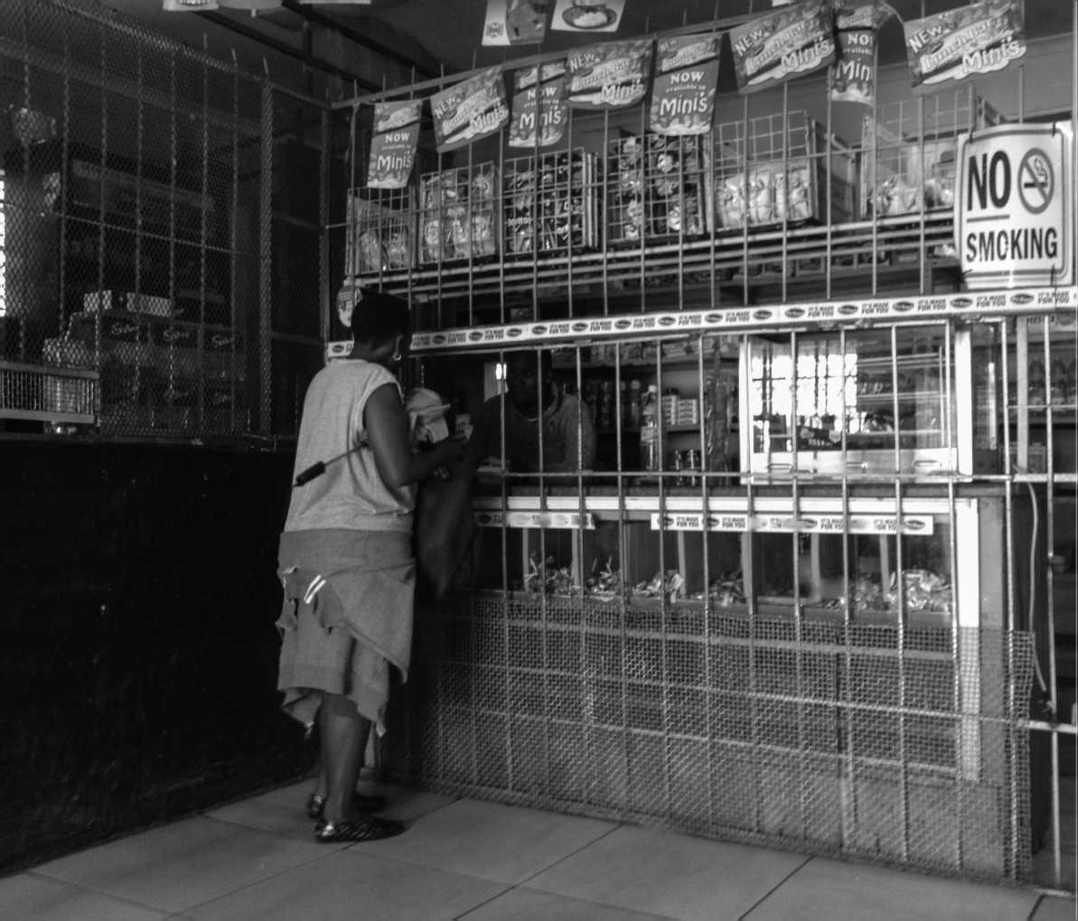

46 | Conclusion

Annexures

Annex 1: A Note on Terminology: Mixed

**Migration and Forced Displacement** As Van Hear, Brubaker and Bessa (2009, p.1) have pointed out: ‘In the analysis of migration a basic distinction is often made between those who choose to move and those who are forced to — that is, between ‘voluntary' and ‘forced' migrants. This distinction is maintained in the policy world, where the governance of international migration is shaped by the con­ceptual distinction between ‘voluntary' and ‘forced' migra­tion as mutually exclusive categories.' This is reflected in the bifurcated global governance architecture for migrants on the one hand, and refugees on the other. For instance, UNHCR's mandate is limited to refugees and other populations of con­cern (UNHCR Division of International Protection, 2013). The ILO has the responsibility for migrant workers (ILO 2006), and the IOM, which initially emerged as a logistical agency to aid refugees and displaced persons in the wake of the Second World War, has a general focus on the promotion of ‘humane and orderly migration' through migration man­agement (IOM 2017; Elie 2010).

The Convention Relating to the Status of Refugees, 1951 (henceforth, the Refugee Convention) defines ‘refugees' as those persons who seek protection in a second country, being unable or unwilling to avail themselves of the protection of their country of nationality ‘owing to well-founded fear of being persecuted for reasons of race, religion, nationality, membership of a particular social group or political opin- ion'.[34] In other words, they are persons who qualify for the protection of the UNHCR, regardless of whether or not they are in a country that is a party to the Refugee Convention or the 1967 Protocol Relating to the Status of Refugees, and irrespective of whether they have been recognized by the host country as a refugee under either of these instruments (IOM 2011; Frouws 2015, p.13). In practice, persons seeking safety from persecution need to apply for refugee status in a country other than their own, under the relevant national and interna­tional legal instruments. While they await a decision, they are usually described as ‘asylum-seekers'.

This study uses the expression ‘migrants and refugees' to describe mixed migration flows (see Frouws 2015, p.13). The distinctions between these categories are not always clear-cut (Turton 2003a;Van Hear 2011; World Bank 2016, p.3). Scholars and policymakers have long acknowledged that migration is driven by a combination of factors; most migrants and refu­gees make their decisions to migrate in response to ‘a complex set of external constraints and predisposing events' (Turton 2003b, p.9). These constraints and events vary in their signif­icance and impact, but there are elements of compulsion and choice in the decision-making of most migrants. For instance, for migrants ‘who are classed as ‘voluntary', especially towards the lower levels of the socio-economic scale — such as labor migrants from lower income backgrounds — there may be only limited choices available. Conversely, those classed as ref­ugees or asylum-seekers — that is ‘forced migrants' — may look to expand their life opportunities, especially once they have reached a place of relative safety; in a way they may transmute from refugees to economic or betterment migrants... those who flee a country where conflict, persecution, discrimina­tion and human rights abuses are rife, for example, may also be trying to escape dire economic circumstances — which them­selves feed into such conflict, persecution, discrimination and human rights abuse.' (Van Hear, Brubaker, and Bessa 2009, p.1) Large numbers of people also leave their country of origin for reasons that do not fall within the definition of ‘refugee'

**BOX 7:** Zimbabwe and Mixed Migration in Southern Africa

within the Refugee Convention, nor can these people be accurately described as voluntary economic migrants (Betts and Kaytaz 2009, p.1). The movement of many Zimbabweans into neighboring countries, scholars have argued, falls into this category (See Betts and Kaytaz 2009; Betts 2013).

A series of policy decisions including ‘fast-track' land reform, economic deprivation, a cholera outbreak, and political violence around contested elections led to massive internal migration within Zimbabwe, as well as outward migration into neighboring countries. By some estimates, between 1-1.5 million crossed into South Africa between 2000-2010 fleeing a humanitarian and live­lihoods crises, and some argue, famine conditions (Betts 2013; Howard-Hassmann 2005).

This movement was referred to as mixed migration or economic migration in South Africa, and for the most part, Zimbabweans were not accorded refugee status, or given the accompanying legal rights, although many continued to live in South Africa as asylum-seekers. Today, many continue to live in precarious socio-economic condi­tions, and remain subject to various forms of police action, detention and deportation (Polzer 2008).

**iNTIC**

**\*o^o^ale to Persons Under the A8o**

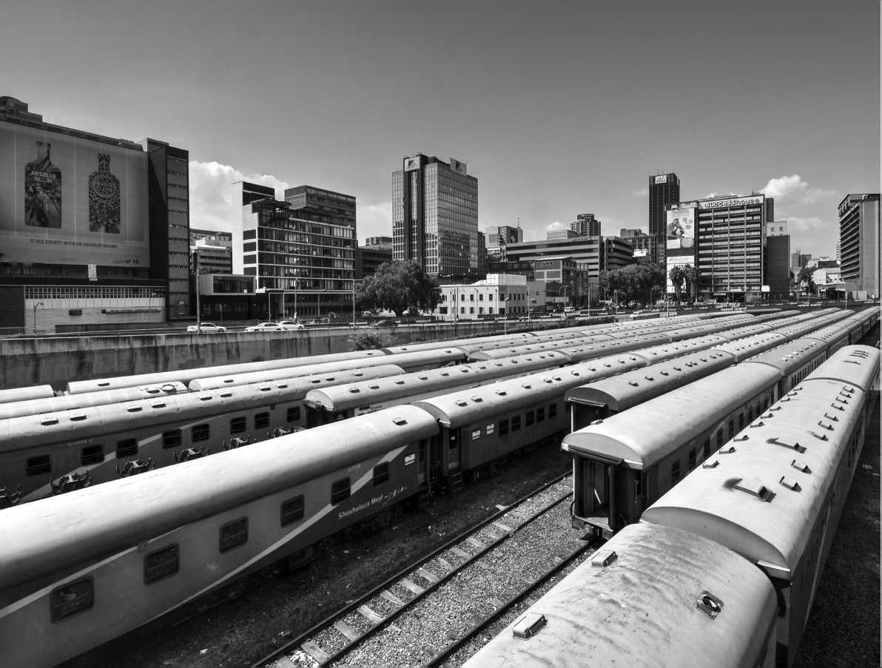

Annex 2: Methodology, Data and Limitations

METHODOLOGY

This study was undertaken by a cross-sectoral team of World Bank Group staff and consultants, and was funded through a World Bank Trust Fund[35] and implemented by the World Bank Group. The research process consisted of a literature review, analysis of the existing sources of quantitative data, econometric analysis, and field research in South Africa.

The literature review for the study took place in two parts. For all the sections other than Chapter 4 the literature search focused on identifying empirically grounded, social science literature (both qualitative and quantitative) on the causes of, trends in, and impacts of migration and displacement in Southern Africa. The search process itself consisted of two stages: a database driven search, and a ‘snowball' search which augmented the database search and also formed the basis of our study of the ‘grey' literature, such as working papers, con­cept notes, donor reports, policy documents and briefings.[36] Only studies published in English were selected (this was an unavoidable limitation given resource constraints), and greater emphasis was placed on studies that contained or referenced local level empirical data.

Quantitative data on forced displacement and migration (which forms the basis for the descriptive statistics set out in chapter 2 of this report) was collected from UNHCR's Population Statistics database and UNDESA's International Migrant Stock database, as well as other international and national databases and reports. The limitations of data in the field of migration and displacement are well known (see Crisp 1999; Landau and Achiume 2017) but some of the specific limitations of data in Southern Africa and concerns around its use are discussed below.

For chapter 3 which is focused on the laws and policies gov­erning migration and displacement in Southern Africa, the researchers prepared a grid of relevant laws and policies. These were organized according to whether they were international legal instruments, regional treaties or national laws or policies. A special effort was made to try and examine laws which were not directly related to mobility, but which have impli­cations for migrants' and refugees' abilities to access services, for instance, health, education and housing. For Angola and Mozambique, this information was drawn mostly from sec­ondary sources.

In addition to the desk research and quantitative data analy­sis, members of the team conducted field research in South Africa, in February-March 2018. Discussions were held with a wide range of stakeholders, such as national, provincial and local government officials, representatives of nongovernmen­tal organizations (NGOs) (both advocacy NGOs and project implementers), representatives from multilateral organizations, such as the UNHCR and IOM, and academics and other researchers. Some of these organizations work directly with refugees and migrants as service providers or advocates. A full list of organizations and persons interviewed is set out in Annexure 2. The team met with some South Africa-based refugees and asylum-seekers during its meetings with NGO's, but regrettably due to time and budgetary constraints, it did not conduct formal interviews with refugees and migrants.

It is worth noting that research on refugees and migrants in Southern Africa remains challenging, and raises major meth­odological and ethical concerns (Jacobsen and Furst Nichols 2011; Jacobsen and Landau 2003a; 2003b). Conducting inter­views without systematic sampling techniques could lead to skewed data and results.[37] Researchers also run the risk of revealing sensitive or damaging information about the sub­jects of their study. Both these concerns came up on several occasions during the field visit. Methodologically, of course, research on forced displacement usually takes the policy cat­egories of ‘refugee', ‘asylum-seeker', ‘voluntary migrant' etc., as its point of departure. This can (but need not) result in causal links being drawn between the category of analysis, and revealed vulnerabilities. For instance, intimate partner violence faced by female asylum-seekers in inner city Johannesburg may be causally linked to the status of these women as asy­lum-seekers, instead of being connected to class or patriarchy more generally (Kihato 2011; 2013).[38] In this vein, the team's research approach was attentive to the following idea: a care­ful parsing of how different facets of a refugee's or migrant's identity intersect in a given social context, is necessary for a nuanced understanding of migration and displacement, and as a precondition for effective policymaking.

**MIGRATION, DISPLACEMENT AND LOCAL JOBS** Chapter 4 on Migration and Jobs in South Africa included an extensive review of the academic literature on the labor market impact of migrants in destination countries as well as specific papers focusing on South Africa's immigration. Studies on immigration mostly rely on empirical estimations as opposed to general equilibrium models. This review helped identify the key econometric approaches used to estimate the impact of immigrants and select the relevant methodology for South Africa. In addition, most studies on immigration focus on the North-South labor mobility and only a few papers analyze South-South migration as in the case of South Africa. The review of the latter helped identify the existing gaps and propose potential areas for improvement. Finally, the team also researched the immigration history of South Africa since the 1990s to better understand the validity of the estimation methodology that relies on an *instrumental variable* approach and past allocations of immigrants across provinces and industries.

The team then surveyed the existing micro-data in South Africa that could be used to provide estimates on the impact of immigration on the labor market outcomes such as employ­ment and wages. The following data sources were used for this analysis: ten percent samples of the South Africa Census data for 1996, 2001 and 2011 and the Post-Apartheid Labor Market Series (PALMS). The South African Census data provide information on the number of immigrant and local workers, their education level, industry, age, and residence. PALMS includes data on labor, wage, and self-employment earnings; it is annual cross-sectional data for labor market and household indicators in South Africa between 1994 and 2017, based on microdata from 61 household and labor force surveys conducted by Statistics South Africa. The team put a lot of effort to carefully merge these several datasets and define variables of interest. Applying data on labor earnings from PALMS instead of using data on total income from the Census is one of the key contributions of this section to the literature as it provides more precise measurement of labor income.

Finally, during the course of the study, the team has shared preliminary results with several World Bank economists across Global Practices, as well as colleagues working on South Africa and Zimbabwe through several internal consultative techni­cal reviews. These discussions helped the team strengthen the interpretation of the findings and develop plausible explana­tions to substantiate the results.

DATA LIMITATIONS AND DATA USE

IN SOUTHERN AFRICA

Existing data on migration and displacement in Southern Africa is of uneven quality, and is far from comprehensive when it comes to capturing the dynamics of movement. Where data does exist, it is often outdated. This is true even in South Africa, which has the best data collection capacity (and systems) in the region (Budlender 2013). In other countries, national census data, and other surveys are of variable quality (Kihato forthcoming). The growth of undocumented migra­tion in the region has made it even more difficult for official statistics to capture the full extent of migration and displace­ment. In such conditions, only rough estimates and projections are possible. In general, however, data collection on migration and displacement reflects the bifurcation between ‘voluntary migration' and ‘forced displacement'.

The process of compiling data for large databases such as those maintained by UNDESA (the International Migrant Stock database), and UNHCR (Population Statistics) is complicated and challenging in almost all circumstances, and largely reliant on national authorities. In Southern Africa, the specific chal­lenges are methodological and political, and sometimes a direct result of migrants' and refugees' desire to remain ‘invisible'.

UNDESA estimates the international migrant stock (at mid­year) for each country based on data obtained primarily from population censuses, other population registers and nationally representative surveys. In its databases, international migrants are generally equated with the foreign-born population. However, where national authorities do not collect data on place of birth, international migrants are equated with for­eign citizens. This latter approach has important shortcom­ings: in countries where citizenship is conferred mainly on the basis of *jus sanguinis* (that is, on the basis of citizenship of an individual's parents), people who were born in the coun­try of residence may be included in the number of interna­tional migrants even though they may have never lived abroad (UNDESA 2017).[39]

Table 6 shows the sources used to compute the total migrant stock for each of the countries considered by this study. ‘B' indi­cates that estimates were derived from data on the foreign-born population; ‘C' indicates that estimates were derived from data on foreign citizens, and ‘R' indicates that the number of ref­ugees or persons in refugee-like situations as reported by the

**TABLE 6:** Sources of UNDESA's migrant data in Southern Africa (UNDESA 2017)

|  |  |
| --- | --- |
| **COUNTRY** | **TYPE OF DATA** |
| Angola | B R |
| Botswana | C |
| Lesotho | C R |
| Malawi | B R |
| Mozambique | B R |
| Namibia | B |
| South Africa | B R |
| Swaziland | B R |
| Zambia | B R |
| Zimbabwe | B R |

Office of the United Nations High Commissioner for Refugees (UNHCR) were added to the estimates (UNDESA 2017).[40]

The coverage of refugees in population censuses is uneven. In countries such as South Africa, where refugees and asy­lum-seekers have been allowed to integrate, they are normally covered by the population census as any other international migrant. However, in all other countries in the region, ref­ugees lack freedom of movement and are required to reside in camps or other designated areas (although enforcement varies). In these cases, population censuses may ignore or par­tially count refugees. Furthermore, when refugee flows occur rapidly in situations of conflict, it is uncommon for a popu­lation census to take place soon after and to reflect the newly arrived refugee population. Among countries in the region, only Malawi, Mozambique, Swaziland and Lesotho have con­ducted very recent population and housing censuses.

For data on forced displacement, this study relies on data collected by UNHCR and the Geneva-based Internal Displacement Monitoring Centre (IDMC). The UNHCR collects yearly data on the extent of forced displacement, including figures on refugees, asylum-seekers, IDPs (though only those assisted by the UNHCR itself), returnees, reset­tlement applications, as well as basic demographic data on gender, age, and location. This data is collected primarily by direct registration, but also from national governments, NGO's, UN-OCHA reports, UNHCR field offices, and other *ad-hoc* surveys and censuses, and some of it is made publicly available.[41] Where national governments provide the data, different countries may use different definitions and methodologies to count refugees and asylum-seekers. This can lead to radically different estimates over time. For instance, in South Africa, UNHCR recorded 1,079,482 asylum-seekers in mid-2016, but revised this number to 215,860 in mid-2017 (UNHCR 2018). This was because the South African DHA's information systems had continued to count asylum appli­cations which were no longer active (for an array of reasons discussed in greater detail in Section 3).[42]

When refugees and migrants live among the local population in low income urban areas, as in the case in South Africa, some may choose to avoid contact with national authori­ties, UNHCR and other aid agencies — preferring to remain ‘invisible'. Others may not know about organizations which are able to assist them, or may be afraid to come forward if they are undocumented, fearing detention and deportation (Jacobsen and Furst Nichols 2011, p.7). In Zambia, as Bakewell has noted in his study of ‘self-settled' Angolan refugees, staying outside camps without making themselves known to author­ities unlocked greater opportunities for refugees to earn live­lihoods, and integrate into local societies (Bakewell 2000; Bakewell 2014).

Registration allows refugees and asylum-seekers to obtain legal status, and remains essential to access formal employment and specific targeted assistance (Jacobsen 2014). In practice, however, (and as the researchers were told multiple times in South Africa) documentation does not provide effective pro­tection in contexts characterised by harsh and often arbitrary policing, corruption, bureaucratic discretion, and anti-mi­grant sentiment (see Landau 2014).[43] Where refugees and asy­lum-seekers have to seek employment in the informal sector, or live in areas far from the writ of the state, legal-status is of limited value (Bakewell 2014). Needless to say, this com­plicates the process of data collection. It also raises an ethical question — that is, how to balance the need for data to ensure effective service delivery while giving effect to the agency of the displaced.[44]

Better data on migration and displacement has long been sought by policymakers and by national governments. Accurate data allows for better assessment of the needs of dis­placed and mobile populations, and facilitates better delivery of services. On the other hand, the collection of data on migration and displacement remains deeply political, and increased data collection efforts do not always lead to poli­cies which protect the rights of refugees and asylum-seek­ers (Crisp 1999; Crisp 2018). For instance, states increasingly view migration and displacement through the lens of national security. While this is certainly their national prerogative, it is clear that better data may be used to control movement or restrict asylum (Crisp 2018).[45] Further, national policy-mak­ers may not have the capacity (or incentives) to use available data effectively (Landau and Duponchel 2011). As the research team inferred from its meetings in South Africa, different levels of government, and different departments and ministries have diverse motivations for wanting better data on migration. Some departments (especially at the municipal level) noted that they do not have the capacity to use the data for pol­icy-making, nor sufficient access to the policy-making pro­cess itself. These range from service delivery (such as access to education), assessing the protection needs of unaccompanied minors, to eviction from occupied buildings, and deportation (Fassin, Wilhelm-Solomon, and Segatti 2017). Consequently, organizations and researchers working on migration and dis­placement ought to go beyond calls for more and better data, and consider the actual uses of data.

Finally, a note on data sources in South Africa. Data on migra­tion and displacement in South Africa comes from three sources (see Budlender 2013; 2014)[46]:

**a. Governmental sources**: This includes Statistics South Africa (StatsSA), which conducts the census, community surveys (in-between censuses), and the Quarterly Labor Force Survey; the Department of Home Affairs — which collects and publishes data on asylum-seekers, deporta­tions, and different categories of visas and permits issued; the Department of Labour — which conducts establish­ment surveys and plays a role in work-p ermit applications; and finally, the data collected by different provincial and municipal governments.[47]

1. **Non-governmental administrative sources**: This includes the Employment Bureau of Africa (TEBA) which continues to be the recruitment agency for the formal migrant labor system prevalent in the mining sector.
2. **Academic and policy sources**: The Southern African Migration Project (SAMP) and the Africa Centre for Migration and Society (ACMS) are foremost among these and have con­ducted several surveys on migration in the region.

Despite these sources, researchers have noted that only ‘approximate trends' can be identified (Budlender 2013, p.83) and by and large, data remains inadequate and lim­ited (Fauvelle-Aymar 2014). Some laudable recent initiatives aim to improve data collection: StatsSA and the Department of Social Development have created an ‘Urbanization and Migration Forum' which will, among other things, aim to improve data collection on migration in South Africa. Various multilateral organizations — namely ILO, IOM, UNHCR and UNODC are also looking to strengthen data collection sys­tems on labor migration at the SADC level.

Annex 3: List of Interviewees in South Africa

|  |  |
| --- | --- |
| **ORGANIZATION** | **INTERVIEWEE(S)** |
| Church World Service | * Ngoto Libula Phily (Refugee) * Paul Kakera Mwanza   (Asylum Seeker)   * Pauline Nfirata (Asylum Seeker) * Roy (Refugee) * Thabile Maphosa * Kathyn Gerber * Jean Guy Kwuimi * Alphonse |
| Jesuit Refugee Services | • Tim Smith |
| Medecins Sans Frontieres | * Garret Barnwell * Liesbeth Schockaert |
| City of Johannesburg | • Robinson Sathekge |
| Gauteng Provincial Government | • Nalini Naicker |
| Southern African Litigation Centre | • Kaajal Ramjathan Keogh |
| ACMS | * Jean Pierre Misago * Loren Landau |
| University of Johannesburg | • Caroline Wanjiku Kihato |
| UNFPA | • Celine Mazars |
| StatsSA | • Diego Iturralde |
| Department of Social Development, South Africa | • Jacques van Zuydam |
| University of Pretoria | • Christopher Nshimbi |
| UNHCR | * Matlotleng Matlou * Madalena Hogg * Cecilie Becker-Christensen Saenz Guerrero |
| Consortium for Refugees and Migrants in South Africa | • Thifulufheli Sinthumule |
| Lawyers for Human Rights | * Kayan Leung * Jacob van Garderen |
| Department of Higher Education and Training, South Africa | • Diana Parker |
| National Planning Commission, South Africa | • Elias Masilela |
| IOM | • Richard Ots |
| ILO | • Redha Ameur |
| Department of Home Affairs, South Africa | • Mandla Madumisa |

Annex 4: References

BIBLIOGRAPHY

Ackermann, Marilize. 2017*. Unaccompanied and Separated Foreign Children in the Western Cape, South Africa: Exploring (the lack of) durable solutions for children in informal relations of care*. Cape Town: Scalabrini Centre of Cape Town. [http://scalabrini.org.za/wp-content/uploads/2017/10/Unaccom-](http://scalabrini.org.za/wp-content/uploads/2017/10/Unaccompanied-children-revised-5.0-Printversion-.pdf) [panied-children-revised-5.0-Printversion-.pdf](http://scalabrini.org.za/wp-content/uploads/2017/10/Unaccompanied-children-revised-5.0-Printversion-.pdf).

ACMS. 2014. *Understanding human trafficking*. Issue Brief No. 10. Johan­nesburg: African Centre for Migration and Society, University of the Witwatersrand.

Afrobarometer. 2016. *Immigration remains a challenge for South Africa's govern­ment and citizens.* Dispatch No. 72.

Altonji, J. and D. Card. 1991. “The effects of immigration on the labor market outcomes of less-skilled natives.” NBER Chapters, in Immigration, Trade, and the Labor Market, ed. J. Abowd and R. Freeman, 201-234, National Bureau of Economic Research.

Amit, Roni. 2012. *All Roads Lead to Rejection: Persistent Bias and Incapacity in South African Refugee Status Determination*. ACMS Research Report, June. Johannesburg: African Centre for Migration & Society, University of the Witwatersrand

Amit, Roni. 2015. *Queue here for Corruption: Measuring Irregularities in South Africa's Asylum System*. July. Johannesburg: Lawyers for Human Rights and the African Centre for Migration and Society, University of the Witwatersrand. [http://www.lhr.org.za/publications/queue-here-corrup-](http://www.lhr.org.za/publications/queue-here-corruption-measuring-irregularities-south-africa%E2%80%99s-asylum-system) [tion-measuring-irregularities-south-africa%E2%80%99s-asylum-system](http://www.lhr.org.za/publications/queue-here-corruption-measuring-irregularities-south-africa%E2%80%99s-asylum-system).

Arrighi, Giovanni, Nicole Aschoff, and Ben Scully. 2010. “Accumulation by Dispossession and Its Limits: The Southern Africa Paradigm Revisited.” *Studies in Comparative International Development* 45: 410-438.

Bakewell, Oliver. 2000. “Repatriation and Self-Settled Refugees in Zam­bia: Bringing Solutions to the Wrong Problems.” *Journal of Refugee Studies* 13, no. 4: 356-373.

Bakewell, Oliver. 2000. “Repatriation and Self-settled Refugees in Zambia: Bringing Solutions to the Wrong Problems.” *Journal of Refugee Studies* 13, no.4: 356-73.

Bakewell, Oliver. 2008a. “'Keeping Them in Their Place': the ambivalent relationship between development and migration in Africa.” *Third World Quarterly* 29, no.7:1341-1358.

Bakewell, Oliver. 2008b. “Research Beyond the Categories: The Impor­tance of Policy Irrelevant Research into Forced Migration.” *Journal of Refugee Studies* 21, no.4: 433-453

Bakewell, Oliver. 2014. “Encampment and Self-Settlement.” In *The Oxford Handbook of Refugee and Forced Migration Studies*, edited by Ele­na Fiddian-Qasmiyeh, Gil Loescher, Katy Long, and Nando Sigona, 128-138. Oxford: Oxford University Press. DOI: 10.1093/oxford- hb/9780199652433.013.0045.

Bamu, Pamhidzai. 2014. *An analysis of SADC migration instruments in light of ILO and UN principles on labour migration*. Second Draft Report. [http://](http://www.ilo.org/wcmsp5/groups/public/---africa/---ro-addis_ababa/---ilo-pretoria/documents/meetingdocument/wcms_239819.pdf) [www.ilo. org/wcmsp5/groups/public/---africa/---ro-addis_ababa/---ilo-](http://www.ilo.org/wcmsp5/groups/public/---africa/---ro-addis_ababa/---ilo-pretoria/documents/meetingdocument/wcms_239819.pdf) [pretoria/documents/meetingdocument/wcms_239819.pdf](http://www.ilo.org/wcmsp5/groups/public/---africa/---ro-addis_ababa/---ilo-pretoria/documents/meetingdocument/wcms_239819.pdf).

Basso, G. and G. Peri. 2015. “The association between immigration and labor market outcomes in the United States.” IZA Discussion Papers, 9436. Betts, Alexander and Esra Kaytaz. 2009. *National and international responses to the Zimbabwean exodus: implications for the refugee protection regime*. Research Paper No. 175, New Issues in Refugee Research. Geneva: UNHCR.

Betts, Alexander. 2013. *Survival Migration: Failed Governance and the Crisis of Displacement*. Ithaca, NY: Cornell University Press.

Bolt, Maxim. 2012. “Waged Entrepreneurs, Policed Informality: Work, the Regulation of Space and the Economy of the Zimbabwean South African Border.” *Africa* 82, no.1: 111-130.

Borjas, G. 2003. “The labor demand curve is downward sloping: Reex­amining the impact of immigration on the labor market.” *The Quarterly Journal of Economics*, 118(4):1335-1374.

Borjas, G. 2006. “Native internal migration and the labor market impact of immigration.” *Journal of Human Resources*, 41, no. 2: 221-258.

Borjas, G., R. Freeman and L. Katz. 1996. “Searching for the effect of im­migration on the labor market.” *American Economic Review*, 86(2):246-251.

Botea, Ioana et al., 2018. *Female Migration in Lesotho; Determinants and Op­portunities*. Policy Research Working Paper 8301, World Bank Group.

Bracking, Sarah and Lloyd Sachikonye. 2006. *Remittances, poverty reduction and the informalisation of household wellbeing in Zimbabwe*. GPRG-WPS-045. Global Policy Research Group. [http://www.gprg.org/pubs/workingpa-](http://www.gprg.org/pubs/workingpapers/pdfs/gprg-wps-045.pdf) [pers/pdfs/gprg-wps-045 .pdf](http://www.gprg.org/pubs/workingpapers/pdfs/gprg-wps-045.pdf) .

Broussard, Nzinga. 2017. “Immigration and the labor market outcomes of natives in developing countries: A case study of South Africa.” *Economic Development and Cultural Change* 65 no. 3: 389-424.

Budlender, Deborah. 2013. *MiWORC Report N°2. Improving the quality of available statistics on foreign labour in South Africa: Existing datasets.* Johannes­burg: African Centre for Migration & Society, University of the Witwa- tersrand. <http://www.miworc.org.za/docs/MiWORC-Report-2.pdf>.

Budlender, Deborah. 2014. *MiWORC Report N°5. Migration and employ­ment in South Africa: Statistical analysis of the migration module in the Quarterly Labour Force Survey, third quarter 2012*. Johannesburg: African Centre for Migration & Society, University of the Witwatersrand. [http://www.](http://www.miworc.org.za/docs/MiWORC-Report-5.pdf) [miworc.org.za/docs/MiWORC-Report-5.pdf](http://www.miworc.org.za/docs/MiWORC-Report-5.pdf).

Burawoy, Michael. 1976. “The Functions and Reproductions of Migrant Labour: Comparative Material from Southern Africa and the United States.” *American Journal of Sociology* 81, no. 5: 1050-1087.

Campbell, Eugene and Jonathan Crush. 2012. *Unfriendly Neighbours: Con­temporary Migration from Botswana to Zimbabwe*. Migration Policy Brief No. 61. Cape Town: SAMP.

Card, D. 2001. “Immigrant inflows, native outflows, and the local labor market impacts of higher immigration.” *Journal of Labor Economics*, 19, no. 1: 22-64.

Castles, Stephen, Hein de Haas, and Mark Miller. 2013. *The Age of Migra­tion: International Population Movements in the Modern World*, 5th ed. London: Palgrave Macmillan.

Castles, Stephen. 2003. “Towards a Sociology of Forced Migration and Social Transformation.” *Sociology* 37, no.1: 13-34.

Chikanda, Abel. and Tawodzera, Godfrey. 2017. *Informal Entrepreneurship and Cross-Border Trade between Zimbabwe and South Africa.* SAMP Migration Policy Series No 74. Cape Town: SAMP.

Chimni, Bhupinder. 2009. “The Birth of a ‘Discipline': From Refugee to Forced Migration Studies.” *Journal of Refugee Studies* 22, no.1: 11-29.

Classsen, Christopher. 2017. *Explaining South African Xenophobia*. Working Paper No. 173. Afrobarometer.

Comaroff, John, and Jean Comaroff. 1987. “The madman and the migrant: Work and labor in the historical consciousness of a South African peo­ple.” *American ethnologist* 14, no. 2: 191-209.

Crisp, Jeff, and Esther Kiragu. 2010. *Refugee Protection and International Mi­gration: A Review of UNHCR's Role in Malawi, Mozambique and South Africa*. PDES/2010/10. Geneva: UNHCR Policy Development and Evaluation Service. [http://www.unhcr.org/en-us/research/evalreports/4c629c4d9/](http://www.unhcr.org/en-us/research/evalreports/4c629c4d9/refugee-protection-international-migration-review-unhcrs-role-malawi-mozambique.html) [refugee-protection-international-migration-review-unhcrs-role-mala-](http://www.unhcr.org/en-us/research/evalreports/4c629c4d9/refugee-protection-international-migration-review-unhcrs-role-malawi-mozambique.html) [wi-mozambique.html](http://www.unhcr.org/en-us/research/evalreports/4c629c4d9/refugee-protection-international-migration-review-unhcrs-role-malawi-mozambique.html).

Crisp, Jeff. 1999. *“Who has counted the refugees?” UNHCR and the politics of numbers*. Working Paper No. 12, New Issues in Refugee Research. Geneva: UNHCR. [http://www.unhcr.org/en-us/research/working/3ae6a0c22/](http://www.unhcr.org/en-us/research/working/3ae6a0c22/counted-refugees-unhcr-politics-numbers-jeff-crisp.html) [counted-refugees-unhcr-politics-numbers-jeff-crisp.html](http://www.unhcr.org/en-us/research/working/3ae6a0c22/counted-refugees-unhcr-politics-numbers-jeff-crisp.html).

Crisp, Jeff. 2008. *Beyond the nexus: UNHCR's evolving perspective on refugee protection and international migration*. Research Paper No. 155, New Issues in Refugee Research. Geneva: UNHCR. [http://www.unhcr.org/en-us/](http://www.unhcr.org/en-us/research/working/4818749a2/beyond-nexus-unhcrs-evolving-perspective-refugee-protection-international.html) [research/working/4818749a2/beyond-nexus-unhcrs-evolving-perspec-](http://www.unhcr.org/en-us/research/working/4818749a2/beyond-nexus-unhcrs-evolving-perspective-refugee-protection-international.html) [tive-refugee-protection-international.html](http://www.unhcr.org/en-us/research/working/4818749a2/beyond-nexus-unhcrs-evolving-perspective-refugee-protection-international.html).

Crisp, Jeff. 2018. “Beware the Notion that Better Data Lead to Better Out­comes for Refugees and Migrants.” Chatham House Expert Comment, 9 March. [https://www.chathamhouse.org/expert/comment/beware-no-](https://www.chathamhouse.org/expert/comment/beware-notion-better-data-lead-better-outcomes-refugees-and-migrants) [tion-better-data-lead-better-outcomes-refugees-and-migrants](https://www.chathamhouse.org/expert/comment/beware-notion-better-data-lead-better-outcomes-refugees-and-migrants).

Crush et al. 2010. *Migration, Remittances and ‘Development' in Lesotho.* Cape Town: SAMP.

Crush, Jonathan and Abel Chikanda. 2014. “Forced Migration in Southern Africa.” In *The Oxford Handbook of Refugee and Forced Migration Studies*, edited by Elena Fiddian-Qasmiyeh, Gil Loescher, Katy Long, and Nando Sigona, 554-569. Oxford: Oxford University Press. DOI: 10.1093/oxford- hb/9780199652433.013.0045.

Crush, Jonathan and Bruce Frayne. 2007. “The migration and develop­ment nexus in Southern Africa.” *Development Southern Africa* 24, no. 1: 1-23.

Crush, Jonathan and McCordic, Cameron. 2017. *Comparing Refugee and South African Migrant Enterprise in the Urban Informal Sector.* AHMR,Vol. 3, No. 2, May-August 2017 — Special Issue.

Crush, Jonathan, Belinda Dodson, Vincent Williams, and Daniel Tevera.

2017. *Harnessing Migration for Inclusive Growth and Development in Southern Africa*. Southern African Migration Program Special Report. Waterloo, Ontario: SAMP. [http://samponline.org/wp-content/uploads/2017/06/](http://samponline.org/wp-content/uploads/2017/06/SAMPSpecialReport.pdf) [SAMPSpecialReport.pdf](http://samponline.org/wp-content/uploads/2017/06/SAMPSpecialReport.pdf).

Crush, Jonathan. 1993. ““The Long-Averted Clash”: Farm Labour Com­petition in the South African Countryside.” *Canadian Journal of African Studies* 27, no. 3: 404-423.

Crush, Jonathan. 2011. *Complex Movements, Confused Responses: Labour Migration in South Africa*. SAMP Policy Brief No. 25. [http://samponline.](http://samponline.org/migration-policy-briefs/) [org/migration-policy-briefs/](http://samponline.org/migration-policy-briefs/).

de Haas, Hein. 2012. “The Migration and Development Pendulum: A

CriticalView on Research and Policy.” *International Migration* 50, no. 3:

8-25. doi:10.1111/j.1468-2435.2012.00755.x.

de Waal, Alex. 2018.*Mass Starvation: The History and Future of Famine*. Cam­bridge: Polity Press.

Department of Home Affairs, Republic of South Africa. 2017. *White Paper on International Migration for South Africa*. July. Pretoria: Department of Home Affairs. [http://www.dha.gov.za/WhitePaperonInternationalMigra-](http://www.dha.gov.za/WhitePaperonInternationalMigration-20170602.pdf) [tion-20170602.pdf](http://www.dha.gov.za/WhitePaperonInternationalMigration-20170602.pdf).

DeWind, Josh. 2007. “Response to Hathaway.” *Journal of Refugee Studies* 20, no.3: 381-390.

Dodson, Belinda. 1998. *Women on the move: Gender and Cross-border Migra­tion to South Africa*. SAMP Policy Paper. Idasa: Cape Town. [http://sampon-](http://samponline.org/wp-content/uploads/2016/10/Acrobat9.pdf) [line.org/wp-content/uploads/2016/10/Acrobat9.pdf](http://samponline.org/wp-content/uploads/2016/10/Acrobat9.pdf).

Dodson, Belinda. 2001. “Discrimination by Default? Gender Concerns in South Africa Migration Policy.” *Africa Today* 48, no.3: 72-89.

Dzingirai, Vupenyu, Eva-Maria Egger, Loren Landau, Julie Litchfield,

Patience Mutopo and Kefasi Nyikahadzoi. 2015. *Migrating out of Poverty in Zimbabwe*. Working Paper 29. Brighton: Migrating out of Poverty Re­search Consortium, University of Sussex.

Dzingirai, Vupenyu, Patience Mutopo and Loren Landau. 2014. *Confirma­tions, Coffins and Corn: Kinship, Social Networks and Remittances from South Africa to Zimbabwe*. Working Paper 18. Brighton: Migrating out of Poverty Research Consortium, University of Sussex.

Elie, Jerome. 2010. “The historical roots of cooperation between the UN High Commissioner for Refugees and the International Organization for Migration.” *Global Governance: A Review of Multilateralism and International Organizations* 16, no. 3: 345-360.

Ellis, Stephen. 1999. “The New Frontiers of Crime in South Africa.” In

*The Criminalization of the State in Africa,* edited by Jean-Francois Bayart, Stephen Ellis and Beatrice Hibou, 49-68. Oxford: James Currey.

Evans, Laura. 2012. “South Africa's Bantustans and the Dynam­ics of ‘Decolonisation': Reflections on Writing Histories of the Homelands.” *South African Historical Journal* 64, no. 1: 117-137, DOI: 10.1080/02582473.2012.655941.

Fassin, Didier, Matthew Wilhelm-Solomon, and Aurelia Segatti. 2017. “Asylum as a Form of Life: The Politics and Experience of Indetermina­cy in South Africa.” *Current Anthropology* 58, no. 2: 160-187. [https://doi.](https://doi.org/10.1086/691162) [org/10.1086/691162](https://doi.org/10.1086/691162).

Fauvelle-Aymar, C. 2014. “The welfare state, migration, and voting rights.” *Public Choice*, 159, no. 1:105-120.

Fauvelle-Aymar, Christine. 2014. *MiWORC Report N°6. Migration and employment in South Africa: An econometric analysis of domestic and international migrants (QLFS (Q3) 2012).* Johannesburg: African Centre for Migration & Society, University of the Witwatersrand. [http://www.miworc.org.za/](http://www.miworc.org.za/docs/MiWORC-Report-6.pdf) [docs/MiWORC-Report-6.pdf](http://www.miworc.org.za/docs/MiWORC-Report-6.pdf).

Feller, Erika. 2005. “Refugees are not Migrants.” *Refugee Survey Quarterly* 24, no.5: 27-35.

Ferguson, James. 1994. “The Anti-Politics Machine: “Development” and Bureaucratic Power in Lesotho” *The Ecologist* 24, no. 5: 176 — 181.

Ferguson, James. 1999. *Expectations of Modernity: Myth and Meanings of Urban Life on the Zambian Copperbelt*. Berkeley, CA: University of California Press.

Ferguson, James. 2013. “Declarations of dependence: labour, personhood, and welfare in southern Africa.” *Journal of the Royal Anthropological Institute* 19, no. 2: 223-242.

Ferguson, James. 2015. *Give a Man a Fish: Reflections on the New Politics of Distribution*. Durham and London: Duke University Press.

Fine, Ben and Zavareh Rustomjee. 1996. *The Political Economy of South Afri­ca: From Minerals Energy Complex to Industrialization*. London: Westview Press.

Fioramonti, Lorenzo and Chris Nshimbi. 2016. *Regional Migration Gover­nance in the African Continent. Current state of affairs and the way forward*. sef: Development and Peace Foundation Study. Bonn: Stiftung Entwicklung und Frieden (sef:). [http://www.sef-bonn.org/fileadmin/Die_SEF/Pub-](http://www.sef-bonn.org/fileadmin/Die_SEF/Publikationen/SB/sb_studie-2016_en.pdf) [likationen/SB/sb_studie-2016_en.pdf](http://www.sef-bonn.org/fileadmin/Die_SEF/Publikationen/SB/sb_studie-2016_en.pdf).

Freedom House. 2017. *Xenophobia and Outsider Exclusion: Addressing Frail Social Cohesion in South Africa's Diverse Communities*. [https://freedomhouse.](https://freedomhouse.org/sites/default/files/South_Africa_Community_Social_Cohesion_Profiles_Synthesis%20Report.pdf) [org/sites/default/files/South_Africa_Community_Social_Cohesion_Pro-](https://freedomhouse.org/sites/default/files/South_Africa_Community_Social_Cohesion_Profiles_Synthesis%20Report.pdf) [files_Synthesis%20Report.pdf](https://freedomhouse.org/sites/default/files/South_Africa_Community_Social_Cohesion_Profiles_Synthesis%20Report.pdf).

Freund, Bill. 1984. “Forced resettlement and the political economy of South Africa.” *Review of African Political Economy* 11, no. 29: 49-63. DOI: 10.1080/03056248408703567.

Frouws, Bram and Christopher Horwood. 2017. *RMMS Briefing Paper 3: Smuggled South*. March. Regional Mixed Migration Secretariat: Nairobi. <http://regionalmms.org/images/briefing/Smuggled_South.pdf>.

Frouws, Bram. 2015. *A Certain Catalyst: an overview of the (mixed) migration and development debate with special focus on the Horn of Africa Region*. Study 9 for the Regional Mixed Migration Secretariat. Nairobi: RMMS. [http://](http://www.regionalmms.org/images/ResearchInitiatives/A_Certain_Catalyst_S9_ESum_Nov_2015.pdf) [www.regionalmms.org/images/ResearchInitiatives/A_Certain_Catalyst_](http://www.regionalmms.org/images/ResearchInitiatives/A_Certain_Catalyst_S9_ESum_Nov_2015.pdf) [S9_ESum_Nov_2015.pdf](http://www.regionalmms.org/images/ResearchInitiatives/A_Certain_Catalyst_S9_ESum_Nov_2015.pdf).

Galvin, Treasa. 2015. “‘We Deport Them but They Keep Coming Back': The Normalcy of Deportation in the Daily Life of ‘Undocumented' Zimbabwean Migrant Workers in Botswana.” *Journal of Ethnic and Migration Studies* 41, no. 4: 617-634.

Galvin, Treasa. 2015. “‘We Deport Them but They Keep Coming Back': The Normalcy of Deportation in the Daily Life of ‘Undocumented' Zimbabwean Migrant Workers in Botswana.” *Journal of Ethnic and Migration Studies*, 41, no. 4, 617-634, DOI: 10.1080/1369183X.2014.957172.

Gastrow,Vanya and Amit, Roni. 2013. *Somalinomics: A Case Study of the Eco­nomics of Somali Informal Trade in the Western Cape.* **ACMS Research Report.**

Gauteng City-Region Observatory (GCRO). 2018. *Quality of Life Survey IV: Social Cohesion.* GCRO Data Brief, No. 8

Grebe, Jan. 2010. “And They Are Still Targeting: Assessing the Effectiveness of Targeted Sanctions against Zimbabwe,” *Africa Spectrum*, Vol. 45, no. 1: 3-29

Hagen-Zanker, Jessica and Richard Mallett. 2013. *How to do a rigorous, evi­dence focused literature review in international development*. ODI Working Paper, September. London: ODI. [https://www.odi.org/sites/odi.org.uk/files/](https://www.odi.org/sites/odi.org.uk/files/odi-assets/publications-opinion-files/8572.pdf) [odi-assets/publications-opinion-files/8572.pdf](https://www.odi.org/sites/odi.org.uk/files/odi-assets/publications-opinion-files/8572.pdf).

Hassim, Shireen, Worby, Eric and Kupe, Tawana (Eds). *Go home or die here: Violence, xenophobia and the reinvention of difference in South Africa*, Johannes­burg: Wits University Press

Hathaway, James. 2007. “Could We Agree Just to Date.” *Journal of Refugee Studies* 20, no. 3: 349-369.

Hayashi, F. 2000. Econometrics. Princeton University Press.

Hoag, Colin. 2014. “Dereliction at the South African Department of Home Affairs: Time for the anthropology of bureaucracy.” *Critique of An­thropology* 34, no. 4: 410-428.

Horwood, Christopher. 2009. *In Pursuit of the Southern Dream: Victims of Necessity*. Geneva: IOM.

Howard-Hassmann, Rhoda. 2005. “Genocide and State-Induced Famine: Global Ethics and Western Responsibility for Mass Atrocities in Africa*.” Perspectives on Global Development and Technology* 4, no. 3-4: 487-516.

IDMC. 2017. *Global Report on Internal Displacement*. Geneva: IDMC; Norwegian Refugee Council. [http://www.internal-displacement.org/](http://www.internal-displacement.org/global-report/grid2017/) [global-report/grid2017/#](http://www.internal-displacement.org/global-report/grid2017/).

IDMC. *Global Internal Displacement Database.* [http://www.internal-dis-](http://www.internal-displacement.org/database/) placement.org/database/. Accessed April 2018.

ILO. 2006. *ILO Multilateral Framework on Labour Migration: Non-binding principles and guidelines for a rights-based approach to labour migration*. Geneva: International Labour Office.

ILO. 2015. *Joint Labour Migration Programme: Labour Migration Governance for Development and Integration in Africa*. ILO Programme Brief. Addis Ababa: ILO. [http://www.ilo.org/wcmsp5/groups/public/---africa/---ro-addis_](http://www.ilo.org/wcmsp5/groups/public/---africa/---ro-addis_ababa/documents/genericdocument/wcms_402370.pdf) [ababa/documents/genericdocument/wcms_402370.pdf](http://www.ilo.org/wcmsp5/groups/public/---africa/---ro-addis_ababa/documents/genericdocument/wcms_402370.pdf).

*in South Africa*, Johannesburg: Wits University Press, Johannesburg: 79-92 International Crisis Group. 2017a. “Zimbabwe's *Military-assisted Transition” and Prospects for Recovery*. Crisis Group Africa Briefing N°134. 20 Decem­ber. Johannesburg/Brussels: International Crisis Group. [https://www.](https://www.crisisgroup.org/africa/southern-africa/zimbabwe/b134-zimbabwes-military-assisted-transition-and-prospects-recovery) [crisisgroup.org/africa/southern-africa/zimbabwe/b134-zimbabwes-mili-](https://www.crisisgroup.org/africa/southern-africa/zimbabwe/b134-zimbabwes-military-assisted-transition-and-prospects-recovery) [tary-assisted-transition-and-prospects-recovery](https://www.crisisgroup.org/africa/southern-africa/zimbabwe/b134-zimbabwes-military-assisted-transition-and-prospects-recovery).

International Crisis Group. 2017b. *Burundi: The Army in Crisis*. Africa Re­port N°247. Brussels: International Crisis Group. [https://d2071andvip0wj.](https://d2071andvip0wj.cloudfront.net/247-burundi-the-army-in-crisis.pdf) [cloudfront.net/247-burundi-the-army-in-crisis.pdf](https://d2071andvip0wj.cloudfront.net/247-burundi-the-army-in-crisis.pdf).

International Crisis Group. 2018. *Electoral Poker in DR Congo.* Africa Re­port N°259. Brussels: International Crisis Group. [https://d2071andvip0wj.](https://d2071andvip0wj.cloudfront.net/259-electoral-poker-in-dr-congo.pdf) [cloudfront.net/259-electoral-poker-in-dr-congo.pdf](https://d2071andvip0wj.cloudfront.net/259-electoral-poker-in-dr-congo.pdf).

IOM. 2011. *Glossary on Migration*. International Migration Law No. 25. Geneva: IOM. <https://publications.iom.int/system/files/pdf/iml25_1.pdf>.

IOM. 2014. *Health Vulnerabilities Study of Mixed Migration Flows from the East and Horn of Africa and the Great Lakes Region to South Africa*. Geneva: IOM. [http://publications.iom.int/system/files/pdf/migration_health_study_fi-](http://publications.iom.int/system/files/pdf/migration_health_study_finalweb.pdf) [nalweb.pdf](http://publications.iom.int/system/files/pdf/migration_health_study_finalweb.pdf).

IOM. 2017. *IOM Snapshot 2017: Dignified, Orderly and Safe Migration for All*. Geneva: IOM.

IOM. 2018. *Mixed Migration in the Horn of Africa and in the Arab Pen­insula (June-December 2017)*. Nairobi: IOM Regional Office for the East and Horn of Africa. [https://reliefweb.int/report/yemen/](https://reliefweb.int/report/yemen/mixed-migration-horn-africa-and-arab-peninsula-iom-regional-office-east-and-horn-africa) [mixed-migration-horn-africa-and-arab-peninsula-iom-regional-of-](https://reliefweb.int/report/yemen/mixed-migration-horn-africa-and-arab-peninsula-iom-regional-office-east-and-horn-africa) [fice-east-and-horn-africa](https://reliefweb.int/report/yemen/mixed-migration-horn-africa-and-arab-peninsula-iom-regional-office-east-and-horn-africa).

Jacobsen, Karen and Loren Landau. 2003a. *Researching refugees: some meth­odological and ethical considerations in social science and forced migration*. Working Paper No. 90, New Issues in Refugee Research. Geneva: UNHCR. [http://www.unhcr.org/en-us/research/working/3f13bb967/research-](http://www.unhcr.org/en-us/research/working/3f13bb967/researching-refugees-methodological-ethical-considerations-social-science.html) [ing-refugees-methodological-ethical-considerations-social-science.html](http://www.unhcr.org/en-us/research/working/3f13bb967/researching-refugees-methodological-ethical-considerations-social-science.html).

Jacobsen, Karen and Loren Landau. 2003b. “The Dual Imperative in Refugee Research: Some Methodological and Ethical Considerations in Social Science Research on Forced Migration.” *Disasters* 27, no.3: 185-206. <https://doi.org/10.1111/1467-7717.00228>.

Jacobsen, Karen and Rebecca Furst Nichols. 2011. *Developing a Profiling Methodology for Displaced People in Urban Areas*. Medford, MA: Feinstein International Center, Tufts University. [http://fic.tufts.edu/assets/Develop-](http://fic.tufts.edu/assets/Developing-a-Profiling-Methodology-final.pdf) [ing-a-Profiling-Methodology-final.pdf](http://fic.tufts.edu/assets/Developing-a-Profiling-Methodology-final.pdf).

Jacobsen, Karen. 2014. “Livelihoods and Forced Migration.” In *The Oxford Handbook of Refugee and Forced Migration Studies*, edited by Ele­na Fiddian-Qasmiyeh, Gil Loescher, Katy Long, and Nando Sigona, 100-111. Oxford: Oxford University Press. DOI: 10.1093/oxford- hb/9780199652433.013.0045.

Jeeves, Alan, and Jonathan Crush. 1995. “The failure of stabilisation experi­ments on South African gold mines.” In *Crossing Boundaries: Mine Migrancy in Democratic South Africa*, edited by Jonathan Crush and Wilmot James, 2-13. Cape Town: Institute for Democracy in South Africa.

Jeeves, Alan, and Jonathan Crush. 1997. “Introduction.” In *White Farms Black Labor: The State and Agrarian Change in Southern Africa, 1910-50*, edit­ed by Alan Jeeves and Jonathan Crush, 1-28. Pietermaritzburg: University of Natal Press.

Jinnah, Zaheera. 2016. “In the Shadow of a State: Self-Settlement Strategies and Informal Governance Amongst Somalis in Johannesburg.”

Kalm, Sara. 2010. “Limits to Transnational Participation: The Global Gov­ernance of Migration.” In *Transnational Actors in Global Governance: Patterns,*

*Explanations and Implications,* edited by Christer Jonsson and Jonas Tallberg, 134—54. London: Palgrave Macmillan UK.

Kariuki, Samuel. 2004. “Can negotiated land reforms deliver? The case of Kenya, South Africa and Zimbabwe.” *South African Journal of International Affairs* 11, no. 2: 117-128.

Kihato, Caroline Wanjiku. 2007. “Invisible lives, inaudible voices? The social conditions of migrant women in Johannesburg.” *African Identities* 5, no. 1: 89-110.

Kihato, Caroline Wanjiku. 2011. “The city from its margins: rethinking urban governance through the everyday lives of migrant women in Johan­nesburg.” *Social Dynamics* 37, no. 3: 349-362.

Kihato, Caroline Wanjiku. Forthcoming. *Migration dynamics and priorities for action in Southern Africa: A report drafted in preparation for Southern Africa's response to the Global Compact Process*. Addis Ababa: UNECA.

Kihato, Caroline Wanjiku. 2013. *Migrant Women of Johannesburg: Everyday Life in an In-Between City*. New York: Palgrave Macmillan.

Kiwanuka, Monica and Tamlyn Monson. 2009. *Zimbabwean migration into Southern Africa: new trends and responses.* Forced Migration Studies Pro­gramme, November. Johannesburg: University of the Witwatersrand.

Kiwanuka, Monica, Zaheera Jinnah and Becca Hartman-Pickerill. 2014. *Getting the house in order: Foreign migrant workers in the domestic work sector in South Africa*. Johannesburg: African Centre for Migration and Society, University of the Witwatersrand.

Krystalli, Roxanne, Allyson Hawkins, and Kim Wilson. 2018. “‘I followed the flood': a gender analysis of the moral and financial economics of forced migration.” *Disasters* 42, no.S1: S17-S39.

LaLonde, R and R. Topel. 1991. “Immigrants in the American labor market: Quality, assimilation, and distributional effects.” *American Economic Review*, 81, no. 2:297-302.

Landau, Loren and E. Tendayi Achiume. 2017. “Misreading Mobility? Bu­reaucratic Politics and Blindness in UN Migration Reports.” *Development and Change* 48, no.5: 1182-1195. DOI: 10.1111/dech.12325.

Landau, Loren, and Marguerite Duponchel. 2011. “Laws, policies, or social position? Capabilities and the determinants of effective protection in four African cities.” *Journal of Refugee Studies* 24, no. 1 (2011): 1-22.

Landau, Loren, Aurelia Segatti and Jean Pierre Misago. 2011. “Mobility and Municipalities: Local Authorities, Local Impacts and the Challenges of Movement.” In *Contemporary Migration to Southern Africa: A Regional Development Issue*, edited by Aurelia Segatti and Loren Landau, 81-104. Africa Development Forum. Washington, DC: The World Bank. [http://](http://documents.worldbank.org/curated/en/943521468101356700/Contemporary-migration-to-South-Africa-a-regional-development-issue) [documents.worldbank.org/curated/en/943521468101356700/](http://documents.worldbank.org/curated/en/943521468101356700/Contemporary-migration-to-South-Africa-a-regional-development-issue) [Contemporary-migration-to-South-Africa-a-regional-development-issue](http://documents.worldbank.org/curated/en/943521468101356700/Contemporary-migration-to-South-Africa-a-regional-development-issue).

Landau, Loren, Aurelia Segatti, and Jean Pierre Misago. 2013. “Planning and participation in cities that move: identifying obstacles to municipal mobility management.” *Public Administration and Development* 33, no. 2: 113-124.

Landau, Loren, Caroline Kihato, Aditya Sarkar, and Romola Sanyal. 2017. “Towards a blueprint for responding to urban displacement.” IRIN, 14 April. [https://www.irinnews.org/opinion/2017/04/14/towards-blue-](https://www.irinnews.org/opinion/2017/04/14/towards-blueprint-responding-urban-displacement) [print-responding-urban-displacement](https://www.irinnews.org/opinion/2017/04/14/towards-blueprint-responding-urban-displacement).

Landau, Loren, Jean Pierre Misago, Nassim Majidi, Aditya Sarkar, Jabulani Mathebula, Brian Muahwa, and Irann Freemantle. Forthcoming. *Free and Safe Movement in Africa: Report on research to inform advocacy promoting safe and unencumbered movement of people across Africa's international borders*. Addis Ababa: Open Society Foundations.

Landau, Loren. 2005. “Urbanisation, Nativism, and the Rule of Law in South Africa's ‘Forbidden' Cities.” *Third World Quarterly* 26, no. 7: 1115­1134.

Landau, Loren. 2007. “Can We Talk and Is Anybody Listening? Reflections on IASFM 10, ‘Talking Across Borders: New Dialogues in Forced Migra­tion'.” *Journal of Refugee Studies* 20, no.3: 335-348.

Landau, Loren. 2010. ‘Loving the Alien? Citizenship, Law, and the Future in South Africa's Demonic Society. *African Affairs,* 109, no. 435: 213-230.

Landau, Loren. 2014. “Urban Refugees and IDPs.” In *The Oxford Handbook of Refugee and Forced Migration Studies*, edited by Elena Fiddian-Qasmiyeh, Gil Loescher, Katy Long, and Nando Sigona, 140-150. Oxford: Oxford University Press. DOI: 10.1093/oxfordhb/9780199652433.013.0045.

Landau, Loren. 2017. “Southern Urbanism and the Rescaling of Migration Law and Policy.” In *Ideas to Inform International Cooperation on Safe, Orderly and Regular Migration*, convened by McAuliffe and Klein Solomon. Geneva: IOM.

Landau, Wendy and KudaVaniora. 2015. “Adoption of the SADC Labour Migration Policy Framework.” *MiWORC Policy Update 1*, Migrating for Work Research Consortium, [http://www.miworc.org.za/docs/Mi-](http://www.miworc.org.za/docs/MiWORC-PolicyUpdate-1-Adoption-of-SADC-Labour-Migration-Policy-Framework.pdf) [WORC-PolicyUpdate-1-Adoption-of-SADC-Labour-Migration-Po-](http://www.miworc.org.za/docs/MiWORC-PolicyUpdate-1-Adoption-of-SADC-Labour-Migration-Policy-Framework.pdf) [licy-Framework.pdf](http://www.miworc.org.za/docs/MiWORC-PolicyUpdate-1-Adoption-of-SADC-Labour-Migration-Policy-Framework.pdf). Accessed 11 December 2017 Long, Katy and Jeff Crisp. 2011. “In harms way: the irregular movement of migrants to Southern Africa from the Horn and Great Lakes Regions.

Lopez, R et al. 2011. The Effects of Internal Displacement on Host Com­munities: A Case Study of Suba and Ciudad Bolivar Localities in Bogota, Colombia. ICRC and Brookings Institute.

Lopez, Roberto et al. 2011. *The Effects of Internal Displacement on Host*

*Communities A Case Study of Suba and Ciudad Botivar Localities in Bogota, Colombia*. ICRC and Brookings Institute.

Malkki, Liisa. 1995a. “Refugees and Exile: From “Refugee Studies” to the National Order of Things.” *Annual Review of Anthropology* 24: 495-523.

Malkki, Liisa. 1995b. *Purity and Exile: Violence, Memory and National Cosmol­ogy among Hutu Refugees in Tanzania*. Chicago and London: University of Chicago Press.

Marais, Hein. 2011. *South Africa Pushed to the Limit: The Political Economy of Change*. London and New York: Zed Books.

Mbembe, Achille, and Sarah Nuttall. “Writing the World from an African Metropolis.” *Public Culture* 16, no. 3: 347-372.

McCormick, Ty. 2016. “In Pursuit of the African Dream.” *Foreign Policy*. August 19. [http://foreignpolicy.com/2016/08/19/in-pursuit-of-the-afri-](http://foreignpolicy.com/2016/08/19/in-pursuit-of-the-african-dream-ethiopia-south-africa-migration-crisis/) [can-dream-ethiopia-south-africa-migration-crisis/](http://foreignpolicy.com/2016/08/19/in-pursuit-of-the-african-dream-ethiopia-south-africa-migration-crisis/).

Medecins Sans Frontieres (MSF). 2015. *Migrants in Maula Prison.* MSF Malawi Briefing Note. June. Lilongwe: MSF.

Mezmur, Benyam Dawit, Julia Sloth-Nielsen, Aquinaldo Mandlate, Maria Usang Assim, Maralize Ackermann, and Jill Stein. 2017. *Study on Unaccom­panied Migrant Children in Mozambique, South Africa, Zambia and Zimbabwe*. IOM. <http://scalabrini.org.za/wp-content/uploads/2017/09/IOM.pdf>.

Misago, Jean Pierre. 2016. *Migration and Socio-Economic Development in African Cities: The Dual Challenge to the Aerotropolis Project of South Africa's Ekurhuleni Metropolitan Municipality.* Working Paper 35. Brighton: Migrat­ing out of Poverty Research Consortium, University of Sussex.

Mlambo, Alois. 2010. “A History of Zimbabwean Migration to 1990.” In

*Zimbabwe's Exodus: Crisis, Migration, Survival*, edited by Jonathan Crush and Daniel Tevera, 52-78. Cape Town: Southern African Migration Pro­gramme.

Moodie, Dunbar, and Vivienne Ndatshe. 1994. *Going for Gold: Men, Mines and Migration*. Berkeley, CA: University of California Press.

MSF. 2011. *Nowhere else to go*. Johannesburg: Medecins Sans Frontieres. [http://www.msf.org/en/article/nowhere-else-go-survival-migrants-sou-](http://www.msf.org/en/article/nowhere-else-go-survival-migrants-south-africa-caught-between-evictions-and-policy-vacuum) [th-africa-caught-between-evictions-and-policy-vacuum](http://www.msf.org/en/article/nowhere-else-go-survival-migrants-south-africa-caught-between-evictions-and-policy-vacuum).

MSF. 2013. *New Roots for Rural Health: Challenging Unequal Access in South Africa*. Johannesburg: Medecins Sans Frontieres. [http://www.msf.org/sites/](http://www.msf.org/sites/msf.org/files/musina_new-roots-for-rural-health_south-africa.pdf) [msf.org/files/musina_new-roots-for-rural-health_south-africa.pdf](http://www.msf.org/sites/msf.org/files/musina_new-roots-for-rural-health_south-africa.pdf).

Nalane, Lafeela. et al. 2012. *The remittances framework in Lesotho : Assessment of policies and programmes promoting the multiplier effect.* ACP Observatory on Migration.

Nmoma,Veronica. 2008. “Son of the Soil: Reclaiming the Land in Zimba- bwe.”*Journal of Asian and African Studies* 43, no. 4: 371-397.

Okoth-Obbo, George. 2001. “Thirty Years On: A Legal Review of the 1969 OAU Refugee Convention Governing the Specific Aspects of Refu­gee Problems in Africa.” *Refugee Survey Quarterly* 20, no. 1: 79-138.

Oliveira, Elsa. 2017. “‘I am more than just a sex worker but you have to also know that I sell sex and it's okay': Lived Experiences of Migrant Sex Work­ers in Inner-City Johannesburg, South Africa.” *Urban Forum* 28: 43-57.

Ottaviano, G. and G. Peri. 2005. “Cities and cultures.”*Journal of Urban Economics*. 58, no. 2:304-337.

Ottaviano, G. and G. Peri. 2006. “The economic value of cultural diversity: Evidence from US cities.”*Journal of Economic Geography,* 6(1):9-44.

Ottaviano, G. and G. Peri. 2008. “Immigration and national wages: Clarify­ing the theory and the empirics.” NBER Working Papers, 14039.

Oucho, John and Jonathan Crush. 2001. “Contra Free Movement: South Africa and the SADC Migration Protocols.” *Africa Today* 48: 139-158.

Ozden C. and M. Wagner. 2014. Immigration versus Natives? Displace­ment and Job Creation. The World Bank. Policy Research Working Paper.

Palmary, Ingrid, and Thea de Gruchy. 2016. *Changing Policy: Lessons from the Trafficking in Persons Act (2013) in South Africa*. Working Paper 39, Migrating out of Poverty Research Programme Consortium. [http://migratingoutof-](http://migratingoutofpoverty.dfid.gov.uk/files/file.php?name=wp39-palmary-and-de-gruchy-2016-changing-policy-lessons-from-the-trafficking-in-persons-act-(2013)-in-south-africa.pdf&site=354) [poverty.dfid.gov.uk/files/file.php?name=wp39-palmary-and-de-gruchy-](http://migratingoutofpoverty.dfid.gov.uk/files/file.php?name=wp39-palmary-and-de-gruchy-2016-changing-policy-lessons-from-the-trafficking-in-persons-act-(2013)-in-south-africa.pdf&site=354) [2016-changing-policy-lessons-from-the-trafficking-in-persons-act-(2013)-](http://migratingoutofpoverty.dfid.gov.uk/files/file.php?name=wp39-palmary-and-de-gruchy-2016-changing-policy-lessons-from-the-trafficking-in-persons-act-(2013)-in-south-africa.pdf&site=354) [in-south-africa.pdf&site=354](http://migratingoutofpoverty.dfid.gov.uk/files/file.php?name=wp39-palmary-and-de-gruchy-2016-changing-policy-lessons-from-the-trafficking-in-persons-act-(2013)-in-south-africa.pdf&site=354).

Palmary, Ingrid. 2009. For Better Implementation of Migrant Children's Rights in South Africa. South Africa: UNICEF. [https://www.unicef.org/](https://www.unicef.org/southafrica/SAF_resources_migrantchildrens.pdf) [southafrica/SAF_resources_migrantchildrens.pdf](https://www.unicef.org/southafrica/SAF_resources_migrantchildrens.pdf).

Palmary, Ingrid. Et al. 2002. ‘Violent crime in Johannesburg' in R. Tomlin­son, RA Beauregard, L. Bremner, and X. Mangcu, (Eds.), *Emerging Johan­nesburg: perspectives on the post-apartheid city*. NewYork: Routledge

Pande, Amrita . 2017. “Mobile Masculinities: Migrant Bangladeshi Men in South Africa.” *Gender and Society* 31, no.3: 383-406.

Payment Systems Development Group. 2017a. *Review of the Market for Remittances in Zimbabwe*. Draft. Washington, DC: World Bank Group.

Payment Systems Development Group. 2017b. *The Market for Remittance Services in Southern Africa: Key Issues and Challenges*. Draft. Washington, DC: World Bank Group.

Peberdy, Sally et al. 2015. *Calibrating Informal Cross-border Trade in Southern Africa.* Migration Policy Series no. 69. Growing Informal Cities Project. Cape Town: SAMP.

Peberdy, Sally. 2013. *Gauteng: a province of migrants.* GCRO Data Brief No.5. Gauteng: GCRO. [http://www.gcro.ac.za/media/reports/gcro_data_brief_](http://www.gcro.ac.za/media/reports/gcro_data_brief_migration.pdf) [migration.pdf](http://www.gcro.ac.za/media/reports/gcro_data_brief_migration.pdf).

Pecoud, Antoine. 2009. “The UN Convention on Migrant Workers' Rights and International Migration Management.” *Global Society* 23, no. 3: 333-350.

Peri. G. and C. Sparber. 2009. “Task specialization, immigration, and wag­es.” *American Economic Journal:Applied Economics,* 1, no. 3:135-169.

Polzer, Tara. 2007. “Adapting to changing legal frameworks: Mozambican refugees in South Alrica.” *International Journal of Refugee Law* 19, no. 1: 22-50.

Polzer, Tara. 2008. “Responding to Zimbabwean Migration in South

Africa: Evaluating Options.” *South African Journal of International Affairs* 15, no.1: 1—15.

SAIIA et. al. 2011. *Implementing the APRM: Views from Civil Society.* South Africa Report, June 2011. Available at: [http://www.saiia.org.za/images/](http://www.saiia.org.za/images/stories/pubs/books/aprm_amp_report_sa_20110628.pdf) [stories/pubs/books/aprm_amp_report_sa_201 10628.pdf](http://www.saiia.org.za/images/stories/pubs/books/aprm_amp_report_sa_20110628.pdf) Segatti, Aurelia, and Loren Landau. 2011. “Preface” in *Contemporary Migration to Southern Africa: A Regional Development Issue*, edited by Aurelia Segatti and Loren Landau, xiii-xv. Africa Development Forum. Washing­ton, DC: The World Bank. [http://documents.worldbank.org/curated/](http://documents.worldbank.org/curated/en/943521468101356700/Contemporary-migration-to-South-Africa-a-regional-development-issue) [en/943521468101356700/Contemporary-migration-to-South-Afri-](http://documents.worldbank.org/curated/en/943521468101356700/Contemporary-migration-to-South-Africa-a-regional-development-issue) [ca-a-regional-development-issue](http://documents.worldbank.org/curated/en/943521468101356700/Contemporary-migration-to-South-Africa-a-regional-development-issue).

Segatti, Aurelia. 2011a. “Migration to South Africa: Regional Challeng­es versus National Instruments and Interests.” In *Contemporary Migration to Southern Africa: A Regional Development Issue*, edited by Aurelia Se- gatti and Loren Landau, 9-30. Africa Development Forum. Washing­ton, DC: The World Bank. [http://documents.worldbank.org/curated/](http://documents.worldbank.org/curated/en/943521468101356700/Contemporary-migration-to-South-Africa-a-regional-development-issue) [en/943521468101356700/Contemporary-migration-to-South-Afri-](http://documents.worldbank.org/curated/en/943521468101356700/Contemporary-migration-to-South-Africa-a-regional-development-issue) [ca-a-regional-development-issue](http://documents.worldbank.org/curated/en/943521468101356700/Contemporary-migration-to-South-Africa-a-regional-development-issue).

Segatti, Aurelia. 2011b. “Reforming South African Immigration Policy in the Postapartheid Period (1990-2010).” In *Contemporary Migration to Southern Africa: A Regional Development Issue*, edited by Aurelia Segat- ti and Loren Landau, 31-66. Africa Development Forum. Washington, DC:The World Bank. [http://documents.worldbank.org/curated/](http://documents.worldbank.org/curated/en/943521468101356700/Contemporary-migration-to-South-Africa-a-regional-development-issue) [en/943521468101356700/Contemporary-migration-to-South-Afri-](http://documents.worldbank.org/curated/en/943521468101356700/Contemporary-migration-to-South-Africa-a-regional-development-issue) [ca-a-regional-development-issue](http://documents.worldbank.org/curated/en/943521468101356700/Contemporary-migration-to-South-Africa-a-regional-development-issue).

Segatti, Aurelia. 2014. *MiWORC Report N°7*: *A disposable workforce: Foreign health professionals in the South African public service*. Johannesburg: African Centre for Migration & Society, University of the Witwatersrand. [http://](http://www.miworc.org.za/docs/MiWORC-Report-7.pdf) [www.miworc.org.za/docs/MiWORC-Report-7.pdf](http://www.miworc.org.za/docs/MiWORC-Report-7.pdf).

Segatti, Aurelia. 2016. “Explaining the Impasse of Circular Migration in Southern Africa: From the Migrant Labour System to Deregulation.” In *Impact of Circular Migration on Human, Political and Civil Rights: A Global Perspective*, *United Nations University Series on Regionalism, Vol. 12*, edited by Carlota Sole, Sonia Parella, Teresa Sorde Marti, and Sonja Nita, 85-108. Switzerland: Springer.

Shilpi, Forhad, Lu Xu, Raisa Behal and Brian Blankespoor. 2017. “People on the Move: Spatial Mismatch and Migration in Post-Apartheid South Africa.” *Draft*.

Southall, Roger. 2013. *Liberation movements in power: party and state in South­ern Africa*. James Currey: Oxford.

StatsSA. 2015. *Census 2011: Migration Dynamics in South Africa*. Report 03­01-79. Pretoria: Statistics South Africa.

StatsSA. 2016. *Community Survey 2016: Statistical Release*. Report P0301. Pretoria: Statistics South Africa.

Sutton, Rebecca, and DarshanVigneswaran. 2011. “A Kafkaesque state: deportation and detention in South Africa.” *Citizenship Studies* 15, no. 5: 627-642.

Testaverde, Mauro, Harry Moroz, Claire Hollweg, Achim Schmillen. 2017. *Migrating to Opportunity: Overcoming Barriers to Labor Mobility in Southeast Asia*. Washington, DC:World Bank. [https://openknowledge.](https://openknowledge.worldbank.org/handle/10986/28342) [worldbank.org/handle/10986/28342](https://openknowledge.worldbank.org/handle/10986/28342).

Tevera, Daniel and Abel Chikanda. 2009. *Migrant Remittances and Household Survival in Zimbabwe*. Idasa: Cape Town. [http://samponline.org/migra-](http://samponline.org/migration-policy-briefs/) [tion-policy-briefs/](http://samponline.org/migration-policy-briefs/).

Thebe,Vusilizwe. 2017. ““Two Steps Forward, One Step Back”: Zimba­bwean Migration and South Africa's Regularising Programme (the ZDP).” *International Migration and Integration* 18, 613-622.

Turton, David. 2003a. *Refugees, forced resettlers and ‘other forced migrants': towards a unitary study of forced migration.* Research Paper No. 94, New Issues in Refugee Research. Geneva. UNHCR. [http://www.unhcr.org/en-us/](http://www.unhcr.org/en-us/research/working/3f818a4d4/refugees-forced-resettlers-other-forced-migrants-towards-unitary-study.html) [research/working/3f818a4d4/refugees-forced-resettlers-other-forced-mi-](http://www.unhcr.org/en-us/research/working/3f818a4d4/refugees-forced-resettlers-other-forced-migrants-towards-unitary-study.html) [grants-towards-unitary-study.html](http://www.unhcr.org/en-us/research/working/3f818a4d4/refugees-forced-resettlers-other-forced-migrants-towards-unitary-study.html).

Turton, David. 2003b. *Conceptualising Forced Migration*. RSC Working Paper

No. 12. Oxford: Refugee Studies Centre, International Development Centre, University of Oxford. [https://www.rsc.ox.ac.uk/files/files-1/](https://www.rsc.ox.ac.uk/files/files-1/wp12-conceptualising-forced-migration-2003.pdf) [wp12-conceptualising-forced-migration-2003.pdf](https://www.rsc.ox.ac.uk/files/files-1/wp12-conceptualising-forced-migration-2003.pdf).

Ulicki, Teresa, and Jonathan Crush. 2007. “Poverty, gender and migrancy:

Lesotho's migrant farmworkers in South Africa.” *Development Southern Africa* 24, no.1: 155-172.

UNDESA. 2015. *World Urbanization Prospects: The 2014 Revision*. New

York: UNDESA. [https://esa.un.org/unpd/wup/Publications/Files/](https://esa.un.org/unpd/wup/Publications/Files/WUP2014-Report.pdf) [WUP2014-Report.pdf](https://esa.un.org/unpd/wup/Publications/Files/WUP2014-Report.pdf).

UNFPA. 2016. “General Population and Housing Census Final Results Published.” 31 March. [http://angola.unfpa.org/en/news/general-popula-](http://angola.unfpa.org/en/news/general-population-and-housing-census-final-results-published) [tion-and-housing-census-final-results-published](http://angola.unfpa.org/en/news/general-population-and-housing-census-final-results-published). Accessed 29 April 2018.

UNHCR Population Statistics Database. Available at [http://popstats.](http://popstats.unhcr.org/en/overview) [unhcr.org/en/overview](http://popstats.unhcr.org/en/overview). Accessed April 2018.

UNHCR, Division of International Protection. 2013. “Note on the mandate of the High Commissioner for Refugees and his Office.” [http://](http://www.unhcr.org/en-us/protection/basic/526a22cb6/mandate-high-commissioner-refugees-office.html) [www.unhcr.org/en-us/protection/basic/526a22cb6/mandate-high-com-](http://www.unhcr.org/en-us/protection/basic/526a22cb6/mandate-high-commissioner-refugees-office.html) [missioner-refugees-office.html](http://www.unhcr.org/en-us/protection/basic/526a22cb6/mandate-high-commissioner-refugees-office.html).

UNHCR. 2017. *Burundi Situation — 2017.* May. [http://www.unh.cr.](http://www.unhcr.org/59244aa77.pdf) [org/59244aa77.pdf](http://www.unhcr.org/59244aa77.pdf).

UNHCR. 2018. “UNHCR Population Statistics Database - Mid-Year Trends 2017.” <http://popstats.unhcr.org/en/overview>.

UNICEF. 2009. *Children on the Move: Unaccompanied Migrant Children in South Africa*. [https://www.unicef.org/southafrica/SAF_resources_unac-](https://www.unicef.org/southafrica/SAF_resources_unaccompanied.pdf) [companied.pdf](https://www.unicef.org/southafrica/SAF_resources_unaccompanied.pdf).

United Nations, Department of Economic and Social Affairs, Population Division (UNDESA). 2017. *Trends in International Migrant Stock: The 2017 Revision*. (United Nations database, POP/DB/MIG/Stock/Rev.2017). NewYork: United Nations. [http://www.un.org/en/development/desa/](http://www.un.org/en/development/desa/population/migration/data/estimates2/docs/MigrationStockDocumentation_2017.pdf) [population/migration/data/estimates2/docs/MigrationStockDocumenta-](http://www.un.org/en/development/desa/population/migration/data/estimates2/docs/MigrationStockDocumentation_2017.pdf) [tion_2017.pdf](http://www.un.org/en/development/desa/population/migration/data/estimates2/docs/MigrationStockDocumentation_2017.pdf).

United Nations; World Bank. 2018*. Pathways for Peace : Inclusive Approaches to Preventing Violent Conflict.* Washington, DC: World Bank*.* [https://www.](https://www.openknowledge.worldbank.org/handle/10986/28337) [openknowledge.worldbank.org/handle/10986/28337](https://www.openknowledge.worldbank.org/handle/10986/28337)*.*

Van Hear, Nicholas, Rebecca Brubaker, and Thais Bessa. 2009. *Managing mobility for human development: the growing salience of mixed migration*. UNDP Human Development Research Paper 2009/20. Oxford: Centre on Migration, Policy and Society (COMPAS) at the University of Oxford. <http://mpra.ub.uni-muenchen.de/19202/>.

Van Hear, Nicholas. 2011. “Forcing the Issue: Migration Crisis and the Uneasy Dialogue between Refugee Research and Policy.” *Journal of Refugee Studies* 25, no.1: 2-24.

Vearey, Joanna, Kirsten Thomson, Theresa Sommers, and Courtenay Sprague. 2017. “Analysing local-level responses to migration and urban health in Hillbrow: the Johannesburg Migrant Health Forum.” *BMC Public Health* 17, Supplement No. 3: 427-431.

Vearey, Joanna. 2010. “Hidden Spaces and Urban Health: Exploring the Tac­tics of Rural Migrants Navigating the City of Gold.” *Urban Forum* 21: 37-53.

Vearey, Joanna. 2012. “Learning from HIV: exploring migration and health in South Africa.” *Global Public Health* 7: 58-70.

Vearey, Joanna. 2013. “Migration, urban health and inequality in Johannes­burg.” In *Migration and Inequality*, edited by Tanja Bastia. London: Routledge.

Vigneswaran, Darshan, Tesfalem Araia, Colin Hoag, and Xolani Tshabalala. 2010. “Criminality or monopoly? Informal immigration enforcement in South Africa.” *Journal of Southern African Studies* 36, no. 2: 465-481.

Vigneswaran, Darshan. 2011. “Migration Control, Documentation, and State Transformation.” In *Contemporary migration to South Africa: a regional de­velopment issue*, edited by Loren Landau and Aurelia Segatti, 105-120. Africa development forum. Washington, DC: World Bank. [https://hubs.world-](https://hubs.worldbank.org/docs/imagebank/pages/docprofile.aspx?nodeid=14964992) [bank.org/docs/imagebank/pages/docprofile.aspx?nodeid=14964992](https://hubs.worldbank.org/docs/imagebank/pages/docprofile.aspx?nodeid=14964992).

Walker, Rebecca. 2017. “Selling Sex, Mothering and ‘Keeping Well' in the City: Reflecting on the Everyday Experiences of Cross-Border Migrant Women Who Sell Sex in Johannesburg.” *Urban Forum* 28: 59-73.

Welch, F. 1979. “Effects of Cohort Size on Earnings: The Baby Boom Babies' Financial Boost.” *Journal of Political Economy*, 87, no. 5:65-97.

Wolpe, Harold. 1972. “Capitalism and cheap labour-power in South Africa: from segregation to apartheid.” *Economy and Society* 1, no. 4: 425-456.

Wood, Tamara. 2012. “Legal Protection Frameworks.” *Forced Migration Review*, 39: 8-9. *ProQuest.* Web. 7 December 2017.

World Bank and UNHCR. 2015a. *Forced displacement in the Great Lakes region (English)*. Washington, DC: World Bank Group. [http://documents.](http://documents.worldbank.org/curated/en/472441468001793344/Forced-displacement-in-the-Great-Lakes-region) [worldbank.org/curated/en/472441468001793344/Forced-displacement-](http://documents.worldbank.org/curated/en/472441468001793344/Forced-displacement-in-the-Great-Lakes-region) [in-the-Great-Lakes-region](http://documents.worldbank.org/curated/en/472441468001793344/Forced-displacement-in-the-Great-Lakes-region).

World Bank and UNHCR. 2015b. *Eastern Africa - Forced displace­ment and mixed migration in the Horn of Africa (English)*.Washington, D.C.: World Bank Group. [http://documents.worldbank.org/curated/](http://documents.worldbank.org/curated/en/837351468189856365/Eastern-Africa-Forced-displacement-and-mixed-migration-in-the-Horn-of-Africa) [en/837351468189856365/Eastern-Africa-Forced-displacement-and-](http://documents.worldbank.org/curated/en/837351468189856365/Eastern-Africa-Forced-displacement-and-mixed-migration-in-the-Horn-of-Africa) [mixed-migration-in-the-Horn-of-Africa](http://documents.worldbank.org/curated/en/837351468189856365/Eastern-Africa-Forced-displacement-and-mixed-migration-in-the-Horn-of-Africa).

World Bank and UNHCR. 2016. *Forced Displacement by the Boko Haram conflict in the Lake Chad region*. Geneva and Washington, DC: UNHCR and World Bank Group. [https://data2.unhcr.org/en/documents/down-](https://data2.unhcr.org/en/documents/download/52535) [load/52535](https://data2.unhcr.org/en/documents/download/52535).

World Bank Annual Remittances Data (update as of October 2017).

Available: [http://www.worldbank.org/en/topic/migrationremittancesdias-](http://www.worldbank.org/en/topic/migrationremittancesdiasporaissues/brief/migration-remittances-data) [poraissues/brief/migration-remittances-data](http://www.worldbank.org/en/topic/migrationremittancesdiasporaissues/brief/migration-remittances-data). Accessed May 2018.

World Bank. 2016. *Migration and development: a role for the World Bank*

*Group (English)*. Washington, D.C.: World Bank Group. [http://documents.](http://documents.worldbank.org/curated/en/690381472677671445/Migration-and-development-a-role-for-the-World-Bank-Group) [worldbank.org/curated/en/690381472677671445/Migration-and-devel-](http://documents.worldbank.org/curated/en/690381472677671445/Migration-and-development-a-role-for-the-World-Bank-Group) [opment-a-role-for-the-World-Bank-Group](http://documents.worldbank.org/curated/en/690381472677671445/Migration-and-development-a-role-for-the-World-Bank-Group).

World Bank. 2017a. *Cities of refuge in the Middle East: bringing an urban lens*

*to the forced displacement challenge*. Washington, D.C.: World Bank Group. [http://documents.worldbank.org/curated/en/922371511267498593/Cit-](http://documents.worldbank.org/curated/en/922371511267498593/Cities) [ies](http://documents.worldbank.org/curated/en/922371511267498593/Cities)-of-refuge-in-the-Middle-East-bringing-an-urban-lens-to-the-forced- displacement-challenge

World Bank. 2017b. *Forcibly Displaced: Toward a Development Approach*

*Supporting Refugees, the Internally Displaced, and Their Hosts.* Washing­ton, DC: World Bank*.* [https://openknowledge.worldbank.org/han-](https://openknowledge.worldbank.org/handle/10986/25016) [dle/10986/25016](https://openknowledge.worldbank.org/handle/10986/25016).

Zetter, Roger. 1991. “Labelling Refugees: Forming and Transforming a Bureaucratic Identity.” *Journal of Refugee Studies* 4, no.1: 39-62.

Zetter, Roger. 1995. “Incorporation and Exclusion: The Life Cycle of

Malawi's Refugee Assistance Programme.” *World Development* 23, no. 10: 1653-67

Zetter, Roger. 2007. “More Labels, Fewer Refugees: Remaking the Ref­ugee Label in an Era of Globalization.” *Journal of Refugee Studies* 20, no. 2: 173-192.

Photo Credits

Cover, c2, i

Johannesburg, South Africa by Bafedile Mafologele.

1

3

5

6

Johannesburg Pary Railway Station by Kounosu. Licensed under the Creative Commons Attribution­Share Alike 3.0 unported, 2.5 generic, 2.0 generic and 1.0 generic license.

“Woman hawker selling peanuts at a roadside stall” by Rich Townsend.

“Migrant family pack their belongings as they prepare to flee the Jeppestown suburb after being threat­ened by locals” by Ihsaan Haffejee and Al Jazeera.

Hillbrow Tower - Johannesburg, South Africa by demerzel21.

South Africa - Johannesburg by tuxone.

12

14

20

24

32

35

36

43

44

46

Slum by Steven dosRemedios. Licensed under CC BY-ND 2.0.

Carpentry Workshop, South Africa by monkeybusiness.

“A local teacher from a nursery school in Johannesburg got her class of kids to paint signs calling for the unification and end to xenophobic violence” by Ihsaan Haffejee and Al Jazeera.

Downtown Johannesburg by Jorge Lascar. Licensed by CC BY 2.0.

Zimbabwe in South Africa by Raymond June. Licensed by CC BY-ND 2.0.

Market by Steven dosRemedios. Licensed under CC BY-ND 2.0.

Barber Shop Saloon, Joe Slavo Park, Cape Town, South Africa by Vgrigas. Licensed under the Creative Commons Attribution-Share Alike 3.0 unported license.

Shipping container store, Joe Slavo Park, Cape Town, South Africa by Vgrigas. Licensed under the Creative Commons Attribution-Share Alike 3.0 unported license.

View of Joburg inner city from Gandhi Square, Johannesburg, Gauteng, South Africa by South African Tourism. Licensed under CC by 2.0.

Storeftont by Martyn Smith. Licensed by CC BY-ND 2.0.

48

Braamfontein Railway Yards, Johannesburg by demerzel21.

61

Imizamu Yethu Township Houtbay near Cape Town by tuxone.

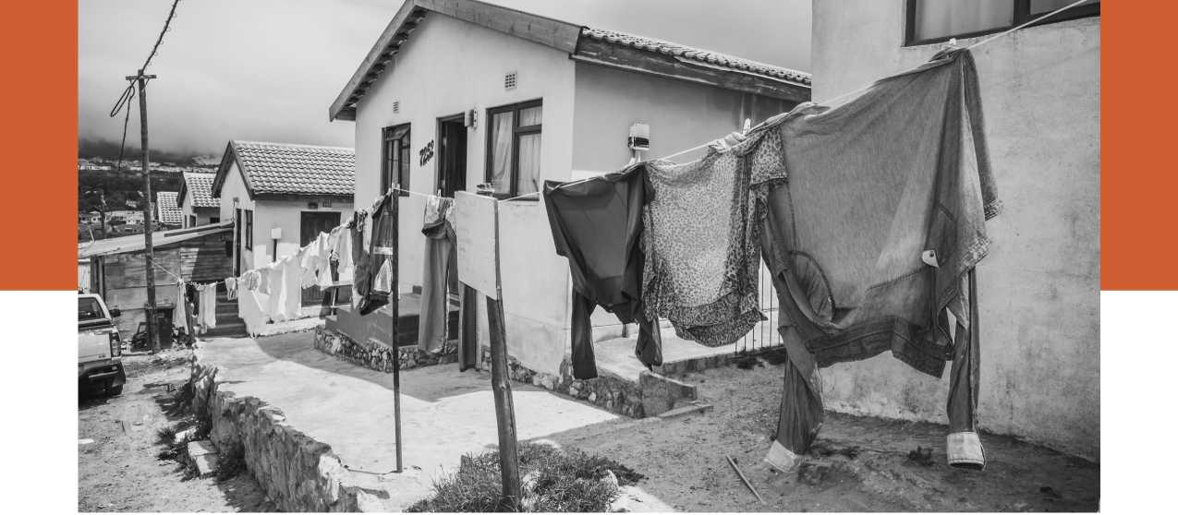



“One immigrant worker generates approximately two jobs for South Africans” — World Bank, 2018



**WORLD BANKGROUP**

*For additional information, please contact:* Helidah R.A. Ogude

Social Development | Africa Region [hogude@worldbank.org](mailto:hogude@worldbank.org)



1. This includes refugees and asylum seekers. See Annexure 1 (Methodology, Data and Limitations) of this report for a discussion on the data.
2. This is a substantial downward revision from the numbers (above 1 million asylum seekers) due to methodological changes in 2015 and 2016.
3. Recent violence resulted in a Nigerian man, Clement Nwaogu, being doused with petrol by protestors and burnt alive. He later died in hospital from his injuries.
4. See for instance, recent research on labor mobility in the ASEAN region (Testaverde, Moroz, Hollweg and Schmillen 2017)
5. There are much broader ethical debates around whether refugees and migrants can and ought to be distinguished from each other, and the impact of this categorisation, but those are beyond the scope of this study - see, for instance, Zetter 1991, Malkki 1995a, Turton 2003a, Feller 2005, DeWind 2007, Hathaway 2007, Landau 2007, Zetter 2007, Bakewell 2008b, Chimni 2009.
6. Particularly, South Africa, Botswana and Namibia (see Crush and Frayne 2007).
7. See Department of Home Affairs, Republic of South Africa 2017
8. See de Haas 2012, for a general discussion
9. Fine and Rustomjee coined the evocative phrase ‘mining-energy-complex' to describe the direct and indirect dependence of South Africa's entire economy on the mining and energy sectors (and associated manufacturing) (1996, p.71-75)
10. The 1913 Land Act barred ‘Africans' from acquiring land outside ‘native reserves', which comprised 7.3% of South African land area. The 1936 Natives and Land Trust Act doubled the land area set aside for the Native Reserves, which had been found to be insufficient to provide even minimum subsistence requirements for the populations residing in them.
11. As classified by UNHCR.
12. For a discussion of the methodology used by UNDESA to estimate these figures, and for a more general discussion on the shortcomings of migration data, please see the section of the report on Methodology.
13. As noted above, UNDESA's data includes refugees and asylum seekers in the total migrant population.
14. See section 3.7 for a brief discussion on the female composition of migration flows.
15. UNHCR estimated that 420,689 had fled Burundi between April 2015 and April 2017 (UNHCR 2017).
16. On the topic of land reform in Zimbabwe, see Kariuki 2004; Nmoma 2008. ZA- NU-PF's efforts to reform massive racial inequities in colonial land distribution were initially restricted by its commitments to market-based measures under the Lancaster House Agreement (which governed Zimbabwe's political transition at independence). This provided for land redistribution strictly on a “willing seller, willing buyer basis.” In 1997, the British government abruptly reneged on its commitment to provide financial support to this land reform process. See also Grebe 2010.
17. For a more comprehensive analysis of Zimbabwean politics at this time, see Southall 2013.
18. Limpopo \ Mozambique (Northern Province)

    163,183

    Namibia

    Mpumalanga  
    151,901
19. Swaziland

    Free State

    68,216

    Northern Cape

    19,543

    South Africa
20. Gender plays a role in structuring kinship, and in shaping the relationship between migrants, asylum seekers and formal and informal authorities. See Krystalli, Hawkins and Wilson 2018.
21. Refugees Amendment Act, 2017. Assented to on 14 December 2017. <http://www.saflii.org/za/legis/num_act/raa201711o2017g41343231.pdf>. Accessed 16 April 2018.
22. The 1969 OAU Convention includes three interesting variations, compared to the 1951 Refugee Convention. (1) It expands the definition of refugee to include those fleeing their country of nationality or residence ‘owing to external aggression, occupation, foreign domination or events seriously disturbing public order in either part or the whole of his country of origin or nationality' (Art. I);

    (2) exhorts states to provide asylum, by using ‘best endeavours', and subject to national legislation (Art. II); and (3) prohibits ‘subversive activities' by refugees (Art. III). See Okoth-Obbo 2001 and Wood 2012.
23. Treaty Establishing the African Economic Community 1991. [https://au.int/sites/](https://au.int/sites/default/files/treaties/7775-treaty-0016_-_treaty_establishing_the_african_economic_community_e.pdf) [default/files/treaties/7775-treaty-0016_-_treaty_establishing_the_african_eco-](https://au.int/sites/default/files/treaties/7775-treaty-0016_-_treaty_establishing_the_african_economic_community_e.pdf) [nomic_community_e.pdf](https://au.int/sites/default/files/treaties/7775-treaty-0016_-_treaty_establishing_the_african_economic_community_e.pdf). Accessed 7 May 2018.
24. See: Consolidated Text of the Treaty of the Southern African Development Com­munity, last amended 21 October 2015, [http://www.sadc.int/documents-publi-](http://www.sadc.int/documents-publications/sadc-treaty/) [cations/sadc-treaty/](http://www.sadc.int/documents-publications/sadc-treaty/). Accessed 8 May 2018.
25. See Oucho and Crush 2001.
26. See ‘Protocol on Facilitation of Movement of Persons (2005),' <http://www.sadc.int/documents-publications/show/800>.Accessed 8 May 2018.
27. See Protocol on Employment and Labour, [http://www.sadc.int/](http://www.sadc.int/files/5714/6193/6406/Protocol_on_Employment_and_Labour_-_English_-_2014.pdf) [files/5714/6193/6406/Protocol_on_Employment_and_Labour_-_En-](http://www.sadc.int/files/5714/6193/6406/Protocol_on_Employment_and_Labour_-_English_-_2014.pdf) [glish_-_2014.pdf](http://www.sadc.int/files/5714/6193/6406/Protocol_on_Employment_and_Labour_-_English_-_2014.pdf). Accessed 8 May 2018.
28. See Code on Social Security in the SADC, [http://www.sadc.int/](http://www.sadc.int/files/2513/5843/3198/Code_on_Social_Security_in_SADC.pdf) [files/2513/5843/3198/Code_on_Social_Security_in_SADC.pdf](http://www.sadc.int/files/2513/5843/3198/Code_on_Social_Security_in_SADC.pdf). Accessed 8 May 2018. In general, Codes are not binding, only Protocols are. See “SADC Protocols,”<http://www.sadc.int/about-sadc/overview/sa-protocols/>. Accessed 8 May 2018.
29. The text of the framework can be obtained from Landau and Vanyora 2015.
30. Agreement between the Government of the Republic of South Africa and the Government of the Kingdom of Lesotho relating to the Establishment of an Office for a Lesotho government Labour Representative in the Republic of South Africa, Lesotho Citizens in the Republic of South Africa and the Movement of such persons across the international border' (24 August 1973: Republic of South Africa Treaty Series No. 1/1973).
31. See Bamu 2014 for an exhaustive analysis of these.
32. See for instance, Lawyers for Human Rights' ‘Refugee and Migrant Rights Programme'. [http://www.lhr.org.za/programme/refugee-and-migrant-rights-pro- gramme-rmrp](http://www.lhr.org.za/programme/refugee-and-migrant-rights-pro-gramme-rmrp).
33. See the Refugees Amendment Act 2017, which reduced this period from 14 to 5 days. Respondents noted that subsidiary legislation to implement these amendments have yet to be formulated.
34. See Article 1(A), Convention Relating to the Status of Refugees, 1951, http:// [www.unhcr.org/3b66c2aa10.html](http://www.unhcr.org/3b66c2aa10.html). It is worth noting that, in addition to the grounds mentioned in the Refugee Convention, the *1969 Organization of African Unity (OAU) Convention* defines a refugee as any person compelled to leave his or her country “owing to external aggression, occupation, foreign domination or events seriously disturbing public order in either part or the whole of his country or origin or nationality.” Similarly, the *1984 Cartagena Declaration* states that refugees also include persons who flee their country “because their lives, security or freedom have been threatened by general­ized violence, foreign aggression, internal conflicts, massive violations of human rights or other circumstances which have seriously disturbed public order.” See IOM 2011, p.80.
35. The Forced Displacement Trust Fund was awarded by the Fragility, Conflict and Violence Cross Cutting Solution Area (CCSA)
36. For a discussion on literature reviews of ‘grey literature' in international devel­opment, see see Hagen-Zanker and Mallett 2013.
37. This was one of the reasons why the researchers chose not to conduct formal interviews with refugees and migrants.
38. See Krystalli, Hawkins, and Wilson (2018) for a discussion on gender and forced migration, albeit in a different geographical context.
39. This also has an implication on the estimated age distribution of the internation­al migrant stock. In countries where citizenship is conferred on the basis of jus soli (that is, on the basis of place of birth) children born to international migrants are granted citizenship on birth and excluded from migrant stock. In other cases, children born to international migrants are considered foreign citizens.
40. Also see UNDESA 2017 for a detailed discussion on the methodology used by UNDESA to extrapolate or estimate the migrant stock growth rates for each country.
41. See World Bank and UNHCR 2015a, p.80
42. The specifics of the South African asylum system are discussed in Chapter 3.
43. For an analysis of deportation practices in Botswana see Galvin 2015.
44. Zetter (1995) has argued that it was international humanitarian aid which led to the adoption of an encampment policy in Malawi.
45. There are a host of other issues around data collection including whether better data is the best use of constrained resources, and data security and privacy of asylum-seekers and refugees.
46. Budlender (2013) contains a detailed analysis of existing datasets on migration in South Africa.
47. See for instance the data collected by the Gauteng City - Region Observatory (GCRO) for Gauteng which is the South African the province with the highest proportion of migrants in its population. The GCRO was established in 2008 as a partnership between the University of Johannesburg (UJ), the University of the Witwatersrand, Johannesburg (Wits) and the Gauteng Provincial Government (Peberdy 2013).